Exercise 5 Solution
GIS in WR 2007

(1) What does the pattern of location of the SpringSeep and Well points tell you about the groundwater system underlying this basin?

The fact that the SpringSeep features are in the upstream end of the watershed and the well features in the downstream end means that the piezometric head of the groundwater system is above ground level in the upstream end of the basin and below ground level in the downstream end. This is the opposite of what you would think normally.

(2) Prepare a plot of the cumulative frequency versus log of the discharge for the San Marcos River at San Marcos with drainage area and ave flow annotated on it. Compare this plot and the corresponding data with the one in the exercise for the Blanco River at Wimberley. The average flows are similar but the drainage areas and flow variability are vastly different. What does this tell you about the source of water flow at the two gaging sites?

The two plots are shown below. The mean flows are 142 cfs at Wimberley from a 355 square mile drainage area and 176 cfs mean flow at San Marcos from a drainage area of 49 square miles. How can this make sense? The key is to look at the variability of the flows – the frequency distribution is very uniform at San Marcos, and that tells us that it is groundwater that supplies the flow there, while Wimberley is a normal surface water flow station. You can go to the USGS water web site as we did in Exercise 2 and make plots of the discharge hydrographs through time to confirm this fact. There is a huge groundwater outflow at San Marcos Springs in the City of San Marcos that is so large it makes sand jump off the bottom of the lake from whose bed the discharge emanates.

(3) Make a map of the San Marcos basin NHDFlowlines attributed with mean annual flow, and compare the flow estimate from the mapped flow line with that at the stream gage for the Blanco River at Kyle.

Here is a basin map for attributed flows. At the Blanco River at Kyle Gage, the MAFLOWU = 248 cfs, MAFLOWV = 137 cfs, and the gaged mean annual flow = 164 cfs. Again, the gaged value is much closer to the Vogel equation value.

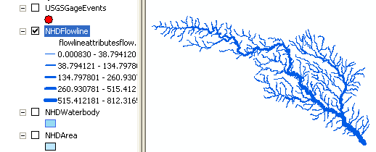

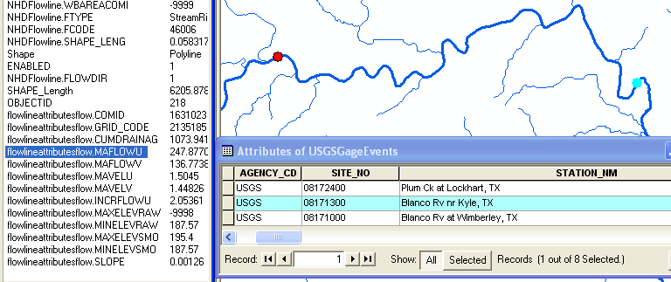

4) To be turned in: Make a layout of the related catchments and flowlines to the USGS gage near the Blanco River at Kyle. Find the number and the total area of the catchments associated with gaging station. What percent of the total San Marcos basin does this constitute? Compare it with the area given in the USGS gage feature class.

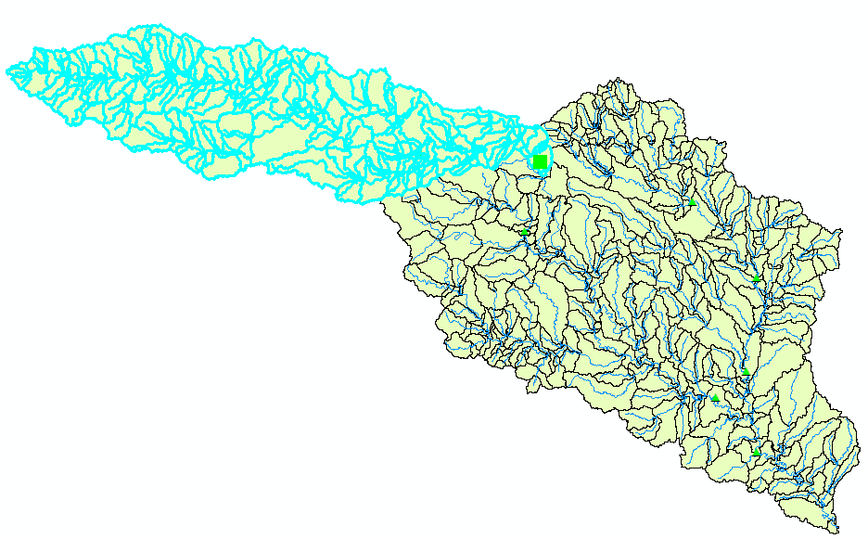
Total number of catchments – 157
Total area of the catchments – 1073.94 sq. km
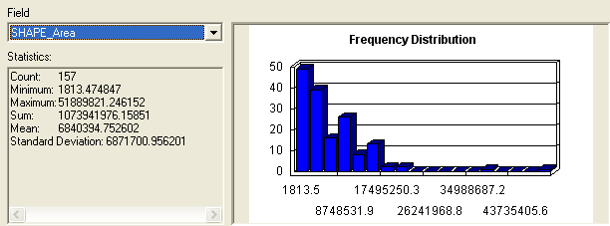

Area given by the USGS gauging station at Kyle – 412 sq. mile = 1067.075 sq km.

(5) What is the total flow length from top to bottom of the San Marcos Basin (km). What is the average length of the 93 NHDFlowLines on this flow path (km). What is the average slope of these lines (%). What is the elevation drop along the flow path (m). If you divide the elevation drop by the flow path length, do you get a result consistent with that from the mean slope computation? If it is different is that ok? Think carefully about this last question before you answer it. The average of a set of ratios (a/b) is not the same thing as the ratio of the average values of a and b.

The selected set of 93 flow lines is shown below.

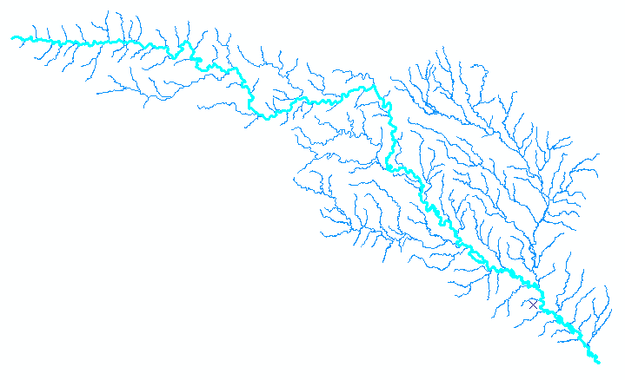
The statistics display shown below gives the total flow length = 270 km, and 2.90 km is the mean length for the flow lines.
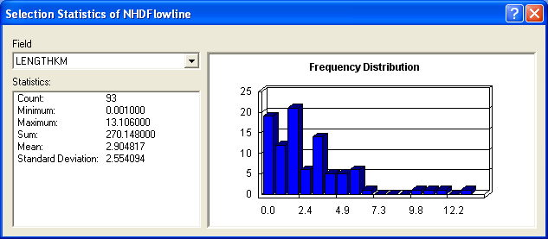

The Statistics for the slope attribute are given below, from which it can be seen that the average slope of the NHDFlowlines is 0.117%
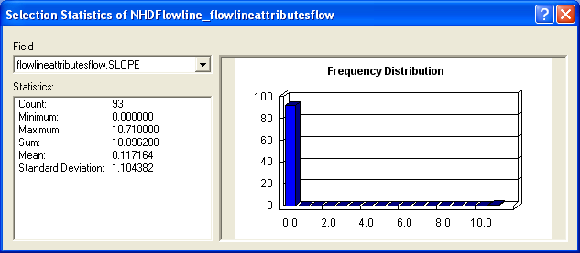

The maximum elevation is 593.36 m and minimum is 77.97 m, so the elevation drop is 515.39 m. Over a distance of 270.148 km or 270148 m, this represents a slope of 515.39/270148 = 0.001907 = 0.19%.

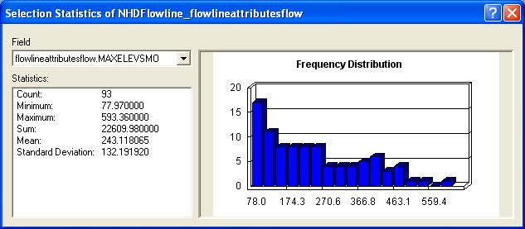

What this says is that if you join the highest point and lowest point on the flowline by a straightline, that line is steeper than the average slope of the individual flow lines that make up the flowpath. This is so because in the headwaters the slope is initially very steep and then it flattens out in the middle and lower portions of the basin. This fact can be verified by using the Identify tool to click along the flow path.

(6) To be turned in: Make a layout of the Edwards Aquifer overlayed on the San Marcos basin. What is the river on the right that has low base flow. What is the river on the left that has high base flow. Make a base flow balance between these two rivers to see if you can reasonably predict the base flow at the most downstream station (the San Marcos River at Ottine).
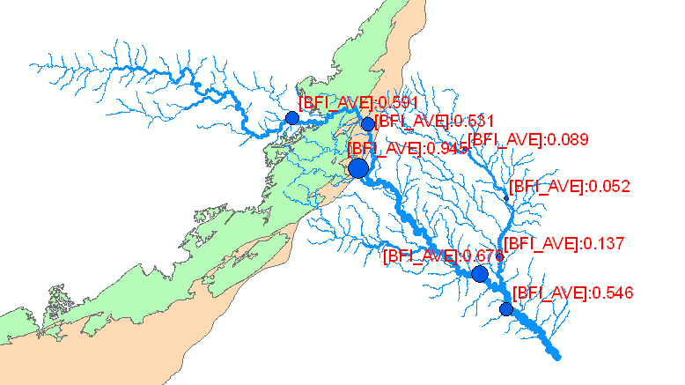

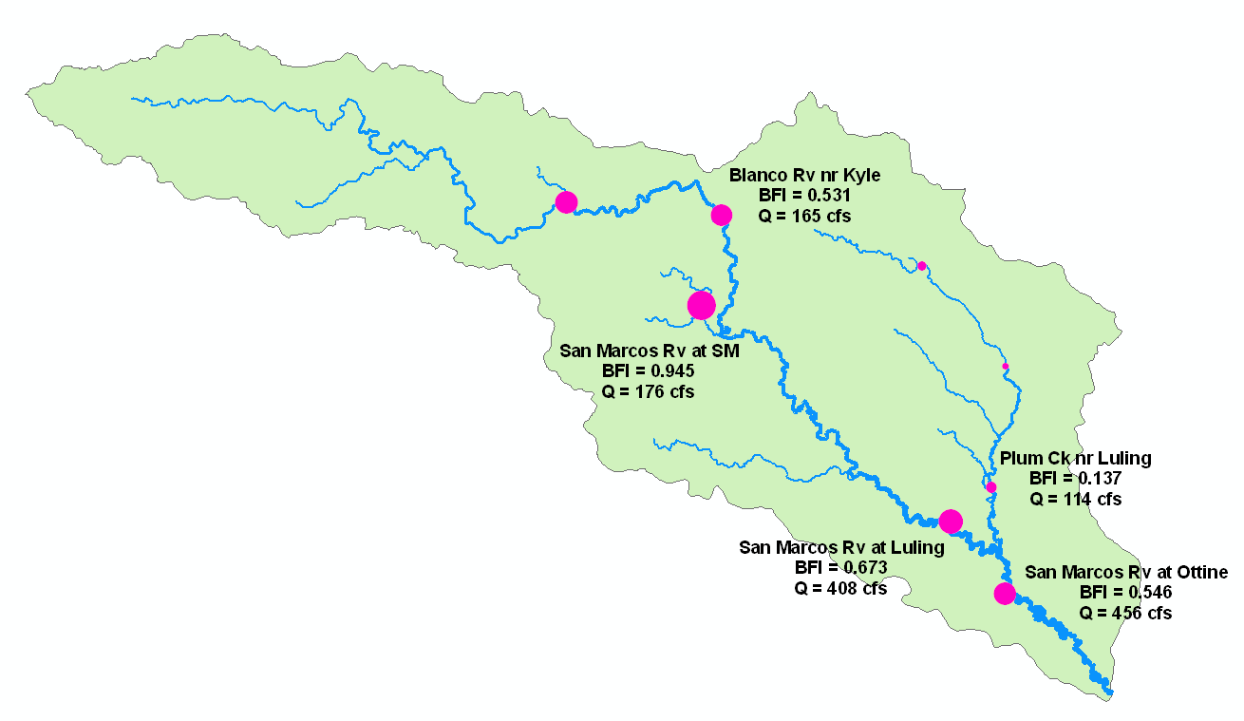
The river on the left with high base flow is the San Marcos River; the river on the right with low base flow is Plum Creek.

San Marcos Rv @ Luling + Plum Crk nr Luling:

[ (0.673*408 cfs) + (0.137*114 cfs) ] / [ 408 + 114 ] = 290 / 522 = 0.556
The predicted BFI for the San Marcos Rv @ Ottine (BFI = 0.546) is reasonable.

(7) Prepare a layout of the San Marcos basin characterized by intensity of residential development. What is the total area (km²) has a local land cover that is at least 30% high intensity residential? For each of the stream gage locations, what is the % of upstream land cover that is high intensity residential?
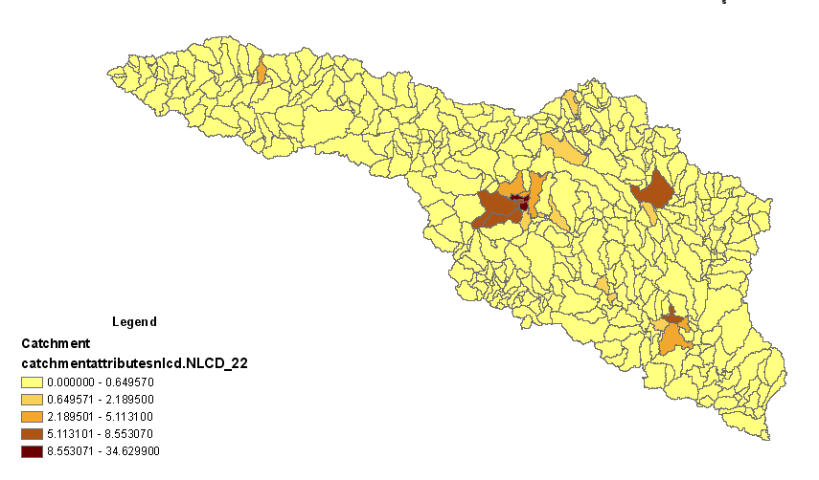
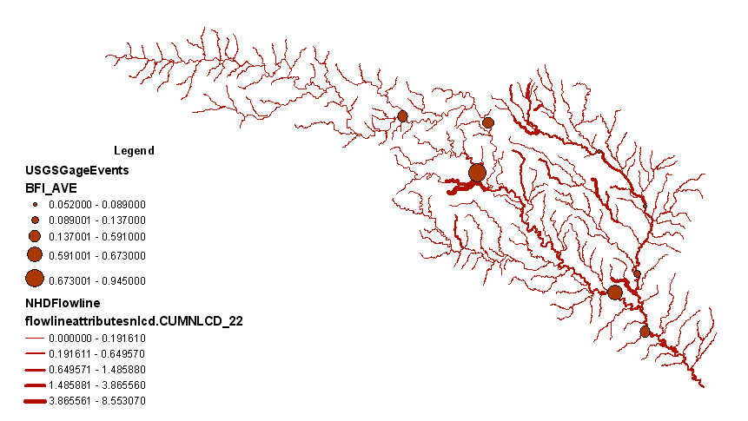
To find the total area of the basin with 30% or greater highly residential cover we open the attribute table of the catchments and use the Select by Attributes feature under Options. Here we choose the NLCD_22 and apply the constraint of the value being greater than 30%.

The selection would provide us all the catchments with a highly residential cover greater than 30%. Now we can find statistics using the area field under the catchment attribute table. It looks like this.

The total area under highly residential more than 30% = 3.1 sq kms.

For the next part find the associated catchments for each of the USGS gages and then from within the selection choose those which have an NLCD_22 value greater than 0. You will get the following results.

Name of Site | Upstream high intensity residential cover (%)
Blanco River at Wimberly | 0.03
Blanco River near Kyle | 0.03
San Marcos River at San Marcos | 1.26
Plum Creek at Lockhart | 0.96
Plum Creek near Lockhart | 0.65
Plum Creek near Luling | 0.42
San Marcos River at Luling | 0.35
San Marcos at Ottine | 0.36

Addendum:
(8) To be turned in: A graph of the longitudinal stream bed profile of the San Marcos River main stem with nice labels, axes, and colors.

