Final Exam Solution – Problem 3
GIS in WR 2007

(1) Prepare a histogram that shows the statistical distribution of the catchment areas for the 551 Catchments that are contained in this basin. What is the mean, minimum and maximum catchment area (km²)?

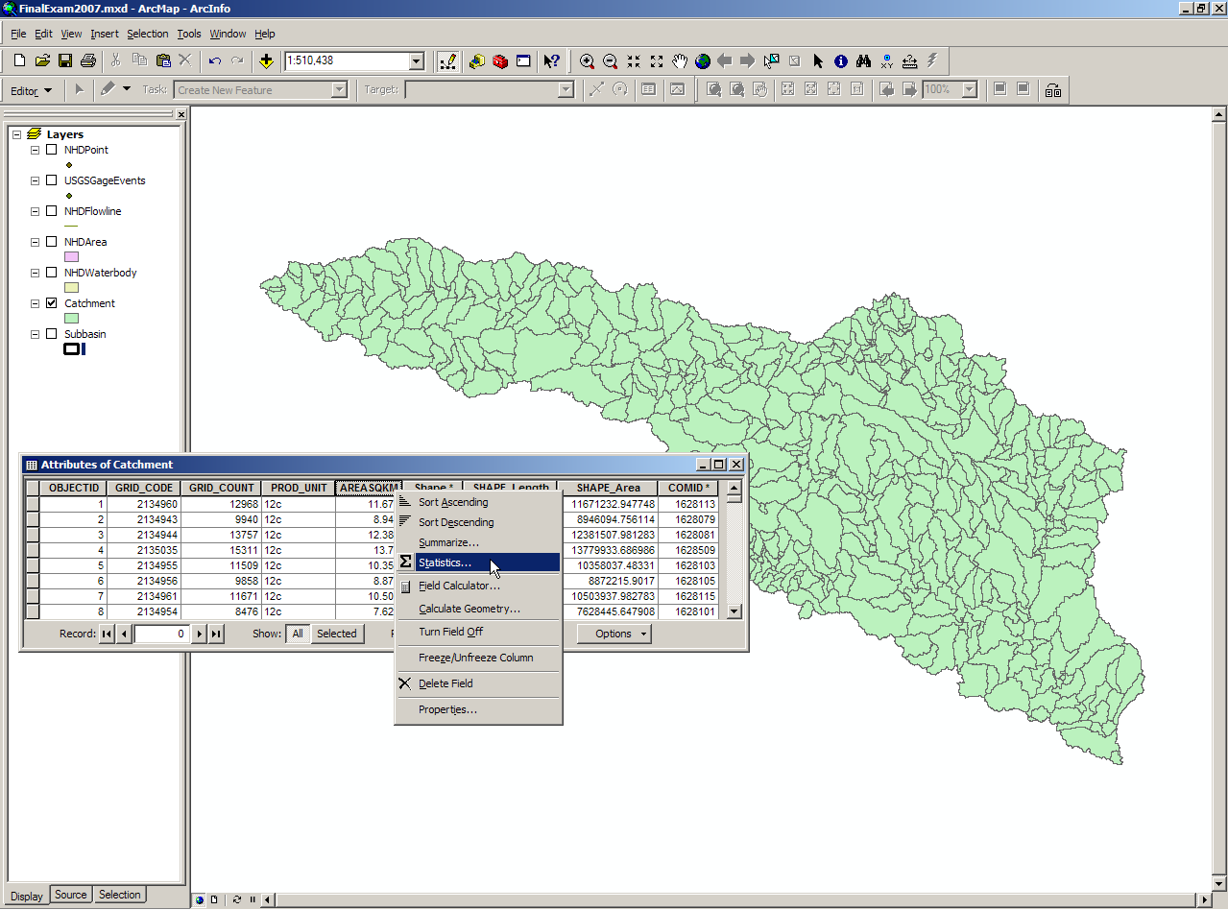

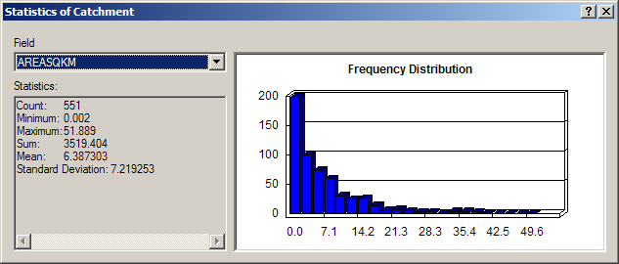

The mean, minimum, and maximum catchment areas for the 551 Catchments are 6.4, 0.002, and 51.9 km², respectively.

(2) Prepare a histogram that shows the statistical distribution of the stream lengths for the 557 NHDFlowLines that are contained in this basin. What is the mean, minimum and maximum stream length (km)?

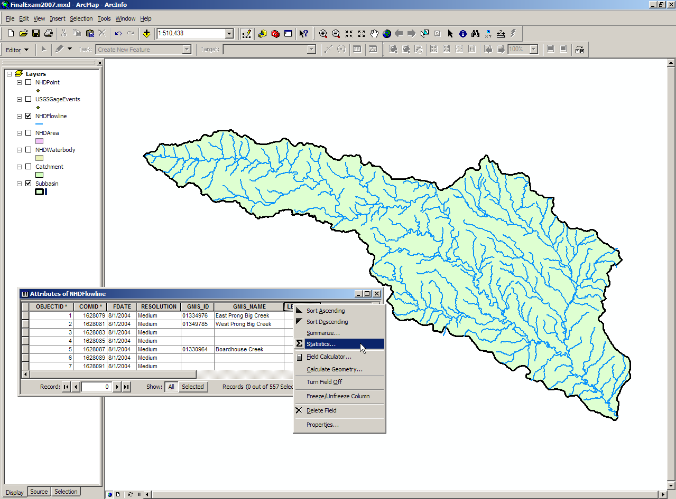

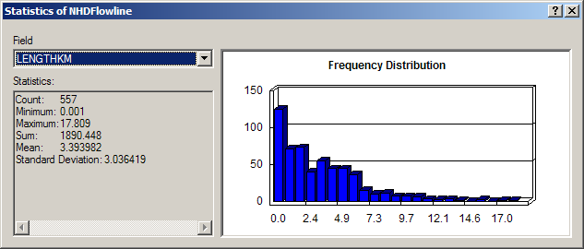

The mean, minimum, and maximum stream (reach) lengths for the 557 NHD Flowlines are 3.4, 0.001, and 17.8 km, respectively.
(3) Make a nice publication quality map of the Edwards Aquifer and the San Marcos Catchments, NHDFlowLines, and USGS Gages.

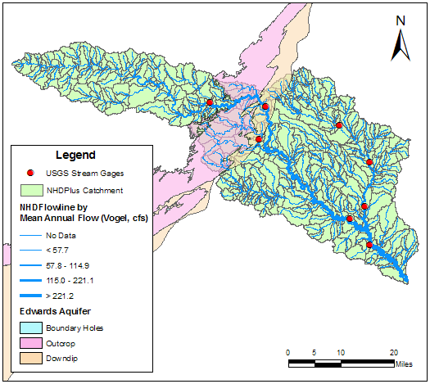
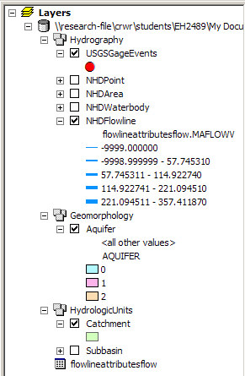

(4) The Edwards aquifer outline is in the Geomorphology feature dataset. What area (km²) of this basin is entirely upstream of the Edwards Aquifer? What is the area (km²) of the recharge zone (indicated by attribute AQUIFER = 1) that lies within the San Marcos Basin? What length of streams (km) in the San Marcos basin lies within the recharge zone of the Edwards Aquifer?

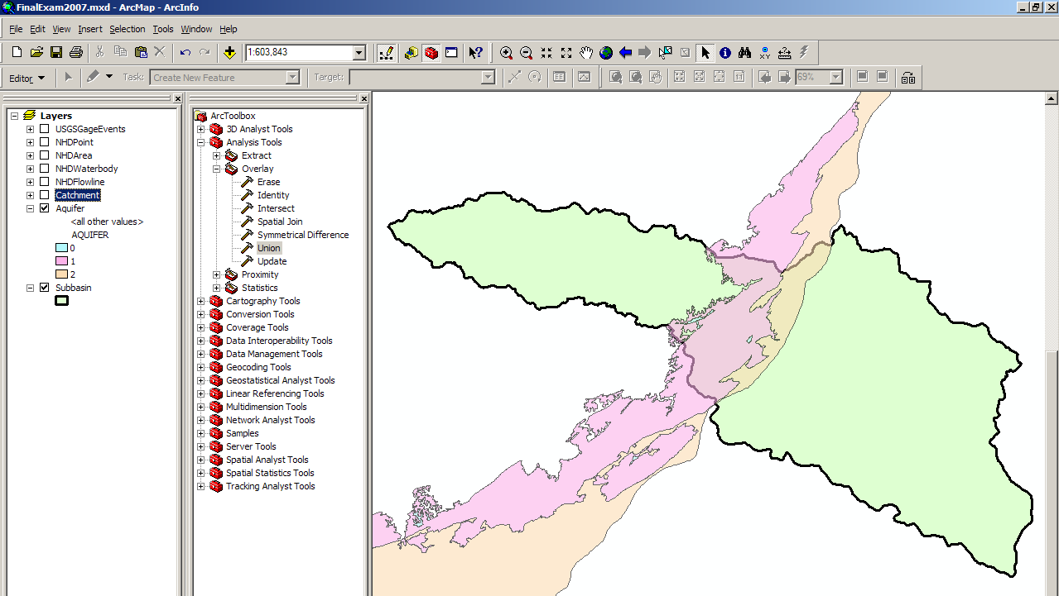

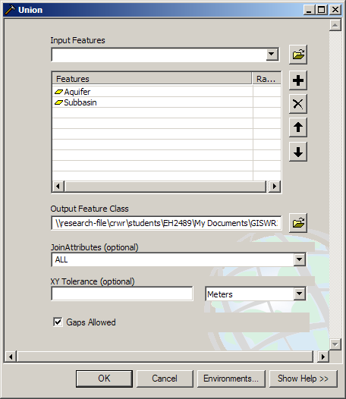

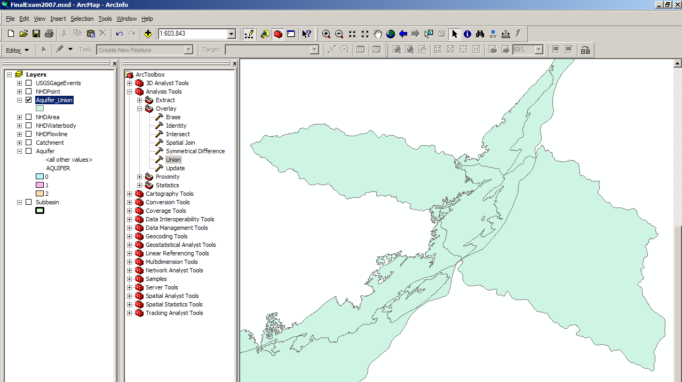

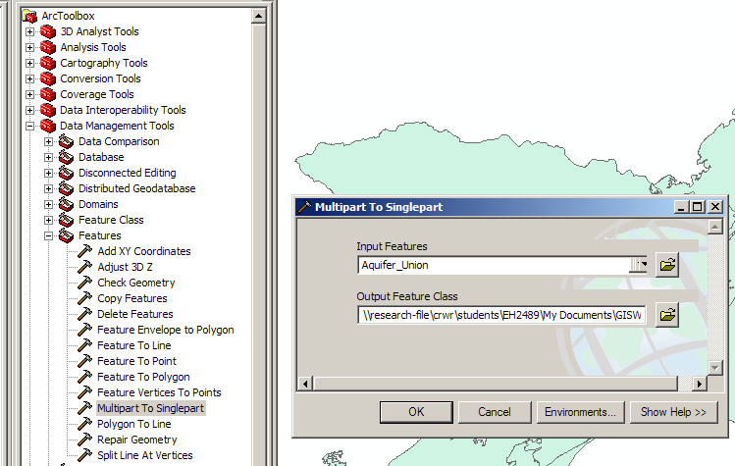

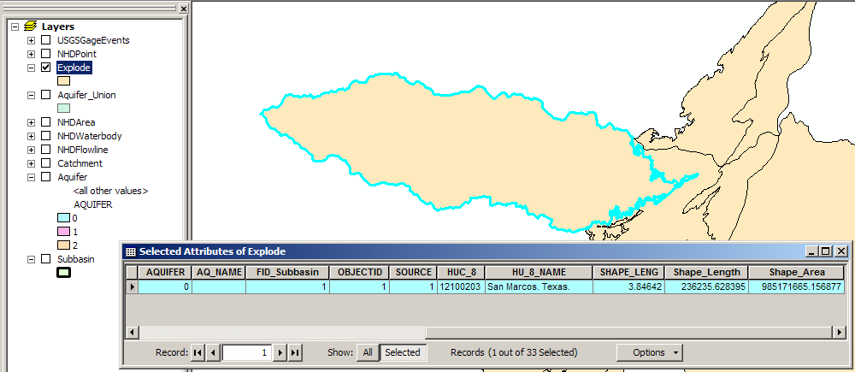

The area of the San Marcos basin that is entirely upstream of the Edwards Aquifer is 985,171,665 m² or 985.2 km².

This value was obtained via a three-step process as shown above and described below:
- Use the “Analysis Tools → Overlay → Union” tool on the Aquifer and Subbasin feature classes to create a new Aquifer_Union feature class.
- Use the “Data Management Tools → Features → Multipart to Singlepart” tool to explode the components of the unioned feature class.
- Use the Select or Identify tool to determine the new subbasin area.

The area of the recharge zone (Aquifer = 1) that lies within the San Marcos Basin is 305,761,856 m² or 305.8 km².

This value was obtained via a two-step process as shown and described below:
- Select the recharge zone of interest using the Select Tool.
- Calculate Geometry (area) within the Aquifer_Union attribute table.

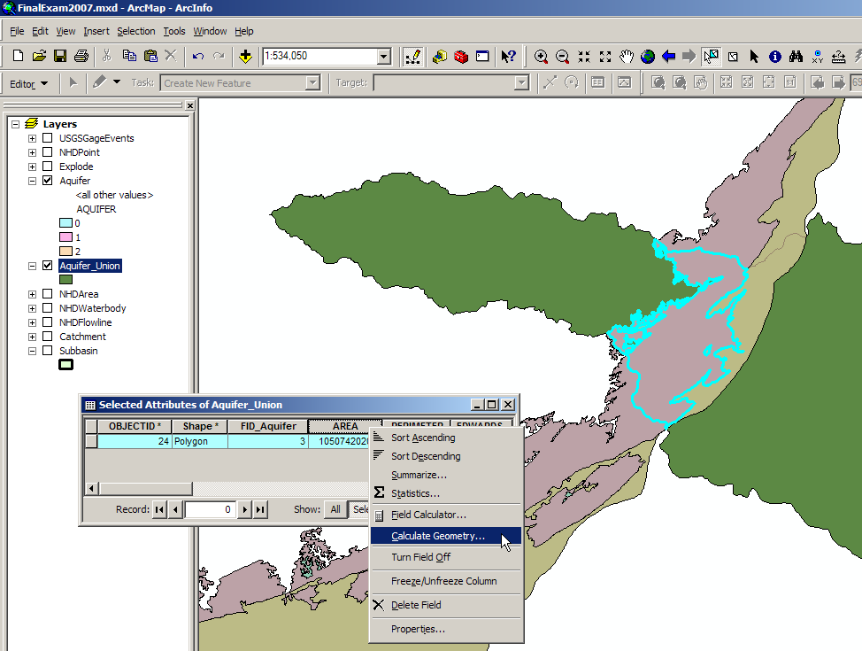

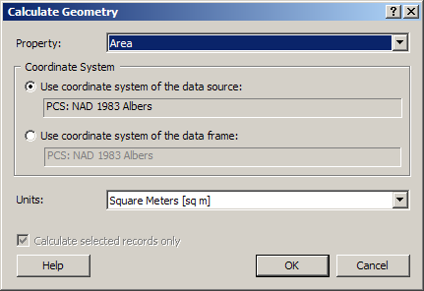

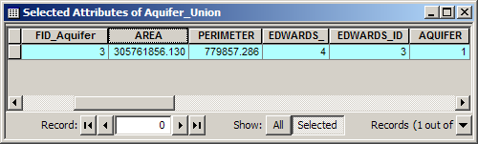

The total length of streams in the San Marcos Basin which lie within the Edwards Aquifer recharge zone is 131.3 km.

This value was obtained via a three-step process as shown above and described below:
- Export Data for the recharge zone of interest and add to map as a new feature class, RechargeZone_SanMarcos.
- Use the “Analysis Tools → Extract → Clip” tool to clip the NHDFlowline feature class with the RechargeZone_SanMarcos feature class into a new feature class, NHDFlowline_Clip.
- Calculate the statistics on the shape length to obtain the sum of the lengths.

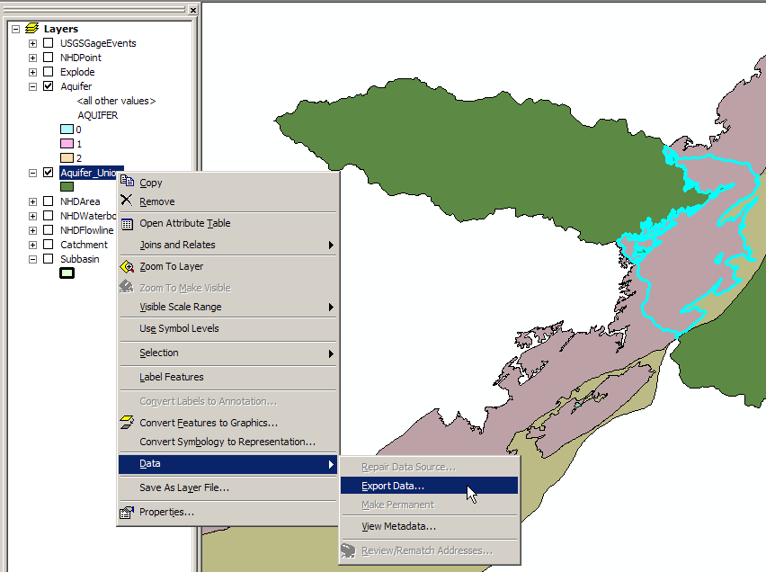

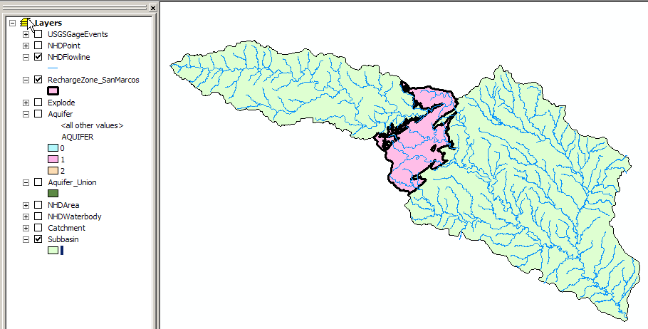

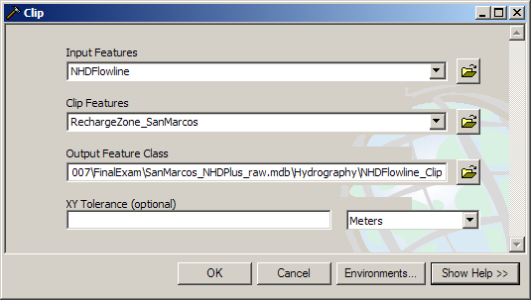

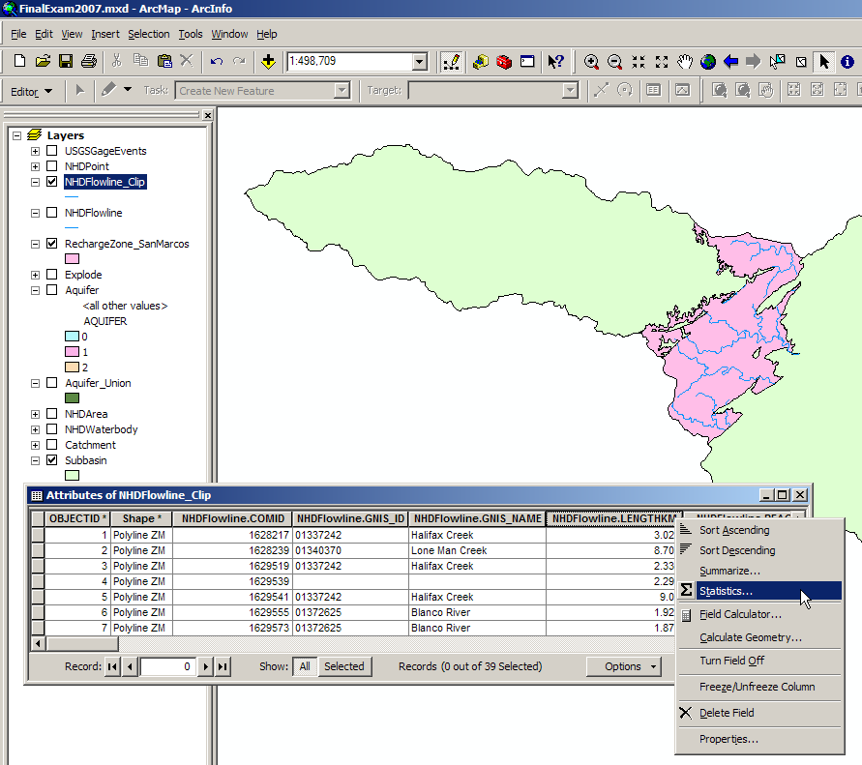

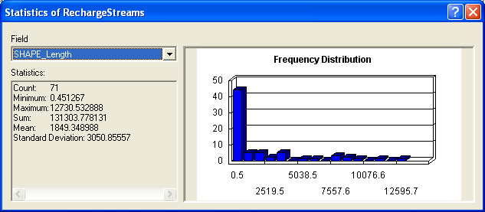
(5) In the USGSGageEvents feature class, the attribute AVE is the mean annual flow in cfs. Does the Blanco River gain or lose flow between the gages at Wimberly and Kyle? The proportion of the annual flow that is base flow from groundwater is indicated by the attribute BFI_AVE. Does the Blanco River gain or lose base flow between Wimberley and Kyle? What is the rate of gain or loss of base flow in terms of flow per unit length of river (cfs/mile)?

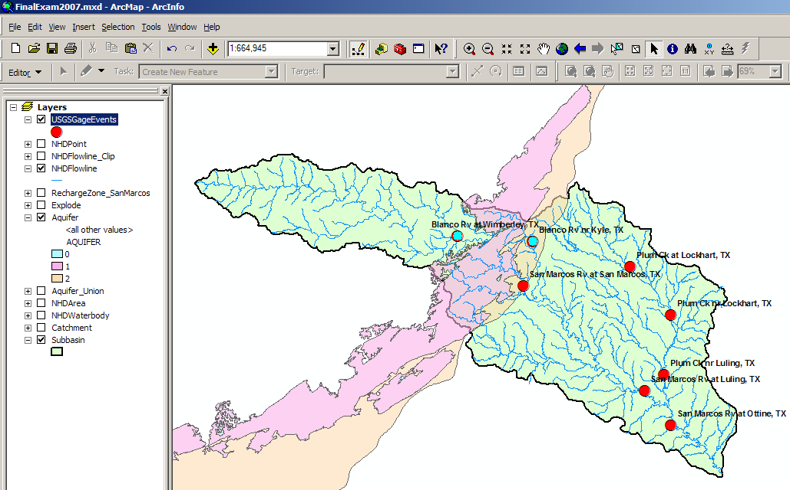

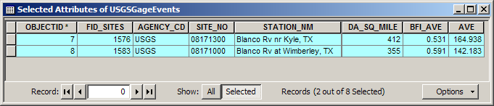

The mean annual flow in the Blanco Rv at Wimberley (upstream) is approximately 142 cfs while the mean annual flow at Kyle (downstream) is approximately 165 cfs. Therefore, the Blanco River gains flow between these two gages.

At Wimberley, there is an annual average of (142.2 cfs * 0.591) = 84.0 cfs of base flow. At Kyle, there is (164.9 cfs * 0.531) = 87.6 cfs of base flow. Thus, the Blanco River gains a slight amount of base flow between these two stations in real terms (3.6 cfs) but loses base flow when considered as a relative proportion of the total average annual streamflow (BFI of 0.591 upstream versus 0.531 downstream).
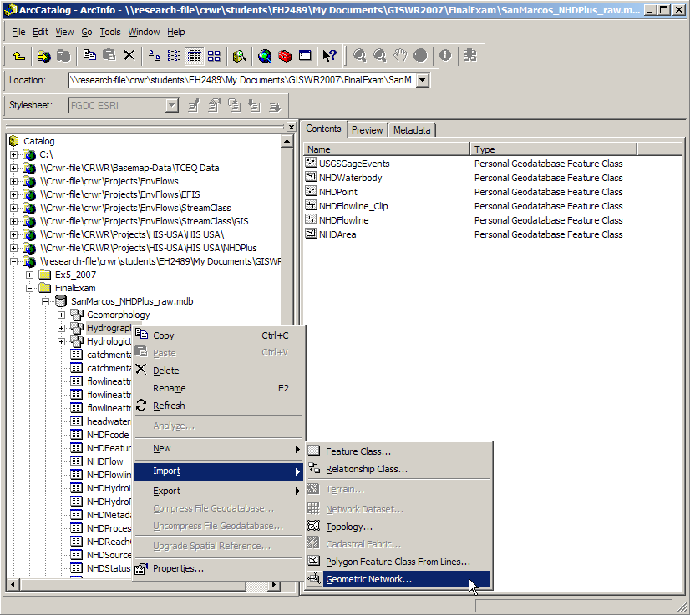

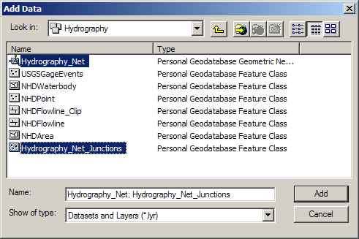

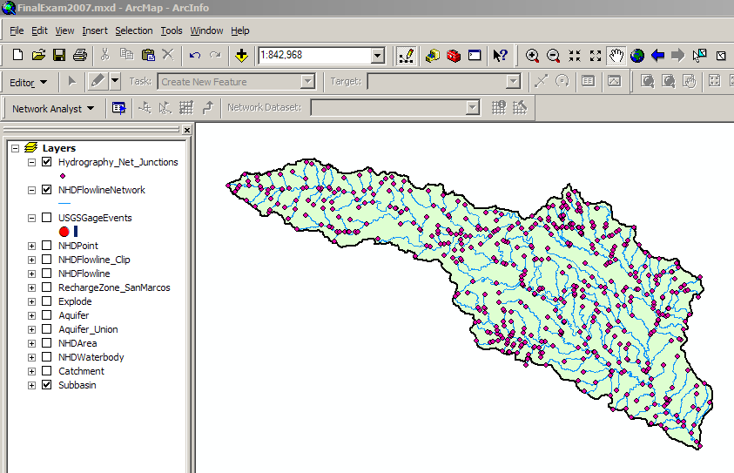

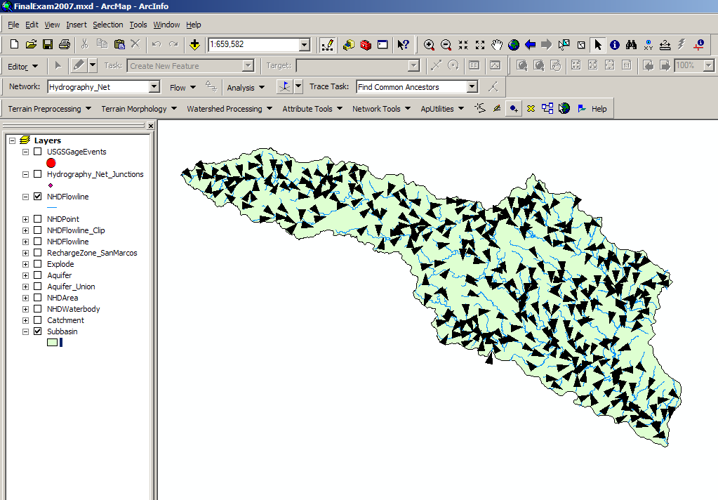

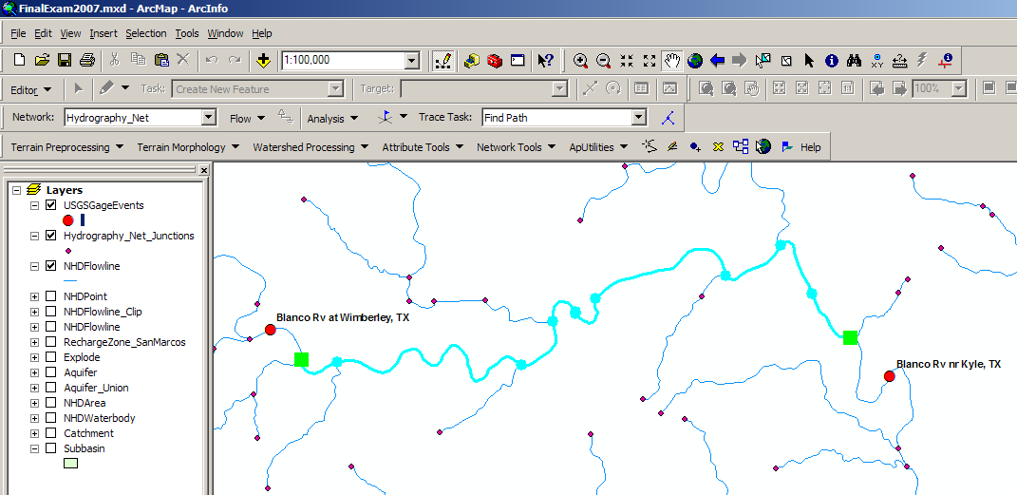

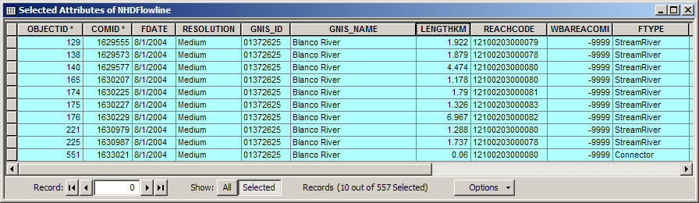

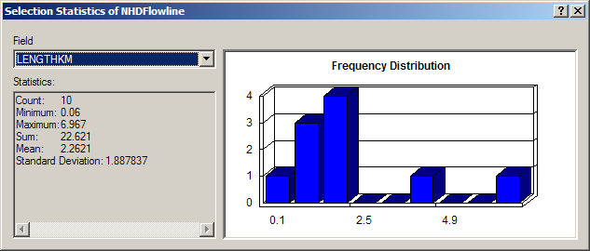

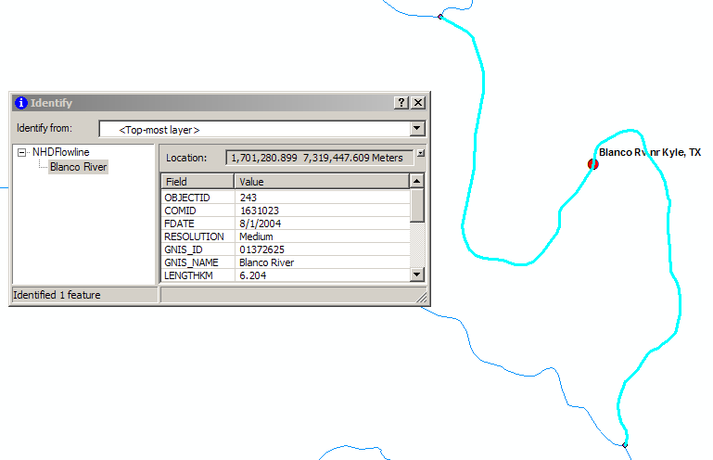

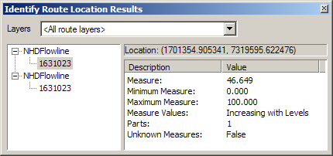

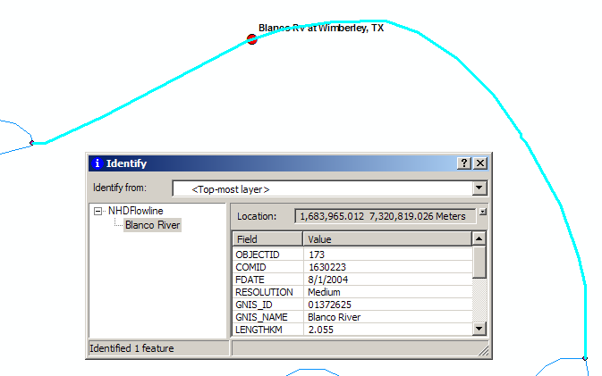

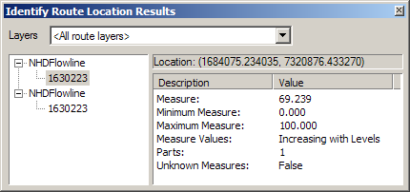

To determine the river length between the Wimberley and Kyle gages:
- A geometric network was built on the NHDFlowline feature class
- The flow direction was set using the ArcHydro Network tools
- The Utility Network Analyst toolbar Add Junction Flag Tool was used to place flags at the reach junctions downstream of the Wimberley gage and upstream of the Kyle gage
- The Utility Network Analyst toolbar was used to find the path between these two flags with the output set to select the reaches along by the path
- Statistics were calculated on the attributes of these reaches to determine the total length of the reaches entirely contained within the path (22.621 km)
- The Identify Route Locations tool was added and used to determine the measures of both the Wimberley gage (69.239%) along its reach length (2.055 km) and the Kyle gage (46.649%) along its reach length (6.204 km)
- The within-reach distance downstream of the Wimberley gage (0.69239*2.055 km = 1.423 km) and upstream of the Kyle gage [(1-0.46649)*6.204 km = 3.310 km] were added to the previous total length (22.621 km) to obtain a new total length (27.354 km).

The rate of gain of base flow between the two gages is thus 3.6 cfs per 27.354 km (17.000 mi), or +0.212 cfs/mile.
(6) What is the average slope of the Blanco River between Wimberley and Kyle?

To calculate the average slope of the Blanco River between these two gages (as shown below):
- Join the FlowlineAttributeFlow Table to the NHDFlowline feature class
- Export the reaches which had been selected by the previous question’s path trace

To calculate the reach length-weighted average slope:
- Compute the reach rise in km by multiplying each reach length by its reach slope, including the modified reach lengths for the first and last reaches
- Sum the reach rises and divide by the total length between the gages.

To calculate the bulk (non-weighted) average slope:
- Subtract the minimum elevation of the downstream-most reach from the maximum elevation of the upstream-most reach and divide this total rise (converted to km) by the total length.

The weighted average slope is 0.001853 km/km and the non-weighted average slope is 0.001857 km/km, extremely close.

