Name:____Key______________

GIS in Water Resources Midterm Exam Fall 2007
There are 4 questions on this exam. Please do all 4.

1. [20 points] Concepts

(a) The NHDPlus contains the synthesis of three large national geospatial datasets. What are they?
National Hydrography Dataset, National Elevation Dataset, National Land Cover Dataset.

(b) A geometric network of a set of streams combines three different data models. Explain what each of these data models does:

(i) Geometric model
This specifies the (x,y) geographic location of all the features. It defines “where”on the globe.

(ii) Logical model
This specifies the topological connection of the edges and junctions. It defines “what is connected to “what.

(iii) Addressing model
This specifies where things are located along the stream lines like a postal addressing system. It defines “where” on the stream network.

(c) Arc Hydro uses the concept of a HydroID.

(i) What is a HydroID?
A unique identifier for all features in an Arc Hydro geodatabase.

(ii) What does having a HydroID add to the approach normally used in ArcGIS to label feature classes?
Feature classes label features individually with an ObjectID but the same ObjectID can appear in many feature classes. HydroID is unique across all feature classes.

(iii) Why is a HydroID needed to build geodatabases for water resources?
Because we need to make feature to feature connections between feature classes to track the movement of water from one feature to the next.

(d) Explain the difference between a geodatabase and a feature dataset.
A feature dataset contains a set of feature classes with the same spatial reference. A geodatabase can contain any number of feature datasets, feature classes and objects classes.

2. [20 points] Geodesy, Map Projections and Coordinate Systems

Below are the spatial reference properties of the HucReg12 feature class used for Exercise 2

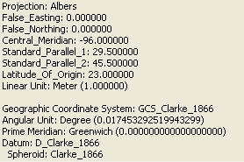

(a) What ellipsoid is used?
Clark 1866

(b) What horizontal earth datum does this correspond to?
NAD 27

(b) What map projection is used? Why is this particular projection used for this exercise?
Albers Equal Area. This is to preserve correct earth surface areas.

(c) What are the geographic coordinates of the origin (φo, λo)?
(23°N, 96ºW)

(d) What are the projected coordinates of the origin (Xo, Yo)?
(0, 0)

(e) Draw the Central Meridian and the Latitude of Origin on the map below

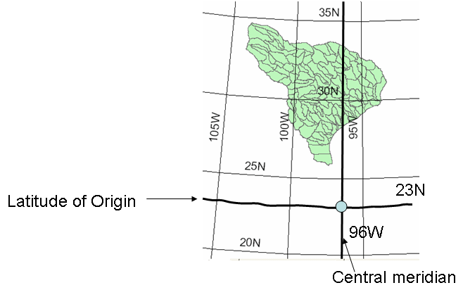
3. [25 points] Earth Surface Areas

2. (a) Consider the one degree box near Austin, Texas, surrounded by parallels 29ºN and 30ºN and meridians 97ºW and 98ºW. Approximate the earth as a sphere with radius 6370 km. Calculate the area of this box (km²).

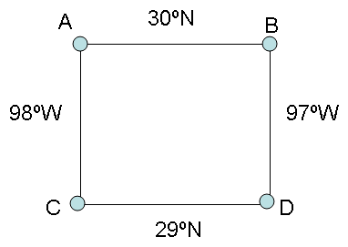
1° = (1/180) * π radians = 0.017453 radians

Length $\text{AC}=RΔφ$= 6370 * 0.017453 = 111.18 km

Length BD = Length AC = 111.18 km

Length $\text{AB}=RΔλ\text{Cos}φ$= 6370 * 0.017453 * Cos30° = 6370 * 0.017453 * 0.866025 = 96.28 km

Length $\text{CD}=RΔλ\text{Cos}φ$= 6370 * 0.017453 * Cos29° = 6370 * 0.017453 * 0.87462 = 97.23 km

Area = AC * (AB + CD)/2 = 111.18 * (96.28 + 97.23)/2 = 111.18 * 96.76 = 10757.6 km²

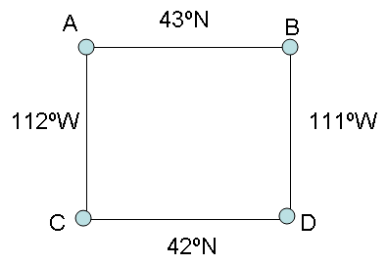
(b) Similarly calculate the area (km²) of a one degree box near Logan, Utah, surrounded by parallels 42ºN and 43ºN and meridians 111ºW and 112ºW.

1° = (1/180) * π radians = 0.017453 radians

Length AC = Length BD = 111.18 km as in part (a)

Length $\text{AB}=RΔλ\text{Cos}φ$= 6370 * 0.017453 * Cos43° = 6370 * 0.017453 * 0.731354 = 81.31 km

Length $\text{CD}=RΔλ\text{Cos}φ$= 6370 * 0.017453 * Cos42° = 6370 * 0.017453 * 0.743145 = 82.62 km

Area = AC * (AB + CD)/2 = 111.18 * (81.31 + 82.62)/2 = 111.18 * 81.97 = 9112.7 km²

(c) Is a one degree box near Austin, Texas larger or smaller in terms of land area than the one near Logan, Utah? What is the % difference in area between these two boxes?

The box near Austin is larger.

The % difference in area is (Austin – Utah) / Utah = [(10756.6 – 9112.7)/9112.7]* 100 = 18.0%

or % difference in area is (Austin – Utah)/Austin = [(10756.6 – 9112.7)/10756.6]* 100 = 15.3%
4. [35 points] Hydrologic Variables derived from DEM’s

Given the following grid of elevations with the flow around the edges specified, answer the questions below

- Identify any pits by drawing a circle around the elevation and indicate the elevation to which they need to be raised to fill them.

32 is the elevation needed to fill the pit grid cell marked in yellow.

- Determine the flow direction grid using the 8-direction pour point method (D8) for the 9 internal grid cells. Indicate the flow direction by using an arrow in each cell on the grid below. Use the space around the diagram to show how you’ve calculated the hydrologic slope for cells whose flow direction is not obvious.

- Determine the flow accumulation grid corresponding to the D8 flow directions. Label each cell on the grid below with the number of upstream cells draining into it (ESRI convention). What is the maximum flow accumulation value in this internal grid (the 9 cells with no arrows in them)?

The maximum flow accumulation value in the internal grid is 10.

d) Determine the slope of the cell with elevation 42 using the ESRI standard slope function. Determine both the magnitude of the slope and also its aspect as measured in degrees clockwise from the North direction.

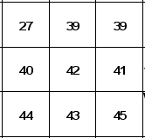
dz/dx = ((B4+2*B5+B6)-(D4+2*D5+D6))/(8*B2)
dz/dy = =((B6+2*C6+D6)-(B4+2*C4+D4))/(8*B2)

