“How To” For Setting Up Term Projects

CE 394K.3 GIS in Water Resources
Fall Semester 2007
University of Texas at Austin

Handout Summary:

1. How to create a document in Word and save it as Single File Web Page (.mht file) which preserves the pictures.
2. How to transfer the file to your WebSpace
3. How to set the permissions so that the file is viewable by others and not just yourself.
4. How to get the web address of the web file so that it can be sent to somebody else and they can see the file.
5. Helpful Resources

1. How to create a document in Word and save it as Single File Web Page (.mht file) which preserves the pictures.

Create the report in a word document. Insert pictures into the report.
The default file type in Word is a (.doc). To change the format from document to web page, choose File 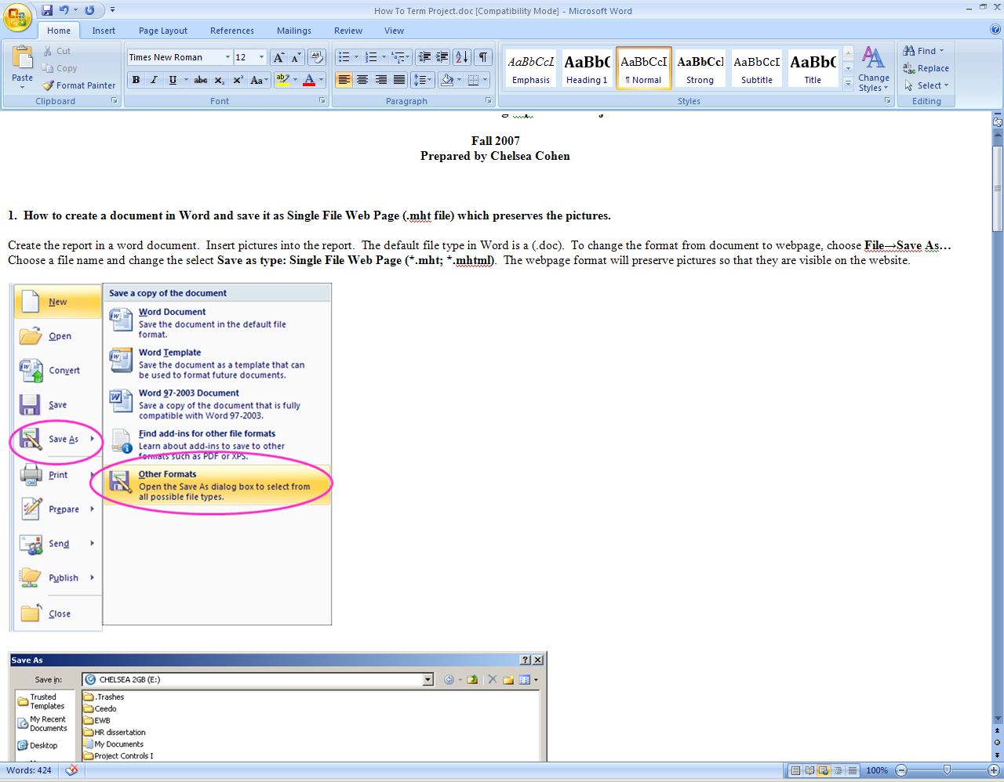 → Save As… → Other Formats

Choose a file name and select Save as type: Single File Web Page (*.mht; *.mhtml). The web page format will preserve pictures so that they are visible on the website.
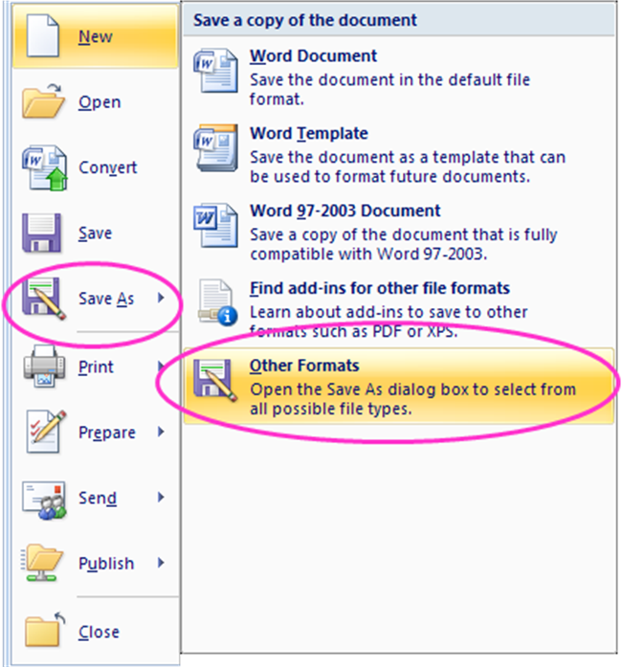
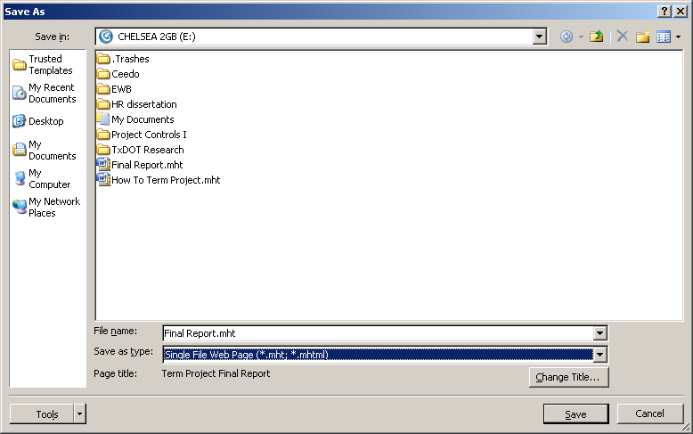

2. How to transfer the file to your WebSpace
Log into WebSpace using your UT EID login and password:
https://webspace.utexas.edu/
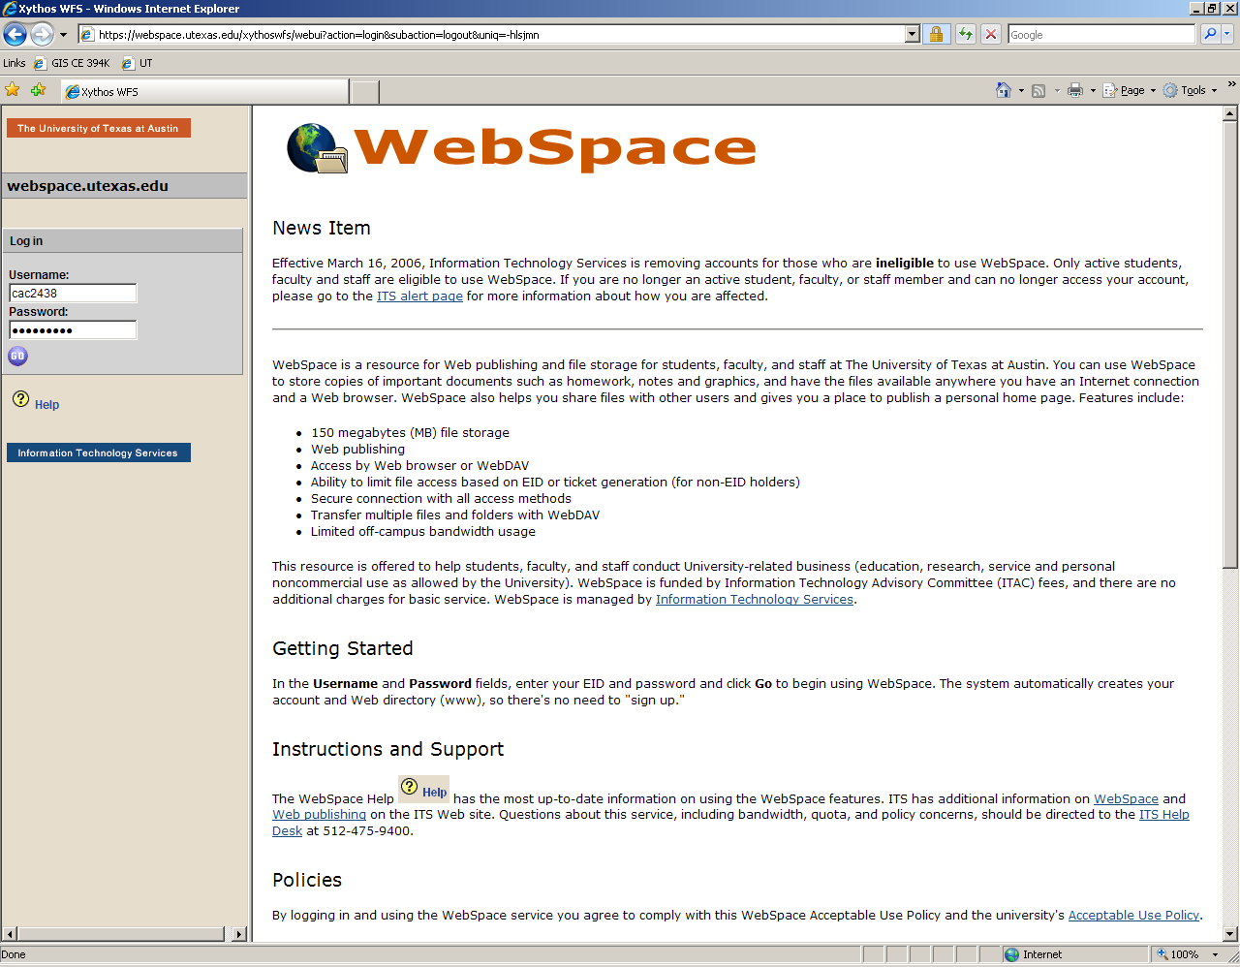
Click on New Directory and create a new folder called “www.”:
Note: The www. directory will allow Internet browsers to access web page files that are uploaded to it. Alternatively, files can be uploaded to the main directory (labeled as your UT EID). However, read below to make sure that the correct permissions are set so that other users can view the web page files.
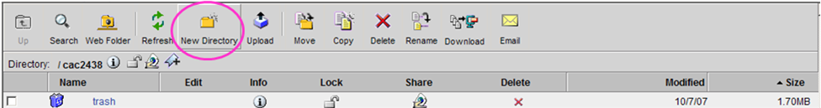
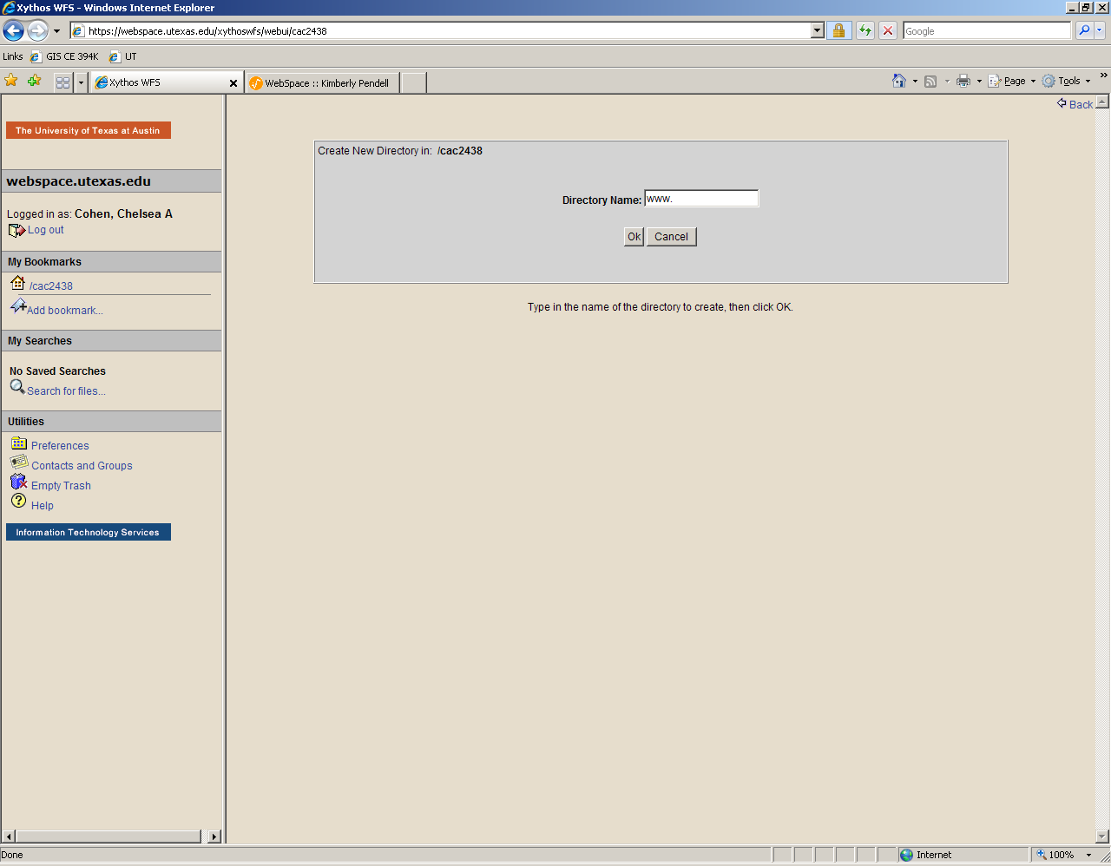
After the Web Directory is created, click on the www. folder. Click on Upload to upload the .mht file:
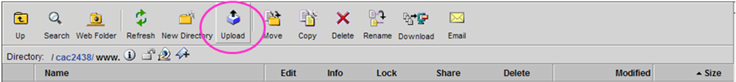
Browse to the Final Report.mht file location and click Ok:
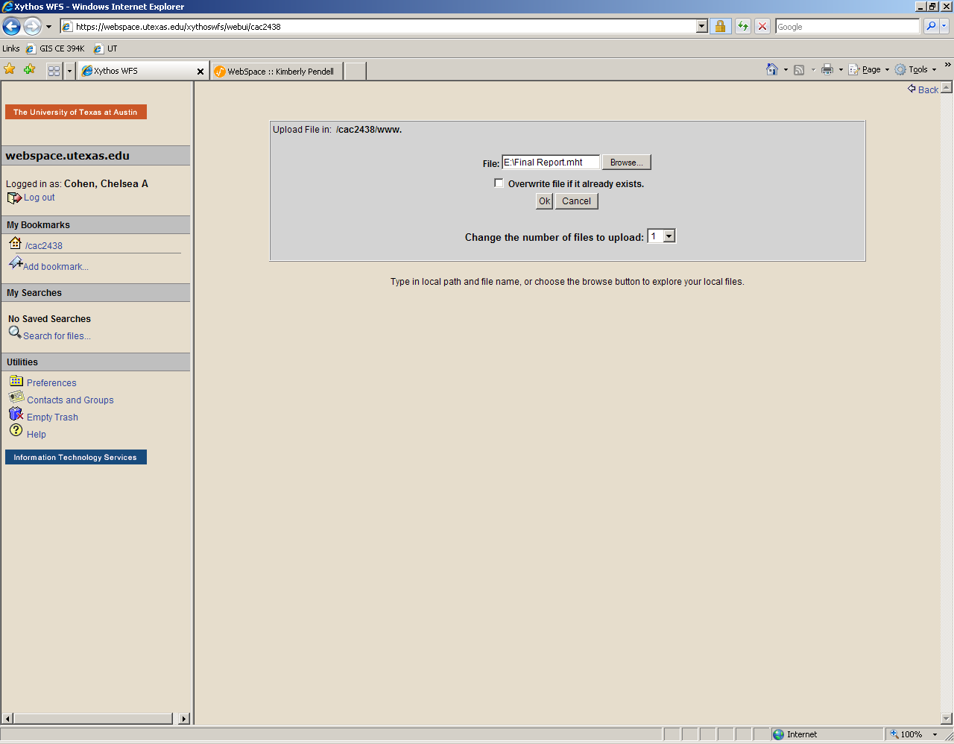
The upload file should show up in the www. directory:
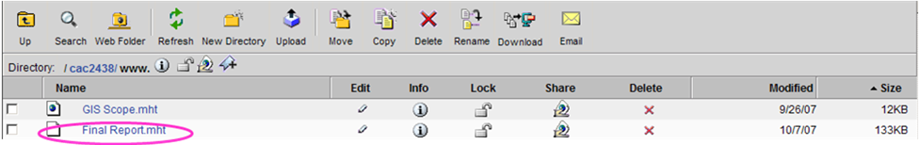
3. How to set the permissions so that the file is viewable by others and not just yourself.
To change the permissions of the file, click on the share icon next to the file Final Report.mht.
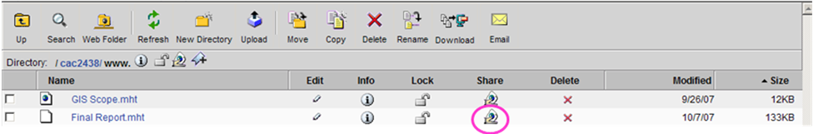
The file can be shared with only the owner, other UT users (Users with accounts) and/or to all internet users (Public).
Make sure the appropriate Read boxes are chosen so that the professors and classmates can view the web page.
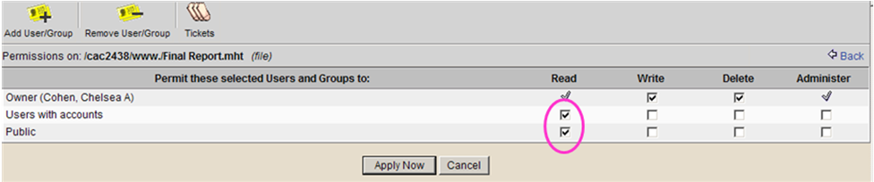
The shared to everyone icon should show up in the directory next to the file name.
Note: If the file or directory is not shared, the Not Shared Icon will show up.

In addition, the permissions can be set for the entire www. directory instead of changing each files permissions individually.
Click on the share icon next to directory address and change the permissions the same way as described above.
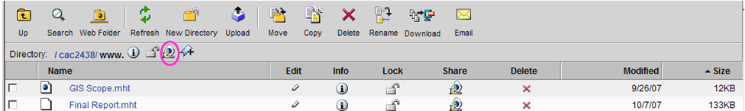
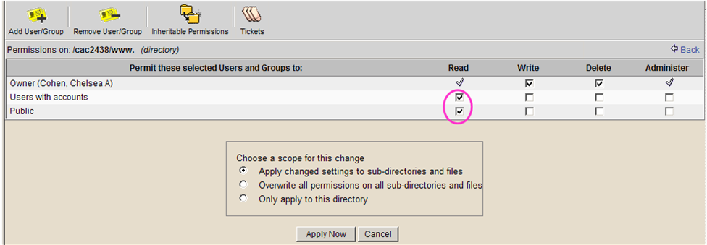

4. How to get the web address of the web file so that it can be sent to somebody else and they can see the file.
Click on the link for the file that was uploaded: Final Report.mht:
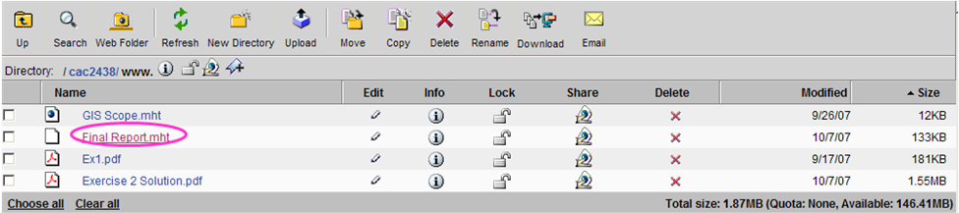
This will open the internet browser with the website address. Copy the website address and send this address to those who need to view the website:
https://webspace.utexas.edu/cac2438/www./Final%20Report.mht?uniq=-hlrn1c
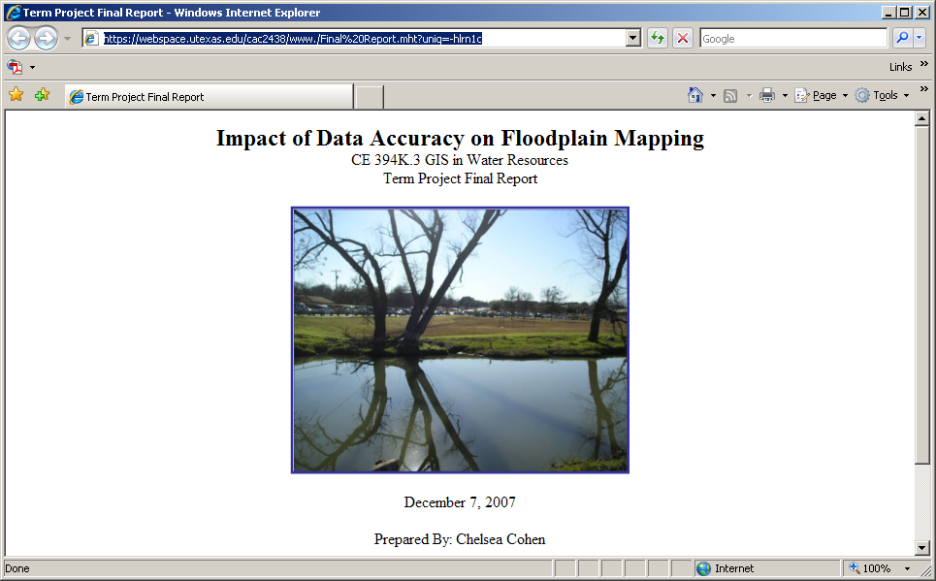
Note: Each file that is uploaded will have its own unique website address.

5. Helpful Resources
UT WebSpace Login page:
https://webspace.utexas.edu/
Computing Resources has created a helpful tutorial for WebSpace users for information about additional features of UT WebSpace,:
Website: http://www.ischool.utexas.edu/technology/tutorials/start/webspace/
PDF version: http://www.ischool.utexas.edu/technology/tutorials/start/webspace/webspace.pdf

