CE 394: GIS - HW 1

ArcMap: Texas, USA (including county lines and rain gage sites)

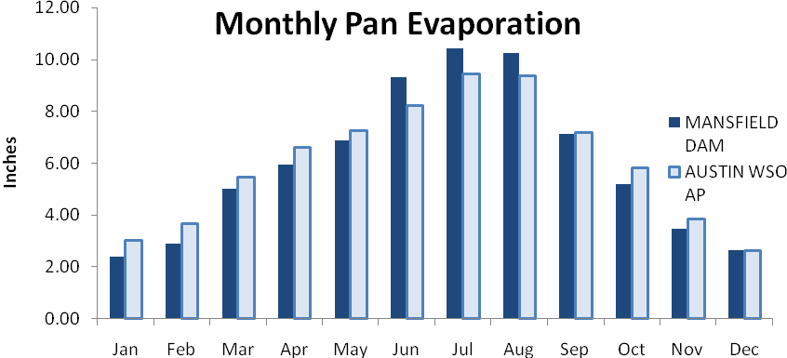
MATT JORDAN

