Exercise 2. Building a Base Map of the San Marcos Basin

CE 394K GIS in Water Resources
University of Texas at Austin
Fall 2008
Prepared by David R. Maidment and Kate Marney
- Goals of the Exercise
- Computer and Data Requirements
- Procedure for the Assignment
  - Creating a Geodatabase
  - Displaying Streams, Basins and Catchments for Region 12
  - Selecting the San Marcos Basin
  - Selecting the San Marcos Catchments
  - Selecting the San Marcos Flowlines
  - Adding Attributes to the Flowlines
  - Creating a Point Feature Class of Stream Gages
  - Add Attributes to the Point Feature Class
  - Creating a Chart and Layout
  - Overlaying the Edwards Aquifer
  - Downloading USGS Flow Data
- Summary of items to be turned in

Goals of the Exercise
This exercise is intended for you to build a base map of geographic and streamflow data for a watershed using the San Marcos Basin in South Texas as an example. The base map comprises watershed boundaries and streams from the National Hydrography Dataset Plus (NHDPlus). A geodatabase is created to hold all these primary data layers and a method for creating relationships inside the geodatabase is also illustrated. In addition, you will create a point Feature Class of stream gage sites by inputting latitude and longitude values for the gages in an Excel table that is added to ArcMap and the geodatabase. The table is used to create an XY Event and a Point Feature Class. You also compare the locations of the San Marcos basin surface boundaries, and the Edwards aquifer subsurface boundaries. You’ll link to the US Geological Survey's Real Time data website in Texas, download some streamflow data and make a plot of a flow hydrograph from a gaging site on the San Marcos Basin.

Computer and Data Requirements
To complete this exercise, you'll need to run ArcGIS 9.3 from a PC.
The HUC boundaries are a subdivision of the US made by the US Geological Survey to show major and minor river basins. There are 2-, 4-, 6-, and 8-digit HUC boundaries, where the larger the number is the smaller the area. The HUC8 boundaries are the basic ones. Each of the 21 Hydrologic Regions in the US are shown below and for this exercise we will focus on Water Resources Region 12, which contains most of Texas.
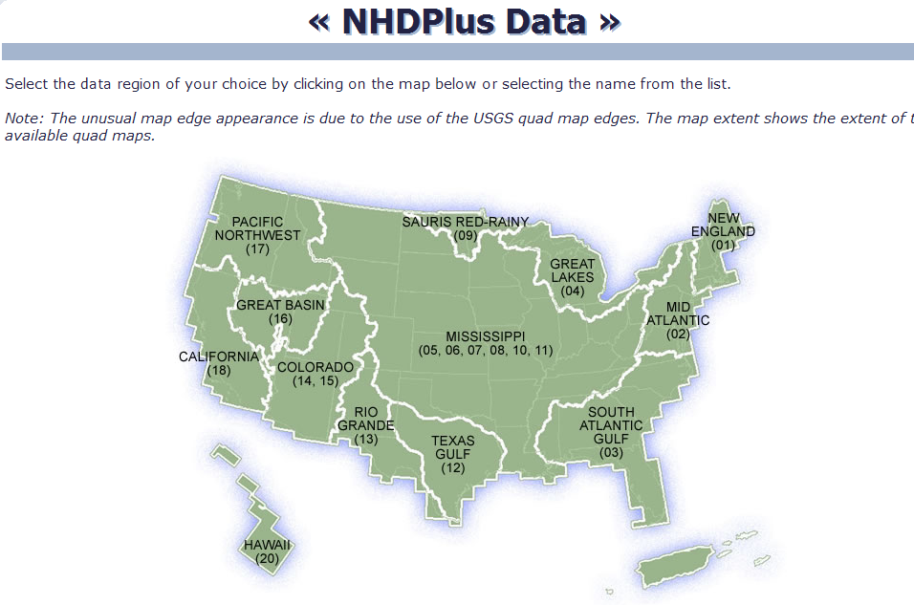
The NHDPlus data for the United States can be downloaded over the internet:
NHDPlus http://www.horizon-systems.com/NHDPlus/
Get the NHDPlus data for Region 12:
http://www.horizon-systems.com/NHDPlus/data.php
For those ambitious students that would like the experience of downloading NHDPlus data for themselves, follow the instructions in this section. Otherwise, skip ahead to the Procedure for the Assignment Section where you will find a zipped file with all the necessary data.
Follow the link to get NHDPlus data, and click on the Region 12 location in the map (or another region if you want a different area of the country). There you will download the following files and save them in a directory of your choosing:
- Region 12, Version 01_02, Catchment Shapefile
- Region 12, Version 01_01, Catchment Flowline Attributes
- Region 12, Version 01_01, National Hydrography Dataset
Don’t download the grid files because they are not needed for this exercise and they are huge in size.

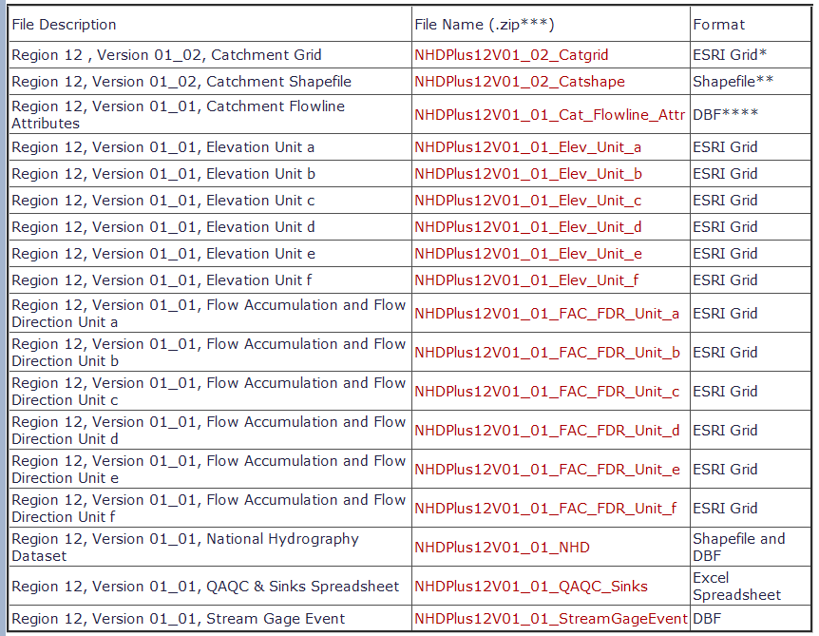

After extracting the zipped files, you should have something similar to the following:

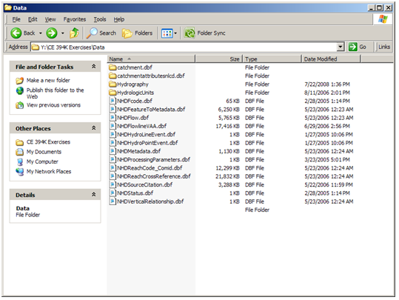

Procedure for the Assignment
Logon to the computer of your choice and make a directory in your workspace for this exercise. I've saved the needed files in the LRC class directory (Civil5/LRC/Class/Maidment/giswr2008/Ex2/). They may also be downloaded as http://www.ce.utexas.edu/prof/maidment/giswr2008/Ex2/Sanmarcos.zip This file is 207 MB and the total file space used for this exercise is a little less than 1GB. If you don’t have this amount of file space available to you, get the smaller file http://www.ce.utexas.edu/prof/maidment/giswr2008/Ex2/SanmarcosGDB.zip and proceed to the section on Adding Attributes to the Flowlines.
Unzip the file to get the following:
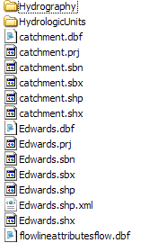
Creating a Geodatabase
Open ArcCatalog and create a new file geodatabase by right clicking the directory where the NHDPlus data is saved and selecting New/File Geodatabase and name it SanMarcos.gdb.
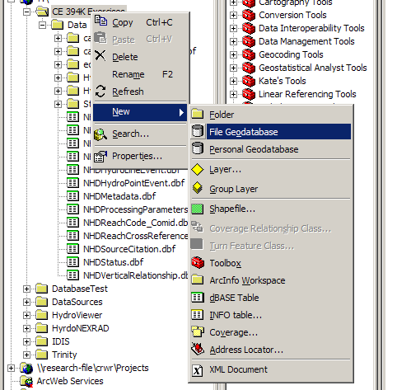
Right click on the new geodatabase and select New/Feature Dataset.
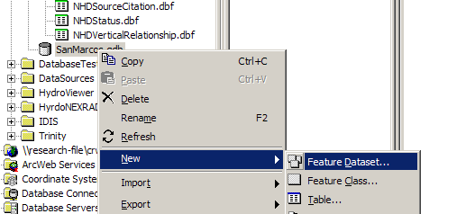
Name the new feature dataset Basemap, and hit Next to set the projection and map extent.
Select Import from the choices in the menu displayed.
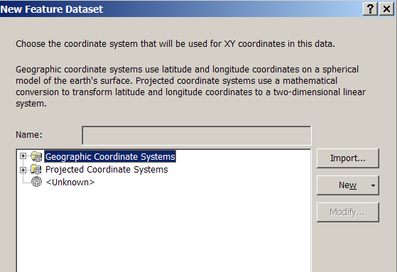
We will import the coordinate system, so select Import and then navigate to the NHDPlus data that was just downloaded. Select the nhdflowlines shapefile.
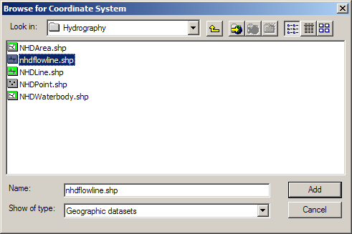
Hit Add to select this horizontal coordinate system. Hit Next and leave the Vertical Coordinate system set at None.
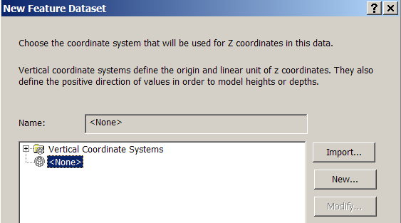
Hit Next and leave the default XY Tolerances as they are, then hit Finish to complete the specification of the spatial reference of the feature dataset. If you right click on the resulting Basemap feature dataset and open Properties, and tab to XY Coordinate System, you’ll see the coordinate system is GCS_North_America_1983. This means that the coordinate system is in geographic coordinates using the North American Datum of 1983.
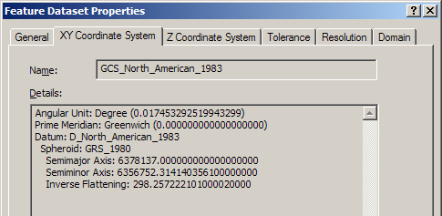

Displaying Streams, Basins and Catchments for Region 12
Open ArcMap and use the 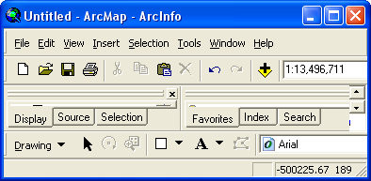 button to add data. Navigate to the folder where the downloaded data is saved.
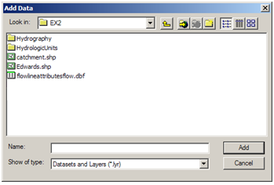
We will first add the subbasin and flowlines layers. The NHDflowline.shp shapefile is located in the Hydrography folder and the Subbasin.shp shapefile is located in HydrologicUnits folder.
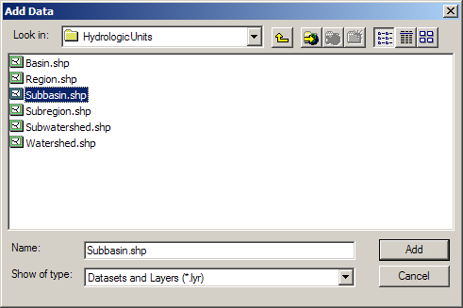
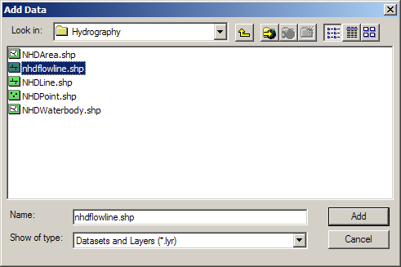
Now lets add the Catchment.shp file to the display also.

Recolor the themes if you wish. The result is a map similar to the following:

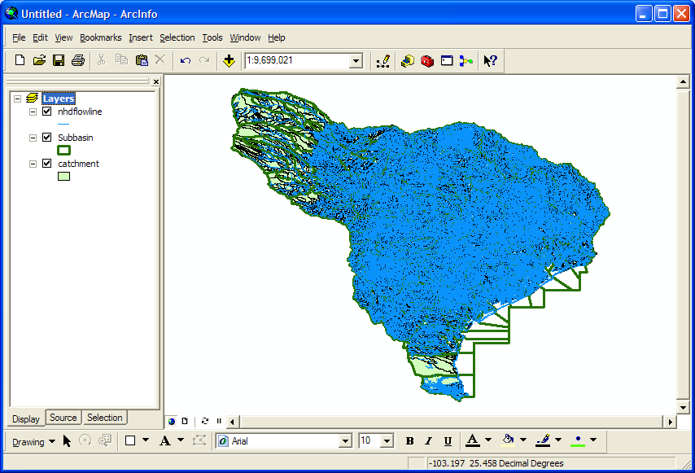

Use File/Save As to save the ArcMap document as Ex2.mxd (to save your own customized colors).

To Be Turned In: What is the approximate map extent in decimal degrees of these data? Use the Draw Tools in ArcMap to draw lines on the map showing the 100º W Meridian and the 30º N Parallel. Screen capture the resulting map display and include it in your solution.

Selecting the San Marcos Basin
The Subbasin, Catchment, and NHDflowlines feature classes cover a large region and we only want to work in the San Marcos Basin. We'll use ArcMap to identify the San Marcos SubBasin and to create new feature classes using pertinent portions of the feature classes for Region 12.
(1) Turn off the nhdflowline and catchment themes in the display, and use the Select button from ArcMap tools to visually select the San Marcos basin (see image below). Open the Subbasin layer attribute table and press the Selected button. This will show you the items you have selected. You will see that the San Marcos Basin is [HUC_8 = 12100203] is the only highlighted feature.
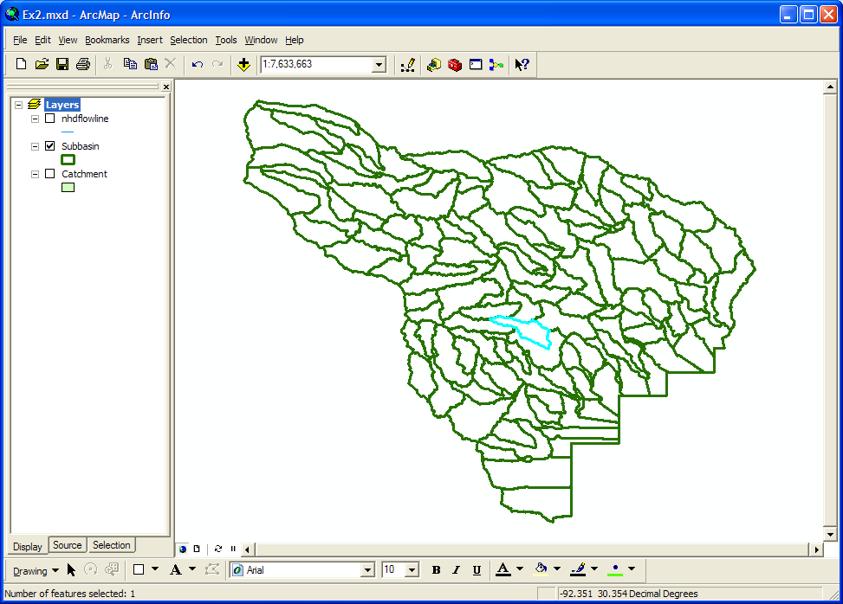
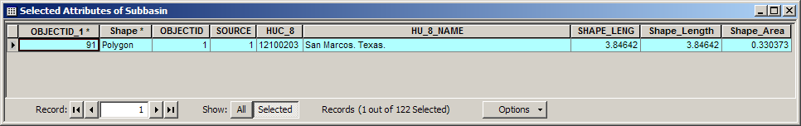
(2) Make sure that Arc Catalog is closed or the next steps won’t work. In ArcMap, Right Click on Subbasin and select Data/Export Data to produce a new theme. If you get a message saying you can’t do this, it means that you haven’t shut down Arc Catalog before trying the data export. Close Arc Catalog and repeat the export steps if this happens.
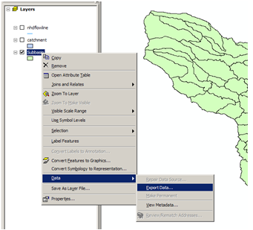
Browse inside your geodatabase to the Basemap Feature dataset (you’ll have to change the Save as Type to File and Personal Geodatabase feature classes first), name this new feature class as Basin and save it in the geodatabase as a File and Personal Geodatabase feature class. Don’t save it as a Shapefile, which is the default option you are first presented with.
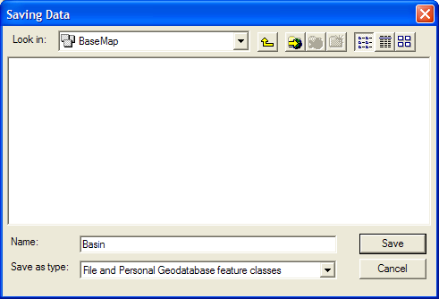
The program will automatically convert only the selected features.
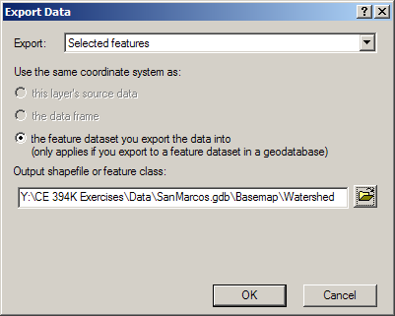
You will be prompted to whether add this theme to the Map, click Yes. Notice the Basin Feature Class looks identical to the earlier subbasin feature class selection for the San Marcos basin, but the new Basin class has only a single feature in it. Notice that it carries all the attributes of subbasin. We are using the term “Basin” here to describe the San Marcos basin in its entirety even though it is a subbasin of the Guadalupe basin, which itself is a part of the Water Resource Region 12. In a later exercise in this course, we will delineate Watersheds within the San Marcos Basin using DEM data.
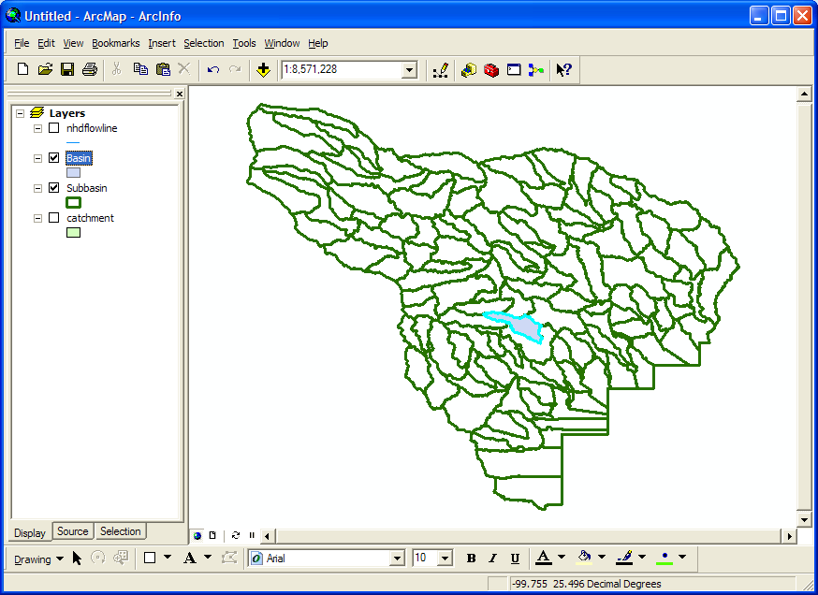
(3) Select Selection → Clear Selected Features to clear the selections you made from Subbasin.
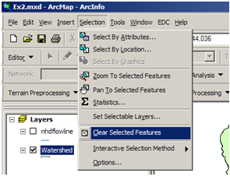

Selecting the San Marcos Catchments
We will create a layer that only contains the catchments in the San Marcos subbasin.
Right click on the Watershed feature class in Arc Map and select Zoom to Layer, and turn on the Catchment layer so you can see the Catchments that you want to work with.
Use the selection menu to Select By Location and select features from the Catchments layer that have their centroid in Basin.
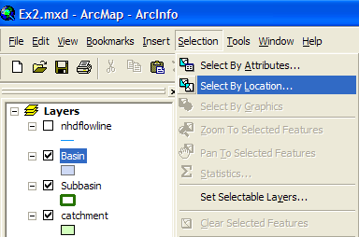
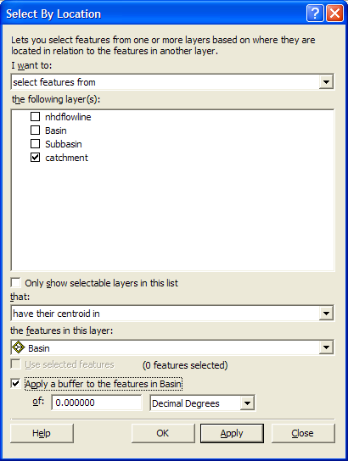
Hit OK to make the selection and close the window.
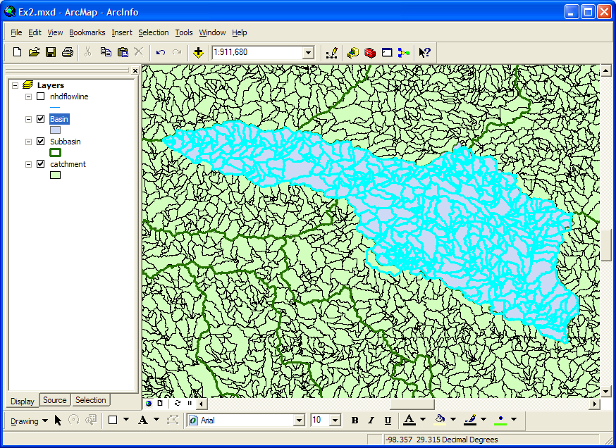
Now right click on the catchment layer name and select Data/Export Data. Navigate to the directory that contains the geodatabase that was created earlier. Change the save as type to File and Personal Geodatabase feature classes to see the SanMarcos.gdb file and save the file as Catchment in the BaseMap feature dataset. Hit OK and add the feature to the map as a layer.
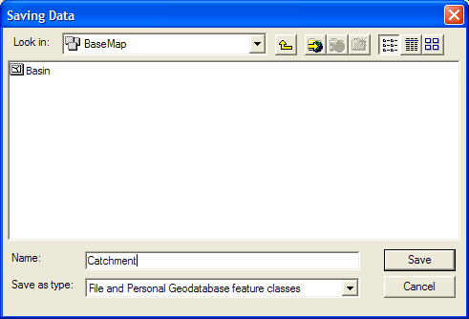
Remove the old catchment layer for Region 12 by right clicking it and selecting Remove. Similarly remove the Subbasin layer for Region 12 so that you only see the San Marcos Basin.
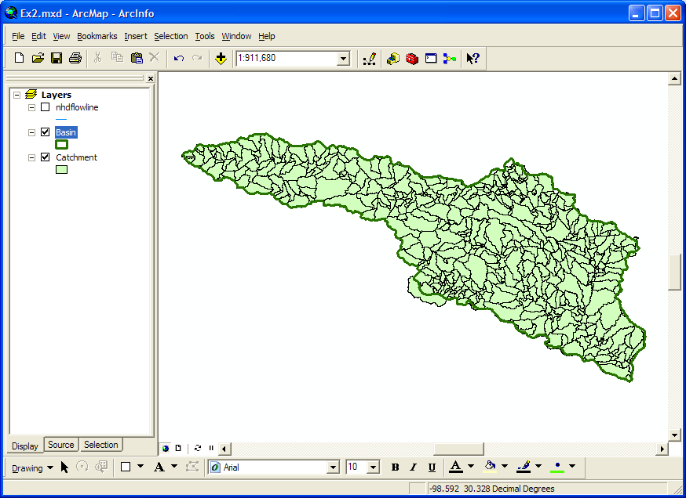
You may notice one catchment on the lower edge of the basin that has its centroid in the San Marcos basin but is not actually contained by this basin. Therefore, we must edit it out manually.
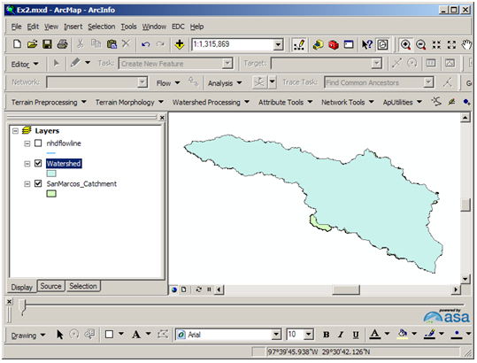
Select the catchment shown below. Open the attribute table and choose to show Selected.
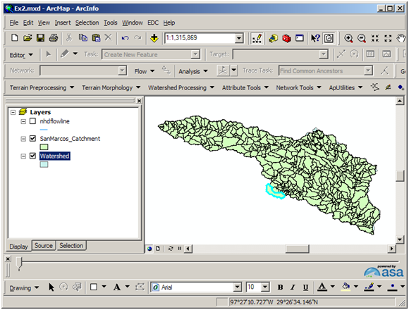
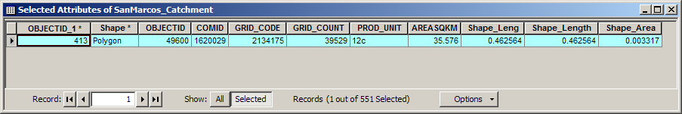
Now, use the Editor Toolbar to edit this selection. If the Editor toolbar is not visible, turn it on using the View menu.
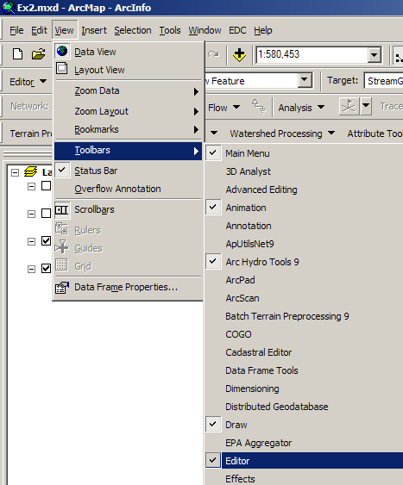
Select Editor/Start Editing to begin an editing session.
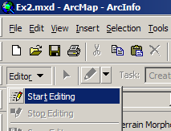
Select the Catchment feature class to be edited. Select the catchment to be deleted by usign the tool in the Editor toolbar, and then right click on that feature and hit Delete.
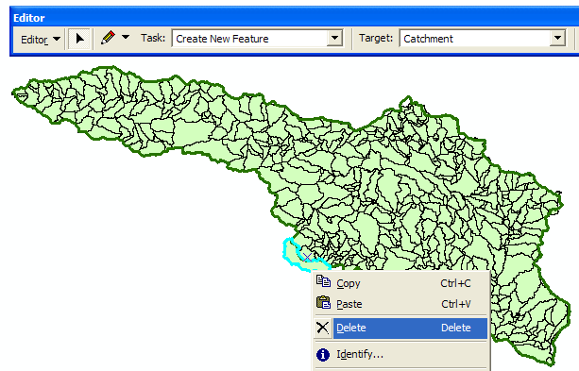
and you’ll see it disappear.
Save Edits then Stop Editing.
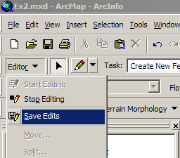

Selecting the San Marcos Flowlines
Now we can create a layer with just the flowlines in the San Marcos Basin. Repeat the select by location with the NHDflowline layer. Select the features from nhdflowline with their centroid in catchments.
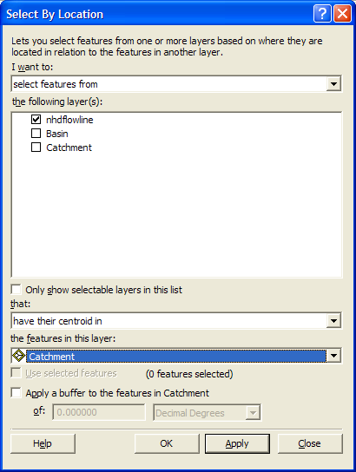
This selects all the flowlines in the San Marcos basin.
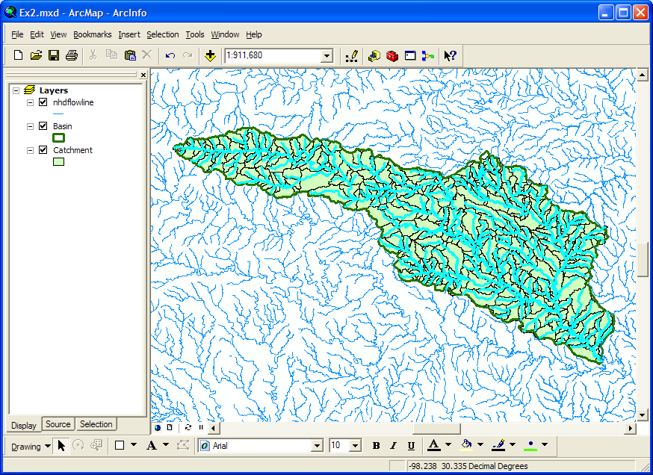
Follow the same process to export this data. Save it as Flowline in the BaseMap feature dataset and add it as a layer to the map. Remove the old nhdflowline.
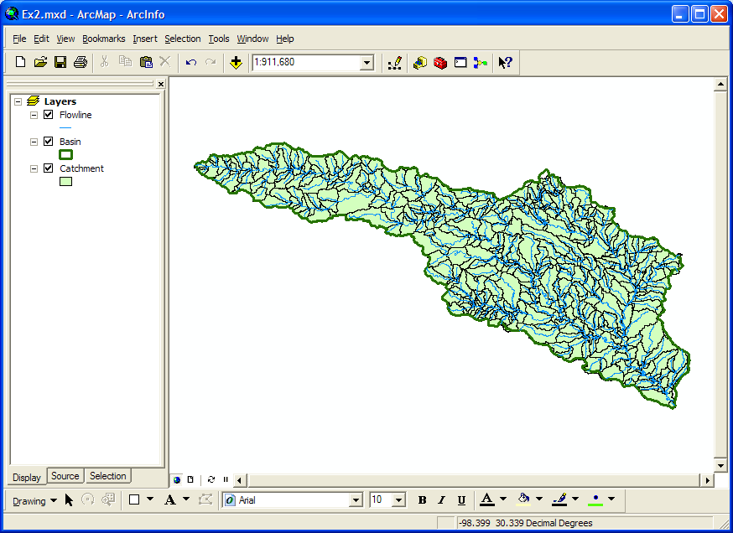
Now lets look at some summary statistics of the flowlines. Right click on the LengthKm field and select Statistics
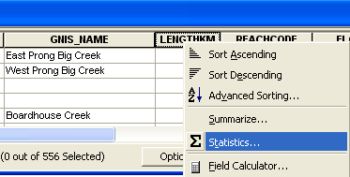
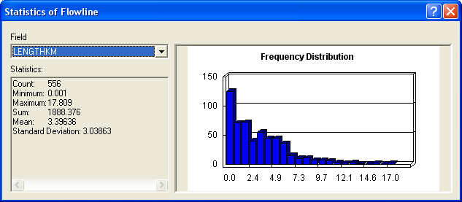
From this display, you can see the statistics of the LengthKm of the flowlines. There are 556 flowlines whose average length is 3.39 km and the total length is 1888 km.
To be turned in: How many catchments are there in the San Marcos Basin? What is their average area in km²? What is the total area of catchments in this basin in km²? What is the ratio of the length of the streamlines to the area of the catchments (called the drainage density) in km⁻¹?

Adding Attributes to the Flowlines
Now we will use the flowline attributes table to symbolize the flowlines based on their mean annual flow. Add the table flowlineattributesflow.dbf to your ArcMap display.
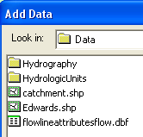
Open the attribute table for the feature class Flowline and select Options/Add Field. You should have Arc Catalog closed while you are doing this or it may not work.
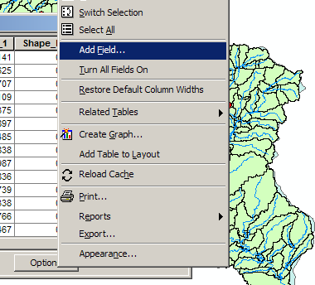
Name the field Mean _Annual_Flow and make it of the type Double.
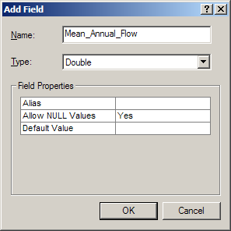
Now we will join the Flowline layer with the flowlineattributesflow table based on COMID. Right click on the Flowline layer and select Joins and Relates/Join.
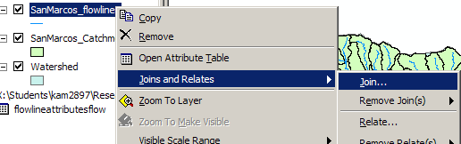
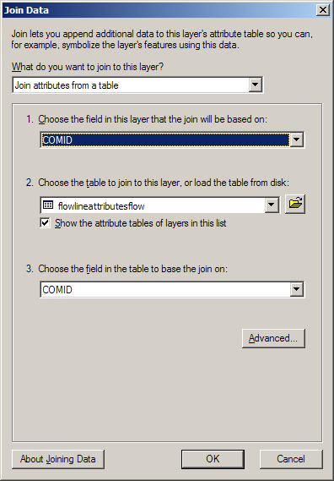
Say no to creating an index.
Now when you open the Flowline attribute table you will find the information contained in the flowlineattributesflow table has been joined to the existing features. Scroll over to the column labeled flowlineattributesflow.MAFLOWU. This field contains the Mean Annual Flow for each reach. It is estimated by averaging the mean annual runoff over the drainage area above this reach.
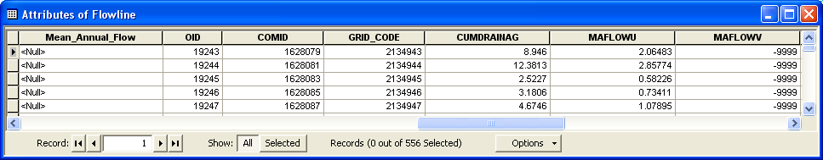
We can set the value of our new field Mean_Annual_Flow by using the field calculator. Scroll back to the column we created, now called Mean_Annual_Flow, and right click on the column label to select the field calculator.
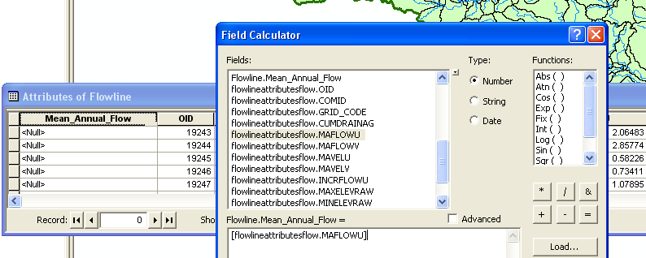
Set this field equal to [flowlineattributesflow.MAFLOWU]. This populates the Mean Annual Flow field with the appropriate value.
Now we can remove the join by right clicking on the Flowline feature class and selecting Joins and Relates/Remove All Joins.
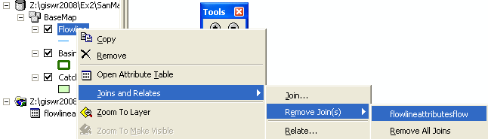
Now our attribute table for SanMarcos_flowlines has a field called Mean_Annual_Flow with the values populated. We can use this field to symbolize the flowlines. Right click on Flowlines and select properties. In the properties menu, select the Symbology tab. Change the Symbology to display graduated symbols for the Mean_Annual_Flow field and hit OK.
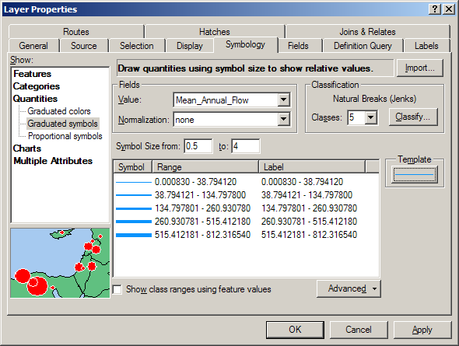
The result is a map displaying the relative flow of the streams and rivers in the San Marcos basin.
To be turned in: the layout of the San Marcos Basin and stream. Add labels to show the San Marcos River, the Blanco River and Plum Creek.
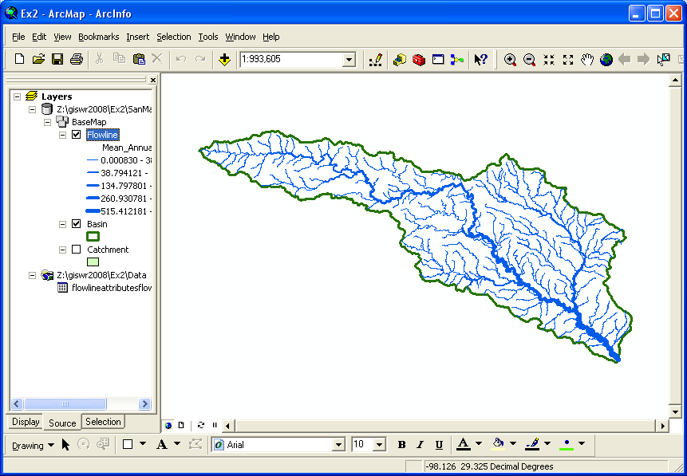

Creating a Point Feature Class of Stream Gages
Now you are going to build a new Feature Class yourself of stream gage locations in the San Marcos basin. I have extracted information from the USGS stream gage data books information about 8 gages in this basin:
The location coordinates and flow data can be obtained from the USGS NWIS server, as described subsequently in this exercise.
(a) Define a table containing an ID and the long, lat coordinates of the gages
The coordinate data is in geographic degrees, minutes, & seconds. These values need to be converted to digital degrees, so go ahead and perform that computation for the 8 pairs of longitude and latitude values. This is something that has to be done carefully because any errors in conversions will result in the stations lying well away from the San Marcos basin. I suggest that you prepare an Excel table showing the gage longitude and latitude in degrees, minutes and seconds, convert it to long, lat in decimal degrees using the formula
Decimal Degrees (DD) = Degrees + Min/60 + Seconds/3600
Remember that West Longitude is negative in decimal degrees. Shown below is a table that I created. Be sure to format the columns containing the Longitude and Latitude data in decimal degrees (LongDD and LatDD) so that they explicitly have Number format with 4 decimal places using Excel format procedures. Note the name of the worksheet that you have stored the data in. I have called mine Latlong. Save the file as an Excel 97-2003 Workbook or it will not appear in ArcMap. Close Excel before you proceed to ArcMap.
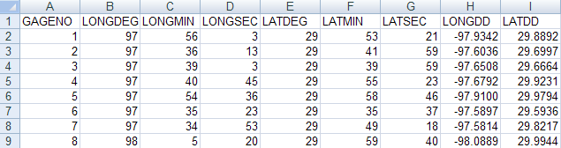
(b) Creating and Projecting a Feature Class of the Gages
(1) Open ArcMap and the Ex2.mxd file you created in the first part of this exercise. Select the add data button and navigate to your Excel spreadsheet
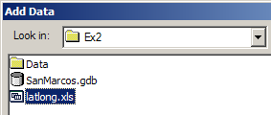
Double click on the spreadsheet to identify the individual worksheet within the spreadsheet that you want to add to ArcMap (it’s a coincidence that they have the same name in this example and that is not necessary in general).
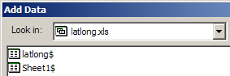
Hit Add and your spreadsheet will be added to ArcMap. Pretty cool!! This is the first time we’ve been able to add worksheets directly in ArcMap. Before ArcGIS 9.2 we had always to save the worksheet as a .dbf file and add that instead. ArcGIS 9.3 recognizes Excel 2007 files but ArcGIS 9.2 does not do that, so if you are using ArcGIS 9.2, you will need to save your Excel file in Excel 2003 format.
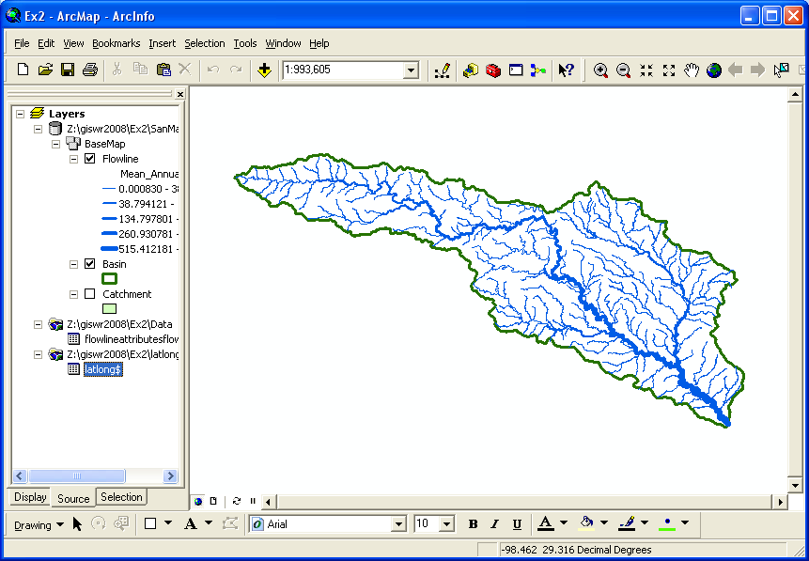
Now we are going to convert the tabular data in the spreadsheet to points in the ArcMap display.
(2) Right click on the new table, LatLong, and select Display XY Data
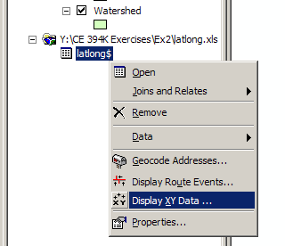
(3) Set the XY Table to latlong, the X Field to LongDD (or Longitude), the Y Field to LatDD (or Latitude), Hit Edit to change the spatial coordinate system, and then Import, and get the coordinate system from the feature dataset Basemap, and you should end up with a display that looks like the one below.
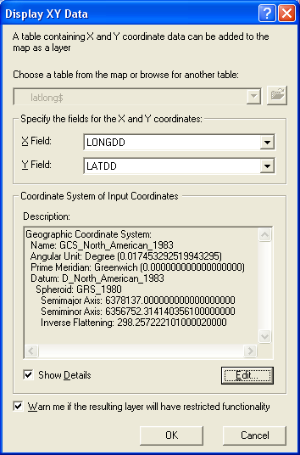
Hit OK, to complete it and you’ll get a warning message about your table not having an ObjectID. Just hit Ok and move on. Hit Ok to add the points and voila! Your gage points show up on the map right along the San Marcos River just like they should. Magic. I remember the first time I did this I was really thrilled. This stuff really works. I can create data points myself! If you don’t see any points, don’t be dismayed. Check back at your spreadsheet to make sure that the correct X field and Y field have been selected as the ones that have your data in decimal degrees.
Click on the point symbol under the legend label latlong event and recolor and resize the points so that they show up more clearly.
What you have created is called an “event” which means that it is a graphical display in the ArcMap window of latitude and longitude points that are stored in a table. It is not a real feature class yet.
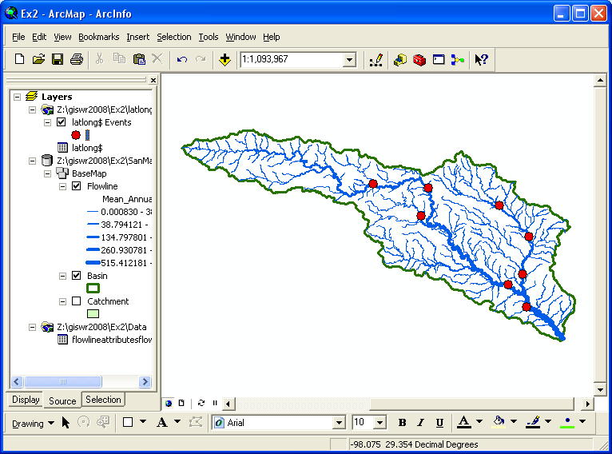
(4) Now, we’ll make a feature class out of the points. Right click on the latlong Events layer and select Data/Export Data
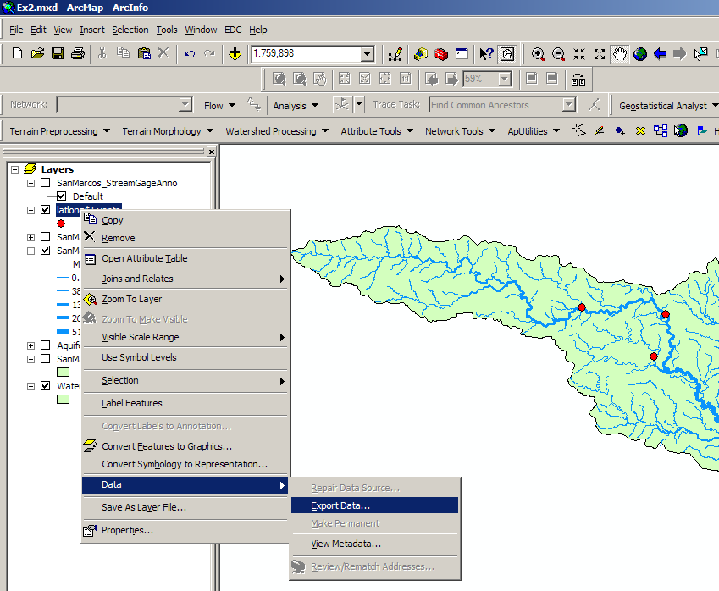
And export the data into the Basemap feature dataset as the feature class MonitoringPoint. Say Yes when you are asked if you want to add the points to your map, and now you’ve got a new feature class in the Basemap feature dataset with your points in the same projection as the other features in Basemap (ArcGIS does the map projection automatically as part of the data export process). Open the Attribute table of the MonitoringPoint feature class so that you can see that all the attributes have been correctly translated from the Excel file.
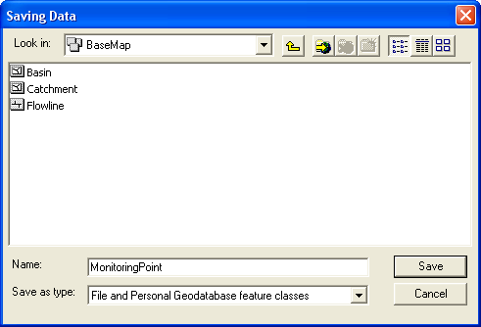
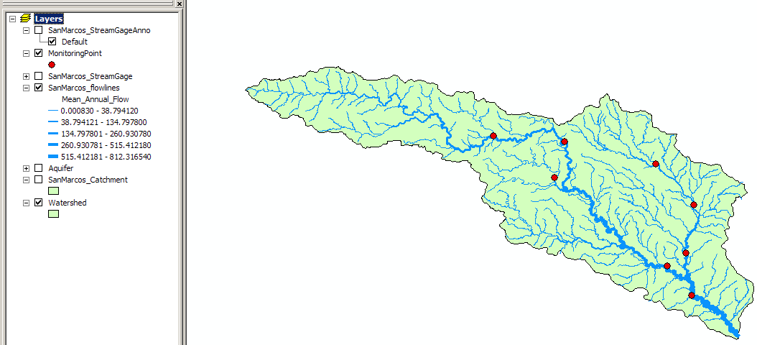
Open ArcCatalog and check out your Basemap feature dataset. The MonitoringPoint feature class now resides there.
(5) Save your Ex2.mxd ArcMap document, and construct a layout to turn in.

Add Attributes to the Point Feature Class
Now we are going to add the USGS gage ID, gage name, and annual discharge for each gage as new attributes in ArcCatalog.
(1) Open ArcCatalog (make sure ArcMap is closed) and navigate to the San Marcos geodatabase that contains your data.
(2) In the Basemap feature dataset, right click on the MonitoringPoint feature class, and click on Properties to open the Feature Class Properties window. Click on the Fields tab and scroll down to the end of the Field Name list. Type the following three entries:
Field Name | Data Type
USGSID | Text
Name | Text
Flow | Double
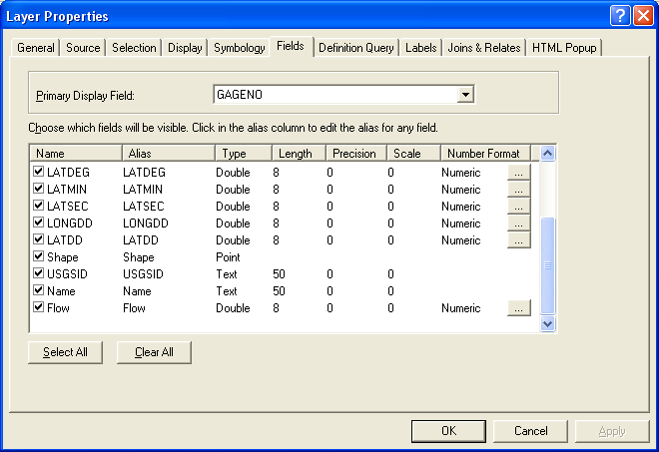
(3) Click OK and open your ArcMap document ex2.mxd.
Adding Data to the Attribute Table
(1) In ArcMap right click on the MonitoringPoint feature class and open the attribute table. Scroll to the right until you see the new fields you have created. Start editing by selecting Editor/Start Editing.
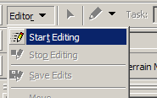
If the Editing Toolbar is not visible it maybe added by selecting View/Toolbars/Editor.
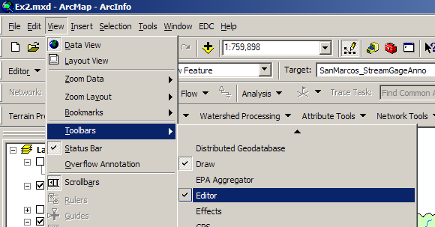
Select Editor/Start Editing and select the San Marcos geodatabase as the target to be edited:
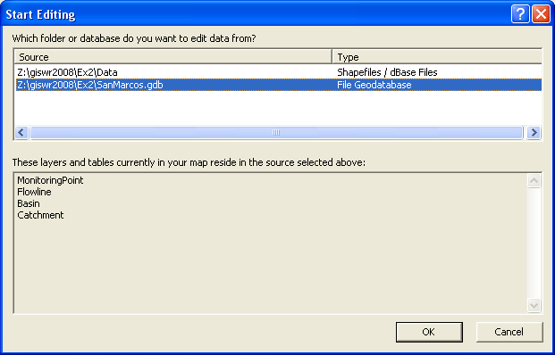
(2) You may now just add the appropriate data values to the table and for the three attribute fields you added. Continue adding the data values until they are all done.
The following data are needed in the table:
Seq # | Station # | Station Name | Mean Annual Flow (cfs)
1 | 08170500 | San Marcos Rv at San Marcos, TX | 176
2 | 08173000 | Plum Ck nr Luling, TX | 114
3 | 08172000 | San Marcos Rv at Luling, TX | 408
4 | 08172400 | Plum Ck at Lockhart, TX | 49
5 | 08171300 | Blanco Rv nr Kyle, TX | 165
6 | 08173500 | San Marcos Rv at Ottine, TX | 456
7 | 08172500 | Plum Ck nr Lockhart, TX | 56
8 | 08171000 | Blanco Rv at Wimberley, TX | 142
(3) Select Editor/Stop Editing to finish editing and say Yes when it asks if you would like to save your edits. Note that you can only edit tables for which you have write permission (i.e. your own tables not tables in my work area).
Labeling the Gages in View
Right click on the MonitoringPoint feature class and select Properties. Click on the Labels tab and from the drop down menu select the label field name to be Name.
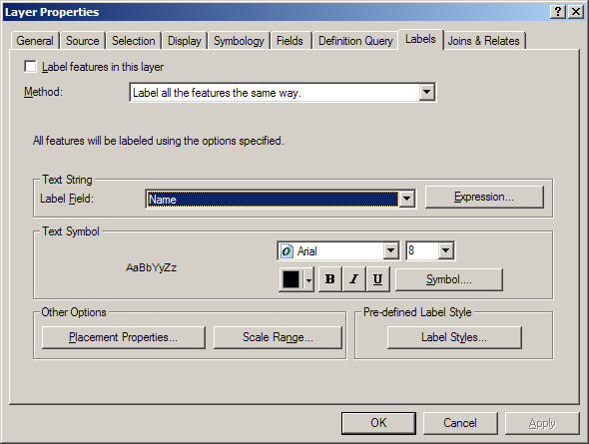
Right click on the MonitoringPoint feature class again and select “Label Features”. You can now create a view like this:
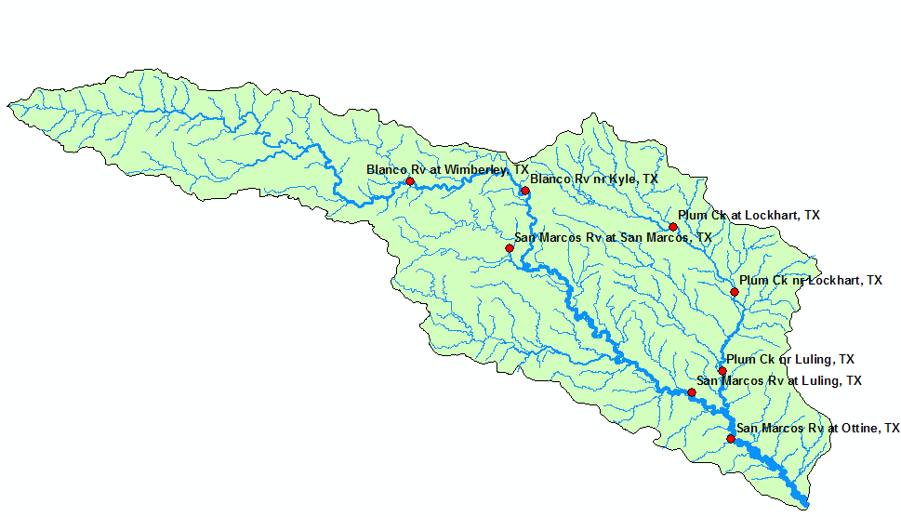
Pretty awesome! If you want to move the labels around to customize your map, you can convert the labels to annotation and then they can be individually moved where you want them to be:
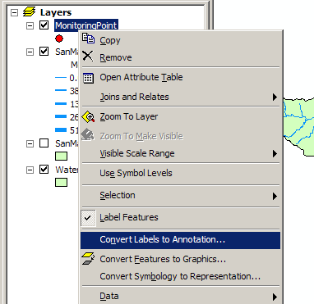
Note that in order to move the labels, you have to open the View/Toolbars/Editor and selected the SanMarcos.gdb geodatabase to edit, and the MonitoringPointAnno as the feature class to be edited:
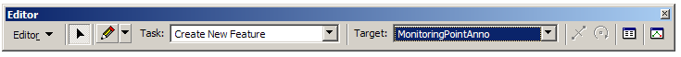
Then, you can move and change the size of the annotation as you wish. When you are done, say Stop Editing and Save your annotation in its new location. Save the ArcMap document Ex2.mxd also.

Creating a Chart and Layout
- Open ArcMap to create a chart of the mean annual flow of the San Marcos gages. The Mean Annual Flow at the gages is recorded in the column labeled Flow in the attribute table. Open the MonitoringPoint attributes table and make a chart using the tools available in ArcMap. Alternatively, you can export the attribute table to a .dbf file and map the chart in Excel. You can also open the geodatabase tables directly in Excel by using Data/Get External Data and doing a query on the Microsoft Access file that contains the geodatabase. The chart may look something like this
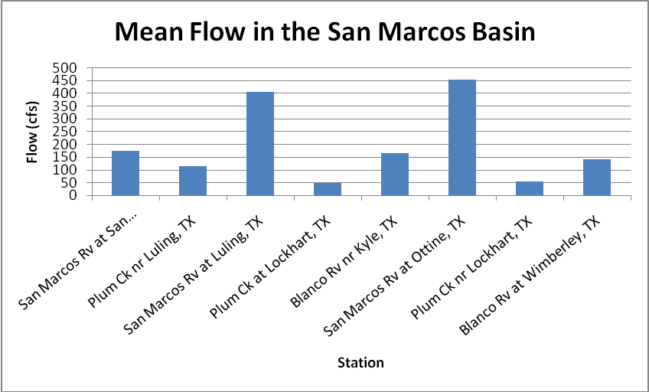
(2) In ArcMap prepare a layout showing a map of the drainage area, the graph of its annual flows at each gage and a table of numerical values describing the gages. You can import your Excel chart and worksheet from the Insert/Object... option in ArcMap. If necessary resize the original chart or table smaller so that it can be displayed in the layout. You'll see in the chart that the flow in the San Marcos River at Luling and Ottine is much higher than in the upstream stations. That is because of the cumulative effect upstream at Luling and because Plum Creek joins the San Marcos River just upstream of Ottine.
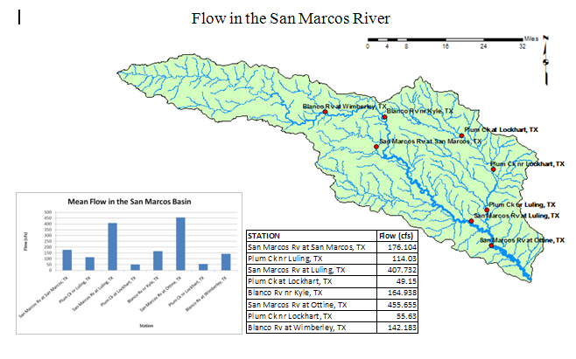
To be turned in: a layout showing the base map, chart and data table for the San Marcos River flows

Overlaying the Edwards Aquifer
The Edwards aquifer is one of the most critical water resources of Central Texas. It is the main source of water supply for San Antonio, the 10th largest city in the United States. The Edwards aquifer is recharged by infiltration from rivers crossing its outcrop area. To determine where the San Marcos River crosses, the outcrop area, I obtained a coverage of the Edwards aquifer from the Texas Natural Resource Information System (http://www.tnris.state.tx.us/)
The Edwards aquifer coverage from TNRIS is in Decimal Degree coordinates. This is the Edwards shapefile that you copied from the zip file at the beginning of the exercise.
- Import your Edwards.shp file into the SanMarcos geodatabase. From the Toolbox window in ArcMap, select Conversion Tools → To Geodatabase → Feature Class to Feature Class. Although the name of the tool is feature class to feature class, it will also convert a shapefile to feature class.
- Choose Edwards.shp as the Input Features, the Basemap feature dataset of the SanMarcos geodatabase as the output location, Aquifer as the output feature class name, and leave the rest of the inputs as their default values. Press OK.
This will not only do the conversion from shapefile to feature class, but also add the new feature class to your map.
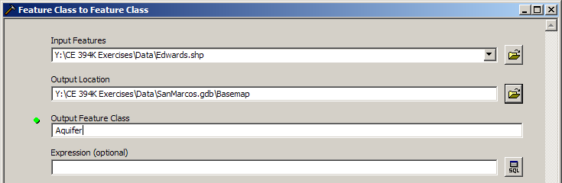
Right click on the Aquifer feature class and select Properties. Click on its Symbology tab and Label the theme using the attribute Aquifer. This attribute has three values: 1 for outcrop, 2 for downdip and 0 for holes within the outer boundary of the aquifer. Classify the values with Unique Value and color them appropriately.
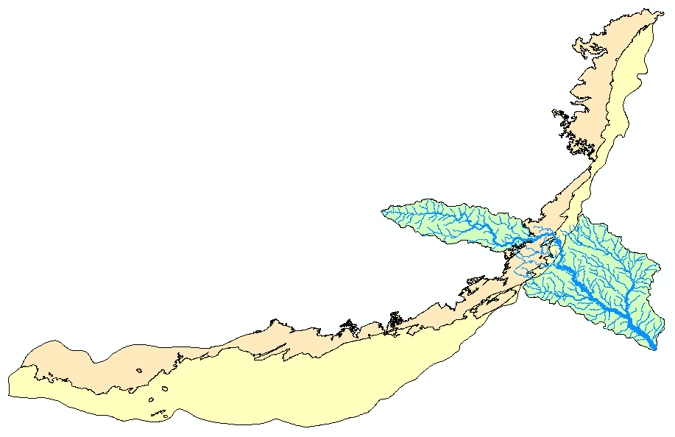
You'll see that as the San Marcos River flows South East towards the Gulf Coast and it crosses first the outcrop and then the downdip portions of the Edwards aquifer. The downdip region is where the aquifer dips below the land surface and is shielded from the surface rivers by overlying hydrogeological units of low permeability. The Edwards is a fissured limestone aquifer whose fissures lie along its Southwest to Northeast orientation, so its flow moves in that direction, transverse to the direction of flow in the San Marcos basin. It is thus quite possible for water to drain from the San Marcos river into the Edwards aquifer and then reappear as a spring further North in another river. Zoom in to the region where the aquifer crosses the San Marcos basin for a closer look.
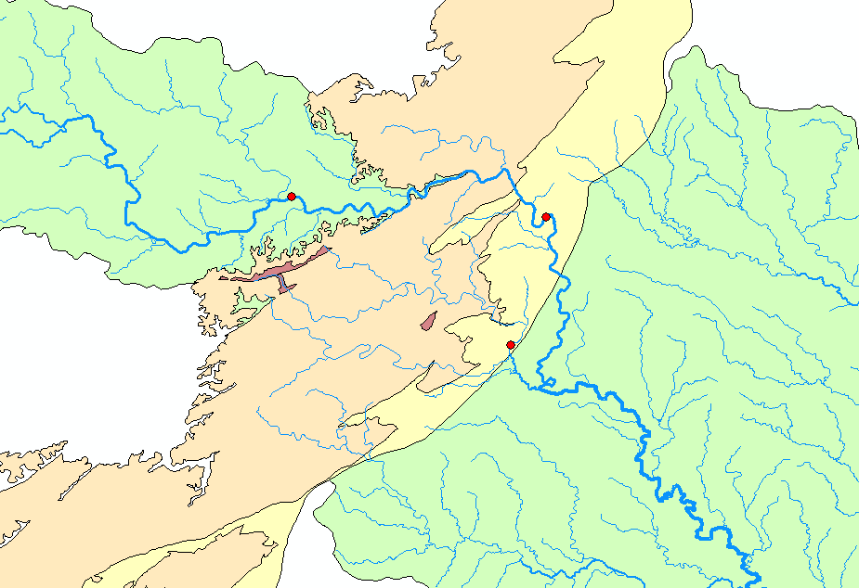
To be turned in: Between which two gaging stations does the Edwards aquifer outcrop area occur? What is the difference in mean annual flow at these two gages? Comment on these data. Do they seem correct to you?

Downloading USGS Flow Data
There are also other sources of flow data. One of them is real time data via Internet from the U.S. Geological Survey (http://water.usgs.gov/realtime.html). This data is taken at the gage sites every 15-60 minutes and is transmitted to the USGS office every 1 to 4 hours. This data relayed using satellite, telephone, and/or radio and can be viewed within minutes on arrival to the office. Notice the difference between the flow conditions in September 2002, 2003, 2006 and this September 2007. In 2002, the Northeast was experiencing a severe drought while in 2006 it was wetter than normal, and today there is drought in the Southeast and very wet conditions in Texas. Hydrology is a wonderful phenomenon – always changing!
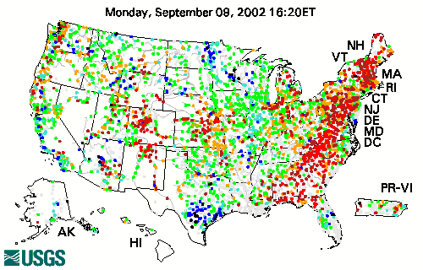
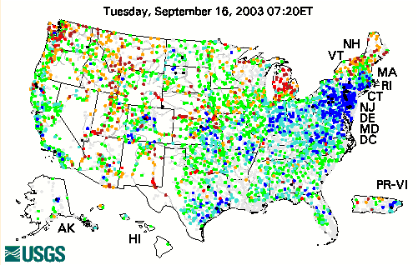
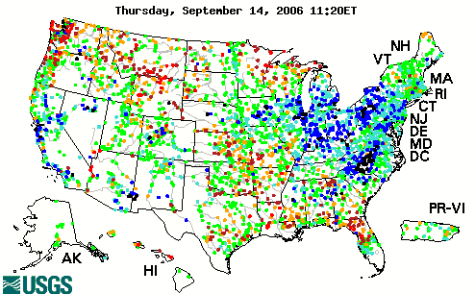

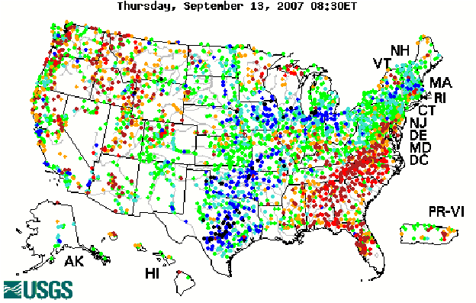
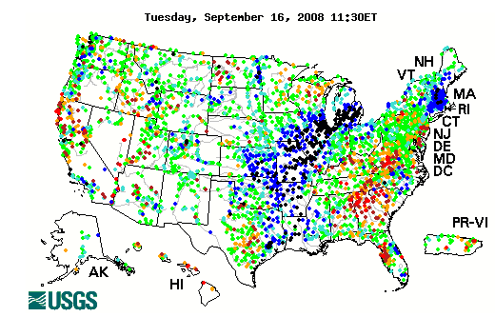
You can see the effect on streamflow of Hurricane Ike which passed through this region Sept 12-15, 2008!
(1) Click on the site http://water.usgs.gov/realtime.html.
(2) Once you have looked around a bit click on Texas on the map of the United States located above. This link will bring you to a web page, which shows real time data for the state of Texas. Click on a gage shown on the map to display a graph. It’s a bit hard to select stations on this map since you can’t zoom into Texas, but you can see the station name on the bar at the bottom of your web browser. The San Marcos River at Luling, Texas is station 08172000.
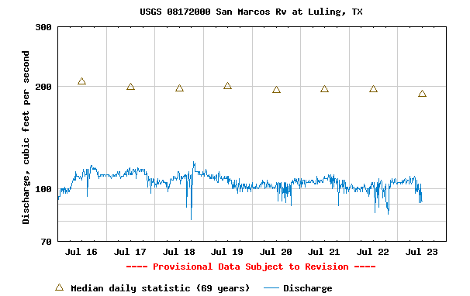
To be turned in: The graph of flow of the San Marcos River at Luling printed from the NWIS website. What are the 20%, 50%, and 80% cumulative probability flows for the calendar day on which you do the download? Approximately what % cumulative probability is the flow currently?
Summary of Items to be Turned in:

1. What is the approximate map extent in decimal degrees of these data? Use the Draw Tools in ArcMap to draw lines on the map showing the 100º W Meridian and the 30º N Parallel. Screen capture the resulting map display and include it in your solution.
2. How many catchments are there in the San Marcos Basin? What is their average area in km²? What is the total area of catchments in this basin in km²? What is the ratio of the length of the streamlines to the area of the catchments (called the drainage density) in km⁻¹?
3. A layout of the San Marcos Basin and streams. Add labels to show the San Marcos River, the Blanco River and Plum Creek.
4. A layout showing the base map, chart and data table for the San Marcos River flows.

5. Between which two gaging stations does the Edwards aquifer outcrop area occur? What is the difference in mean annual flow at these two gages? Comment on these data. Do they seem correct to you?

6. The graph of flow of the San Marcos River at Cuero printed from the NWIS website. What are the 20%, 50%, and 80% cumulative probability flows for the calendar day on which you do the download? Approximately what % cumulative probability is the flow currently?

