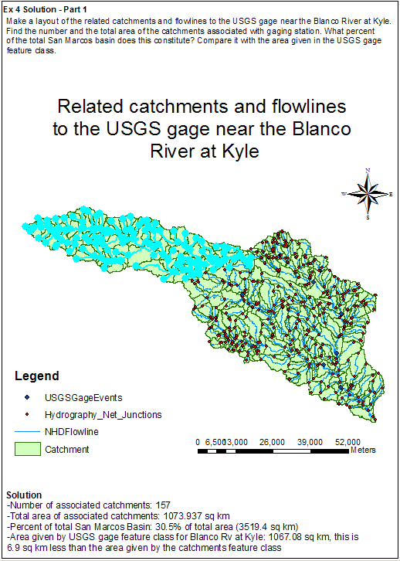

Ex 4 Solution - Part 2
What is the total flow length from top to bottom of the San Marcos Basin (km)? What is the average length of the 93 NHDFlowLines on this flow path (km)?

Total flow length: 270.148 km
Average length of the 93 NHDFlowlines: 2.90 km

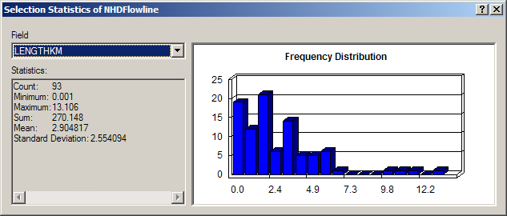

Ex 4 Solution - Part 3

Make a layout of the Edwards Aquifer overlayed on the San Marcos basin.

What is the river on the right that has low base flow? What is the river on the left that has high base flow? Make a base flow balance between these two rivers to see if you can reasonably predict the base flow at the most downstream station (the San Marcos River at Ottine)?
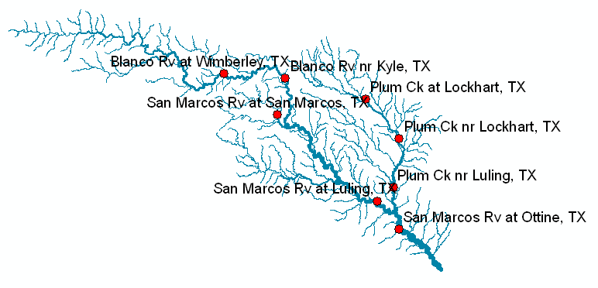
Above are the gages on the rivers. The river on the right is Plum Creek. The river on the left is the San Marcos River (of which the Blanco River is a tributary). As shown below, Plum Creek has a very small proportion of base flow, while the proportion (BFI_AVE) of base flow in the San Marcos River is much higher.
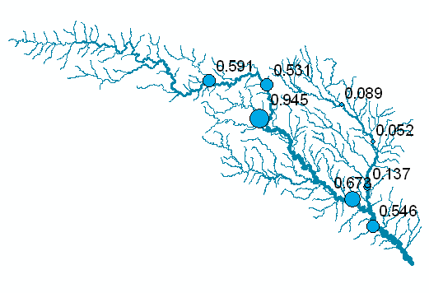

Shown below are the values of the mean annual flow at each stream gage (AVE)
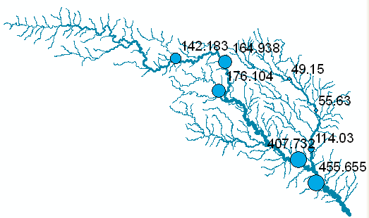

If we take the two gages upstream of the San Marcos River at Ottine, these are the San Marcos River at Luling and Plum Creek near Luling, which have BFI_AVE values of 0.673 and 0.137, respectively, and mean annual flows of 407.73, and 114.03, respectively. If we do a flow-weighted average of these BFI_AVE values, we get

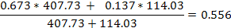

And this is very close to the BFI_AVE value of 0.546 for the San Marcos River at Ottine.
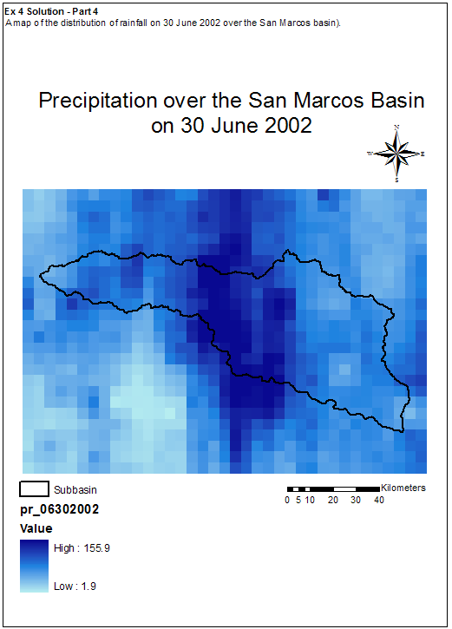
Ex 4 Solution – Part 5
Graphs of the mean precipitation versus time over the San Marcos Basin and the discharge USGS gage data for the San Marcos River at Luling over the same time period. How many days does it take rainfall over this basin to appear as streamflow at Luling? If the rainfall is in mm/day, the streamflow in cfs, and the basin area is 838 square miles, what percentage of the rainfall from June 28 through July 20 became streamflow at the outlet during this period?

Solution:

The values of the mean basin precipitation and the streamflow at the San Marcos River at Luling are shown below.

How many days does it take rainfall over the basin to appear as streamflow at Luling? The heavy rainfall on 06/30/2002 causes a peak streamflow on 07/03/2002, and similarly, heavy rainfall on July 2 and 3 causes a peak flow on July 6, so the rainfall takes 3-4 days to flow out of the basin.

Date | Precipitation (mm/day) | Discharge (cfs)
6/28/2002 | 0.15 | 203
6/29/2002 | 3.88 | 195
6/30/2002 | 75.93 | 2010
7/1/2002 | 47.38 | 6170
7/2/2002 | 81.50 | 11300
7/3/2002 | 72.22 | 18700
7/4/2002 | 15.96 | 15200
7/5/2002 | 36.09 | 10900
7/6/2002 | 8.08 | 19000
7/7/2002 | 4.30 | 7720
7/8/2002 | 4.55 | 5230
7/9/2002 | 2.07 | 3710
7/10/2002 | 2.54 | 3090
7/11/2002 | 0.10 | 2610
7/12/2002 | 1.13 | 2260
7/13/2002 | 1.26 | 1990
7/14/2002 | 10.66 | 1920
7/15/2002 | 9.95 | 1780
7/16/2002 | 13.32 | 2120
7/17/2002 | 23.26 | 3680
7/18/2002 | 15.02 | 4010
7/19/2002 | 1.19 | 2380
7/20/2002 | 0.00 | 1900
Total | 430.54 | 128078

The total rainfall during this period is 430.54 mm. The volume of streamflow is 128078 cfs-days, or 128078 * 864000 (seconds/day) = 11065939200 cubic feet. The basin area is 838 square miles or 838 * (5280)² sq ft = 23362099200 sq ft. Hence the equivalent depth of flow is 11065939200/23362099200 = 0.473 ft = 0.473 * 12 inches = 5.684 inches * 25.4 mm/inch = 144.37 mm.

Hence, the total depth of rainfall from June 28 to July 20 = 430.54 mm and the equivalent depth of streamflow at the streamgage = 144.37 mm, so the ratio of the streamflow / rainfall = 144.37/430.54 = 0.335 or 33.5%.

As a point of comparison, the global average value of streamflow as a percentage of rainfall is 39%.

