Exercise 5 Solution

1. 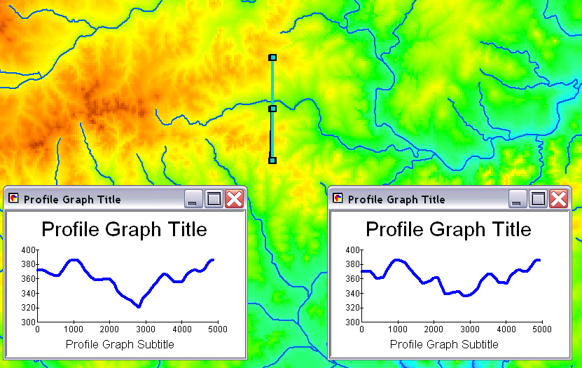
In the figure above the profile graph on the left shows the profile with Agree DEM reconditioning, while the profile graph on the right shows the profile of the original DEM. The difference is most notable at about 2900 m along the profile.

2. Fdr attribute table. The numbers in the value field depict the encoding of flow directions according to the scheme given on the right.

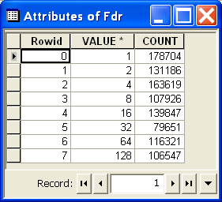 | 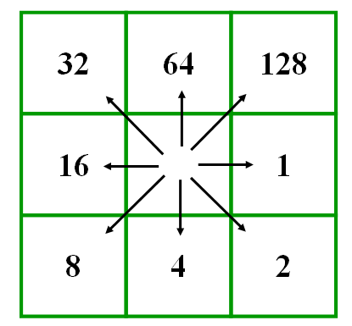

3. The drainage area of the San Marcos basin is given by the flow accumulation at the outlet.
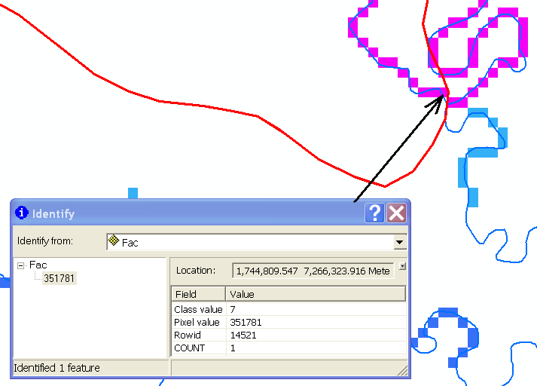
This is 351781 grid cells. This corresponds to a drainage area of
351781 x 100 x 100 = 3.518 x 10⁹ m² = 3518 km²

Flow accumulation entering the omitted area on the south edge is 752 grid cells corresponding to 7.52 km ²

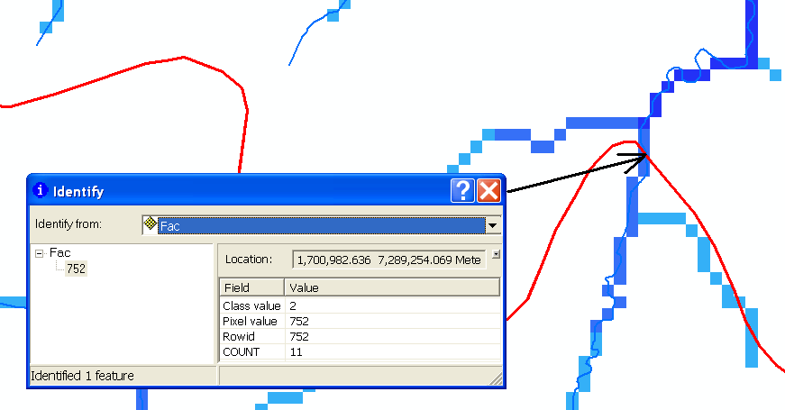

Note that the NHD flow line – a dataset independent of the DEM also crosses the Subbasin boundary suggesting that the discrepancy is most likely in the subbasin boundary because it disagrees with two other datasets.

4. There are 122 Drainage Points, Drainage lines and Catchments. This is the number of features in the DrainagePoint, DrainageLine and Catchment feature classes respectively obtained from examining the attribute tables. These numbers are all the same because there is a one to one correspondence between drainage points, lines and catchments.

The graphic above excerpts information from the Catchment, DrainageLine and DrainagePoint feature classes created by the ArcHydro tools. Note that each feature has a unique HydroID. Note also that the DrainID field in the DrainageLine and DrainagePoint feature classes cross references to the HydroID of the Catchment that these features drain. Missing in the Catchment feature class attribute table is a JunctionId field that should link each catchment to its downstream junction. This is present in the ArcHydro design (Maidment, 2002, ArcHydro, p85) but not implemented in the current version of the tools.

5. The layout below compares DEM derived Drainage Lines with NHD flowlines. The density of DEM derived drainage lines is small due to the large drainage area threshold (~36 km²) used to delineate streams from the DEM. The match between them could be improved by reducing the drainage area threshold used to define drainage lines.
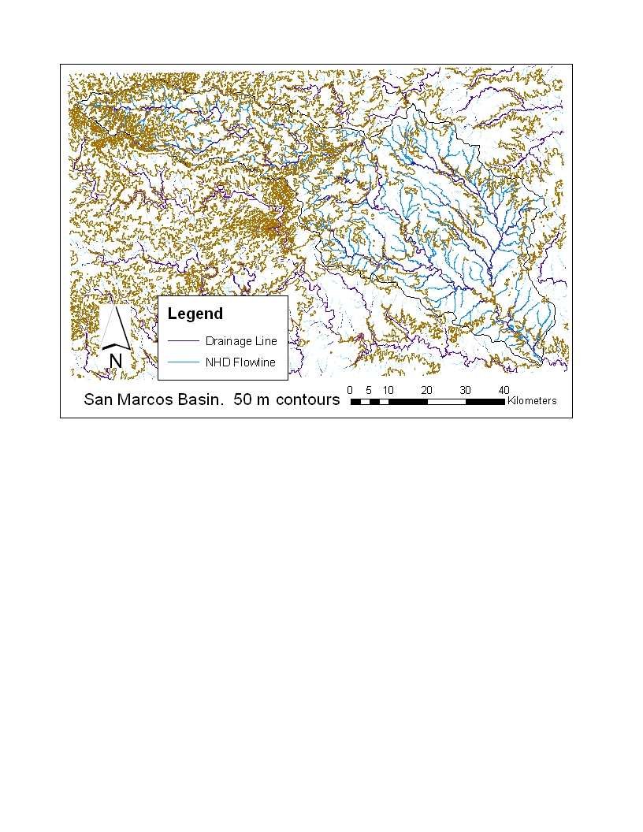

6. Drainage area from DEM flow accumulation: 3518 km² (calculated above)
Drainage area from San Marcos 8 digit HUC subbasin: 3538 km². This is the shape area in the attribute table after the feature class was imported into the geodatabase feature dataset to have it in a consistent spatial reference.

Length of DEM derived Drainage Line feature class: 572 km. This is the sum of the shape length in the attribute table of the Drainage Line feature class for drainage lines selected that intersect with the SanMarcos subbasin HUC evaluated using the statistics command (see below). There is a small error in this length due to the extension of the last Drainage line outside of the subbasin.
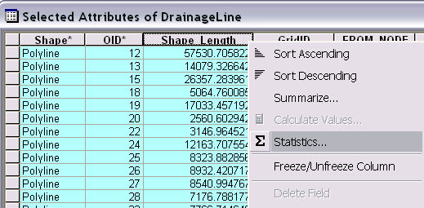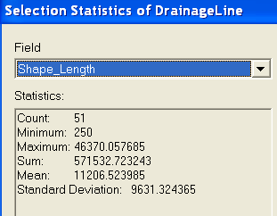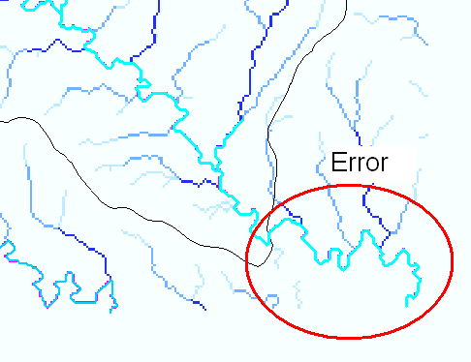
Length of NHD Flowlines for San Marcos Subbasin HUC: 1891 km. This is also evaluated using the statistics tool. This can be some variability in this depending on stray streams being selected that intersect, but are not really part of the San Marcos network. I edited the selection a bit by hand to get this result. A more robust automated selection procedure would be to create a geometric network as was done in exercise 4 and trace upstream from the outlet.

Drainage density of DEM derived Drainage lines: 572/3518 = 0.163 km⁻¹.
Drainage density of NHD flowlines: 1891/3518 = 0.538 km⁻¹.
This difference is primarily due to the large threshold used to delineate DEM derived drainage lines. The DEM derived area was used because it is felt to be more reliable following examination of the boundary and discrepancy between the subbasin boundary and DEM and NHD flowlines noted above.

7. Delineated Watershed.

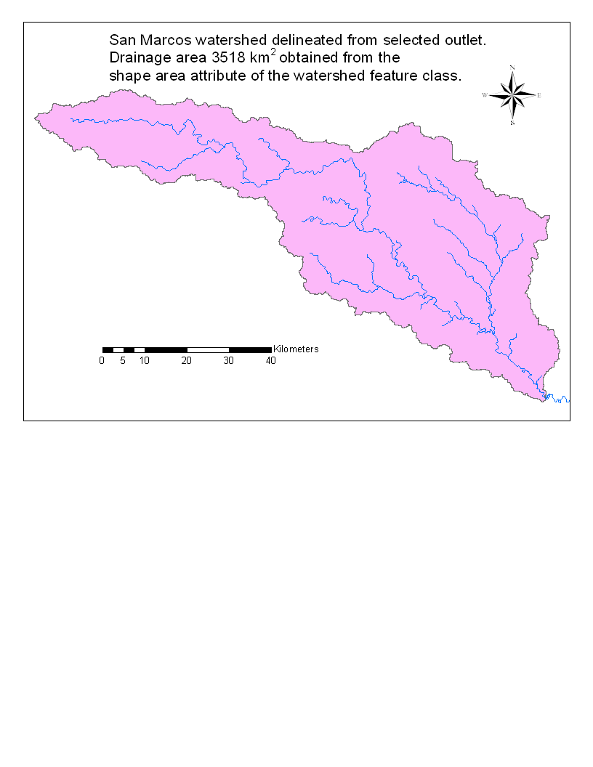

8. Delineated watersheds for each USGS gage. Drainage area from DEM at each gage is labeled in km².
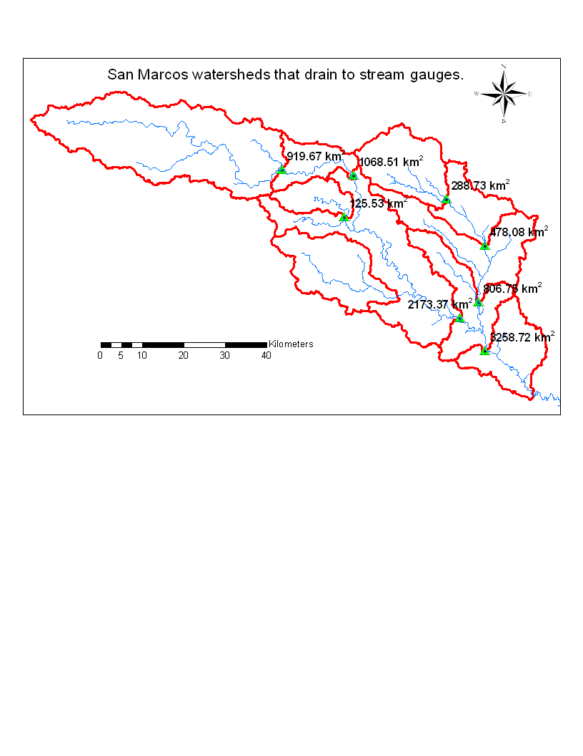

To get these labels I joined the Watershed feature class to the USGS gauge feature class using USGS Siteno and the Siteno that was in the name field of the Watershed feature class. Then labels were formatted using the following label expression

round([Watershed.Shape_Area] / 1000000, 2) & " km<sup>2</sup>"

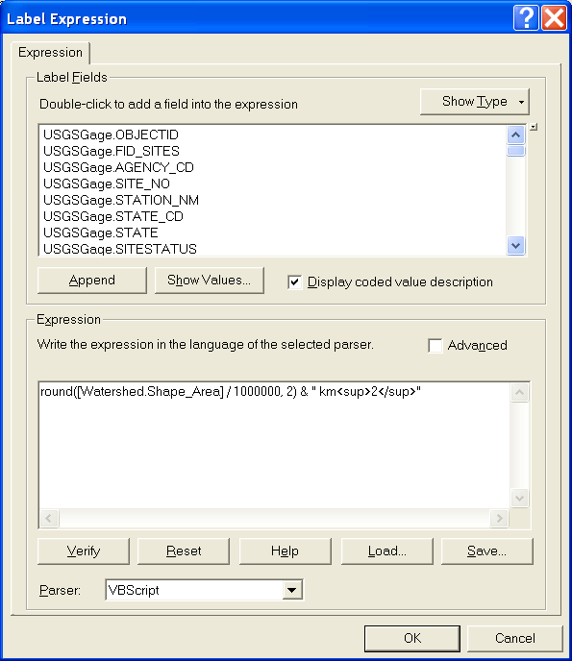

Drainage area table

USGS Site Number | Station Name | USGS Drainage Area (sq miles) | Watershed Area (m^2) | Watershed HydroID |  | USGS Area (km²) |  | Watershed Area (km²)
08171000 | Blanco Rv at Wimberley, TX | 355.0 | 919670000 |  | 546 |  | 919.45 |  | 919.67
08171300 | Blanco Rv nr Kyle, TX | 412.0 | 1068510000 |  | 548 |  | 1067.08 |  | 1068.51
08170500 | San Marcos Rv at San Marcos, TX | 48.9 | 125530000 |  | 550 |  | 126.65 |  | 125.53
08172400 | Plum Ck at Lockhart, TX | 112.0 | 288730000 |  | 552 |  | 290.08 |  | 288.73
08172500 | Plum Ck nr Lockhart, TX | 189.0 | 478080000 |  | 554 |  | 489.51 |  | 478.08
08173000 | Plum Ck nr Luling, TX | 309.0 | 806750000 |  | 556 |  | 800.31 |  | 806.75
08172000 | San Marcos Rv at Luling, TX | 838.0 | 2173370000 |  | 558 |  | 2170.41 |  | 2173.37
08173500 | San Marcos Rv at Ottine, TX | 1249.0 | 3258720000 |  | 560 |  | 3234.90 |  | 3258.72

The drainage areas from the USGS correspond remarkably closely with the drainage areas delineated from the DEM. The DEM drainage areas may be inaccurate due to working with a coarse (100 m resolution) DEM, while it is unknown how the USGS drainage areas were obtained.

9. Delineated watersheds from arbitrary point
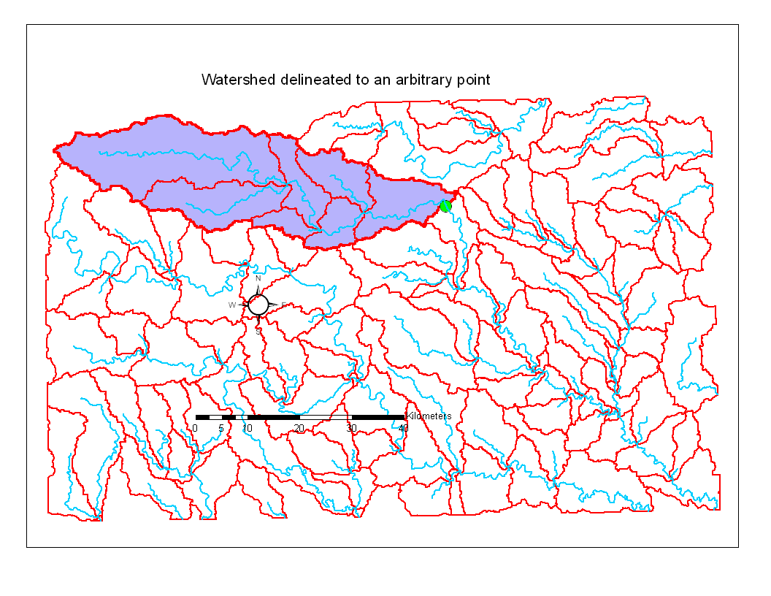

10. Layout of subwatersheds. The outlet is labeled with the subwatershed area. Note that these add up to the total area as shown in the table that follows.
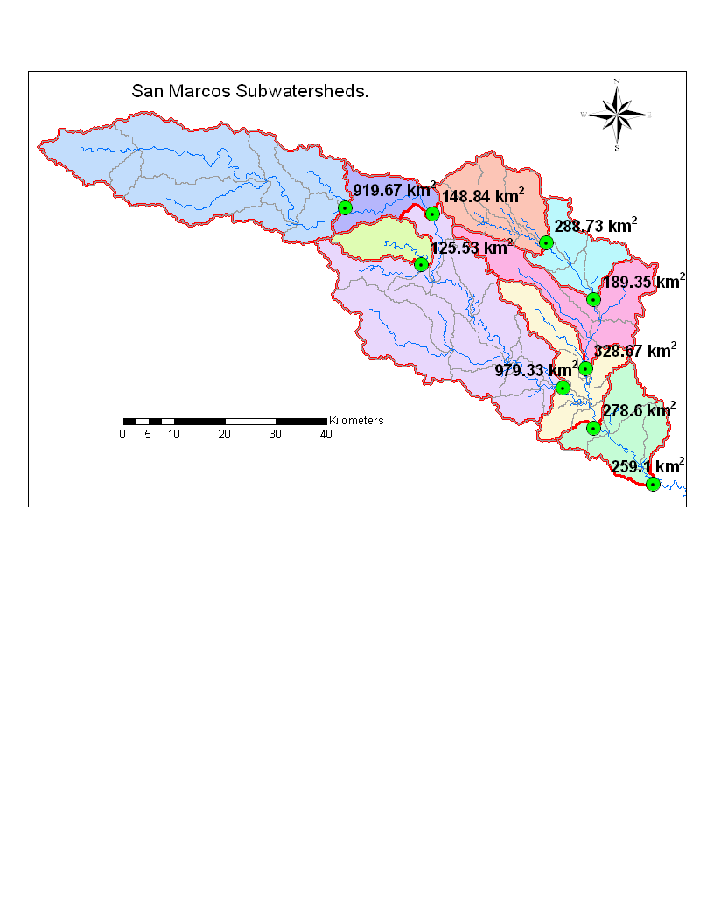

Table of subwatershed areas.
Station Name | USGS site number | Subwatershed area (km²) | Watershed area (km²)
San Marcos Rv at San Marcos, TX | 08170500 | 125.53 | 125.53
Blanco Rv at Wimberley, TX | 08171000 | 919.67 | 919.67
Blanco Rv nr Kyle, TX | 08171300 | 148.84 | 1068.51
San Marcos Rv at Luling, TX | 08172000 | 979.33 | 2173.37
Plum Ck at Lockhart, TX | 08172400 | 288.73 | 288.73
Plum Ck nr Lockhart, TX | 08172500 | 189.35 | 478.08
Plum Ck nr Luling, TX | 08173000 | 328.67 | 806.75
San Marcos Rv at Ottine, TX | 08173500 | 278.60 | 3258.72
San Marcos Outlet | - | 259.10 | 3517.82
Total |  | 3517.82

11. Flow paths
