Computing Actual Evapotranspiration Using GIS
GIS in Water Resources
Fall 2008

Prepared by Parikshit Ranade¹ and Ayse Irmak²
¹: Dept of Biological Systems Engineering
²: Dept of Civil Engineering/School of Natural Resources
University of Nebraska – Lincoln

Contents

- Purpose
- Data download
- Getting started
- Preparing land use layer
- Computing reference ET
- Estimation of fractional vegetation cover
- Computation of actual ET
- Exploring zonal statistics of evapotranspiration
- Adjusting METRIC ET
- Comparison of computed actual ET with METRIC ET
- Summary of items to be turned in

Purpose

The purpose of this exercise is to illustrate, step-by-step, use of ArcGIS to compute actual evapotranspiration (ET) and compare it with a remote sensing approach. In this exercise, students will calculate actual evapotranspiration using a fraction of vegetation cover and reference evapotranspiration from weather station data. Remote sensing based evapotranspiration is calculated using algorithm in METRIC (Mapping Evapotranspiration at high Resolution using Internalized Calibration; Allen et al. 2007a, b) model. Students will explore the actual evapotranspiration distribution over the study region using ArcGIS tools.

Data Download

See http://www.ce.utexas.edu/prof/maidment/giswr2008/Ex6/Ex6.zip

Reference Evapotranspiration
Reference evapotranspiration (alfalfa based referenced ET_{r}) data can be downloaded from high plains regional climatic data center (HPRCC) from http://www.hprcc.unl.edu/ . Select the state, station, select automatic weather data station network (AWDN). Select daily data for required period of the time using the drop down menu. The HPRCC uses a Penman-type combination equation that was modified by Kincaid and Heermann (1974) for Mitchell, NE, climatic conditions by changing the wind function of the Penman (1948) equation (Irmak and Irmak, 2008).

The map showing location of automatic weather station on the study area. The 8 digit HUC (subbasins) are Middle Republican, Upper Little Blue, West Fork Big Blue and Turkey.

Land Use
Land use data can be downloaded from UNL’s CALMIT website (http://calmit.unl.edu/) for entire Nebraska. For this exercise, landuse data was clipped for the study area.

Hydrologic Units
8 digit hydrologic unit data was downloaded from Natural Resource Conservation Service’s Geospatial Data Gateway. (http://datagateway.nrcs.usda.gov/)

Satellite Image
Landsat 5 (LS5) systematic terrain-corrected (Level 1T) satellite image was obtained for Path 29, Row 32 for August 7, 2005 from the Earth Explorer, USGS site (http://www.edcsns17.cr.usgs.gov/).

NDVI can also be obtained from Moderate Resolution Imaging Spectroradiometer (MODIS , (http://modis.gsfc.nasa.gov/) data.

Getting Started

Download the folder “Exercise 6” and save on your computer. Folder contains all the files needed to complete the exercise. For this exercise user needs to enable Spatial Analyst Extension to perform various analysis. Check the Tools menu. Go to Extensions under Tool menu. Check the Spatial Analyst option and close the window. Your spatial analyst extension is now enabled. To display the Spatial Analyst Toolbar, go to View → Toolbars → Spatial Analyst.

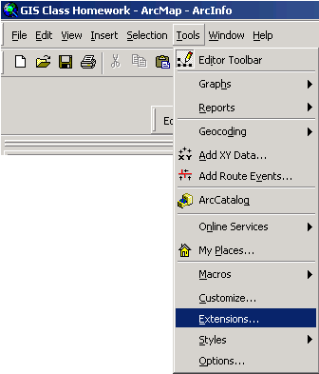

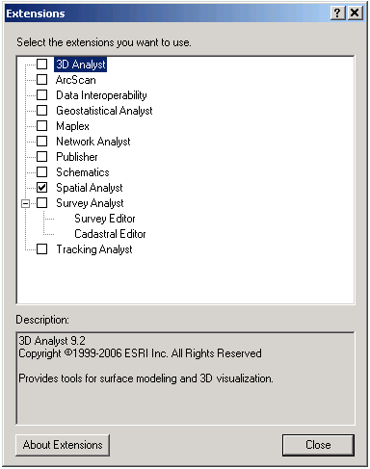

Preparing Land Use Layer

Add table for landuse of Nebraska (landuse class_description) to the map. Then add the Land Use raster for the study area (land_use). We will join the Land Use layer with landuse class_description table to get the class names of land use types. Right click on the Land Use layer. Select Joins and Relates → Joins. Following screen will be displayed on your window.

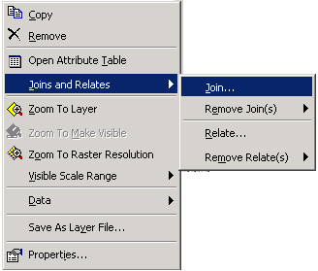

Choose the field Value on which join will be based on. Check ‘show the attributes in this layers’ option. Choose ‘to join to this layer’ as 2005_lc_nebr. Chose the ‘field in table to base the join on’ as Rowid. Click OK.

To change the symbology of Land Use, right click and select properties of the Land Use layer. Select Unique Value renderer and choose 2005_lc_neb.vet:CLASS_NAMES from drop down menu. Select the color scheme of your choice.

After making aforementioned changes, the symbology of Land Use raster will look similar to the following and Class names of land use type will be displayed.

Q1) What is the value for irrigated corn, dryland sunflower and wetlands?

Computing Spatial Distribution of Reference ET

Add Reference Evapotranspiration shapefile (Ref_ET) to the map. To create the reference evapotranspiration surface we are going to use interpolate to raster tool. Click on Spatial Analyst → Interpolate to raster → Spline

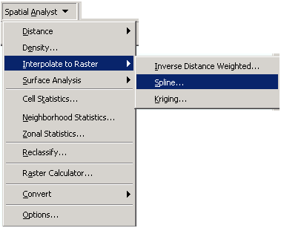

User can define interpolation parameters based on the input data. Select the Ref_ET shapefile layer as input points. Input point is point feature class used to create the interpolated surface. Select Z value field as Day 219. Select spline style as Tension. Select weight value 0.1. We are using commonly used power value 0.1. Selecting higher power will emphasis more on nearest points. Specifying a lower value for power will provide a bit more influence to surrounding points a little farther away. Higher power will lead to “Bull’s eye” effect, i. e. higher values for the locations surrounding the sample points. Select number of points as 4 and output cell size as 250. Kriging is more sophisticated method of interpolation available with spatial analyst. But selection of parameters is crucial and critical for accuracy of interpolation. IDW method gives less smooth surface than other methods. Rename output layer as ref_et_surf.

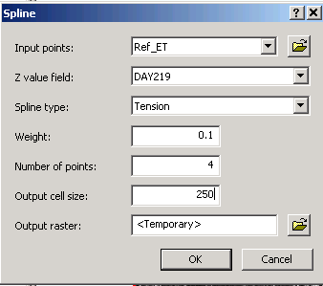

Q2). Which subbasin has the highest reference ET for the most its part?

Estimation of Fractional Vegetation Cover
Below is a map of NDVI for the study area.

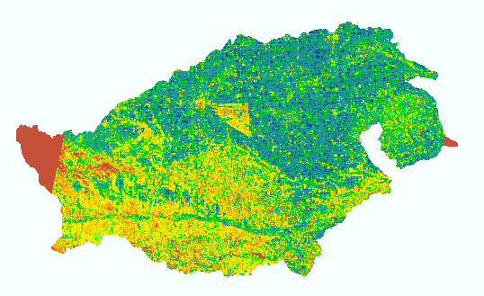
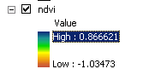

The method proposed by Brunsell and Gillies (2002) to obtain the fraction of vegetation cover will be used. The method scales the NDVI to obtain the fraction of vegetation cover and then scales the fraction between the emissivity of bare soil and a full canopy.

N* = (NDVI – NDVI₀)/(NDVI_{max} – NDVI₀)

Where NDVI₀ is the bare soil NDVI value of the scene and NDVI_{max} is the maximum NDVI of the scene corresponding to full cover dense vegetation. The fraction of cover becomes

Fr = N*2

We will estimate fraction of vegetation cover using raster calculator. Click on Spatial analyst → raster calculator

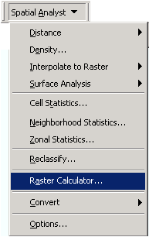

Following screen will appear on your window.

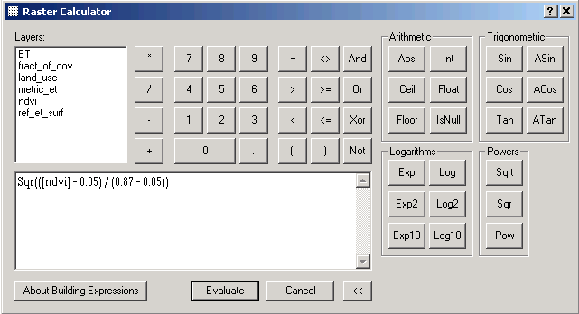

Type following formula as an expression in the raster calculator to calculate the fraction of vegetation cover.

Sqr(([ndvi] - 0.05) / (0.87 - 0.05))

Here we have assumed NDVI for bare soil as (NDVI₀) as 0.05 and maximum NDVI (NDVI_{max}) is the value observed from NDVI map.
Your map will look like this.

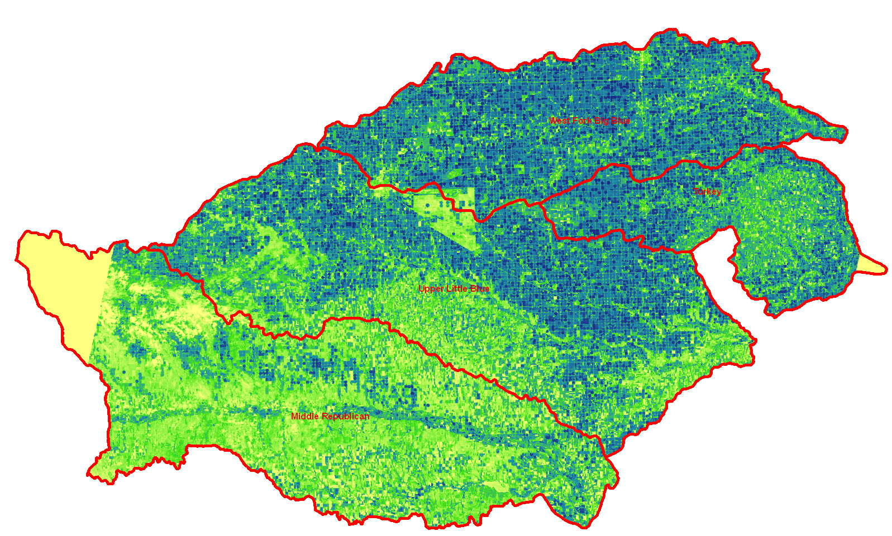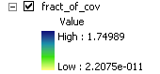

Q 3) Which subbasin has highest value for fraction of vegetation cover and which subbasin has lowest value for fraction of vegetation cover

Computation of actual ET

Calculate the actual ET by multiplying fraction of vegetation cover to reference evapotranspiration. Click on Spatial analyst → raster calculator

Following screen will appear on your window.

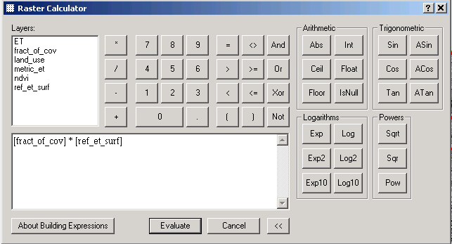
Type following formula as an expression in the raster calculator to calculate the actual evapotranspiration. Click OK and then actual ET layer will be added to the map.Rename it as ET.

[fract_of_cov] * [ref_et_surf]

Your map should look like this.
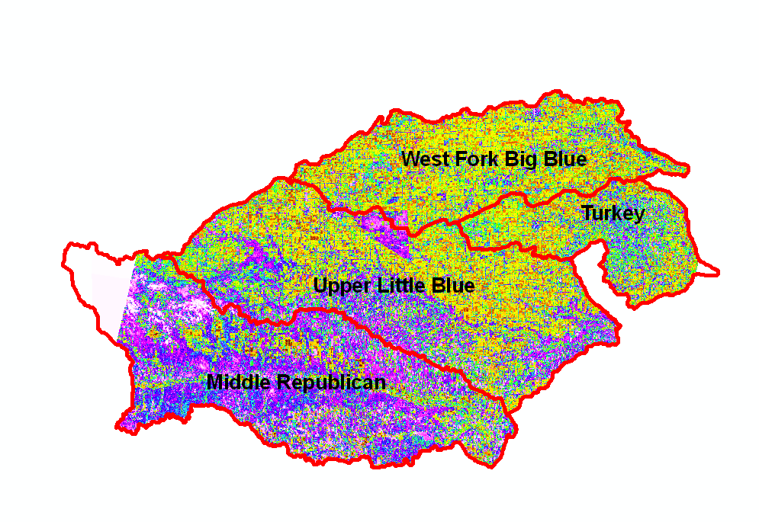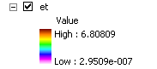

Q 4) Which subbasin has highest ET cover and which subbasin has lowest ET? Does any relation occur between ET and fraction of vegetation cover?

Exploring zonal statistics of Evapotranspiration

By calculating zonal statistics, the statistics for each zone of a zone dataset can be calculated based on the information in a value raster. We will calculate ET statistics of each HUC 8 subbasin. To calculate zonal statistics click on Spatial Analyst → Zonal Statistics

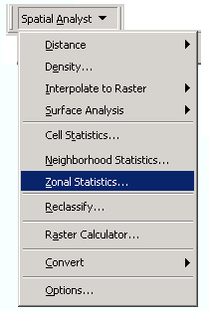

Following screen will appear on your window.

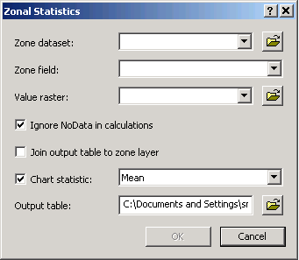

Select HUC 8 as Zone dataset. Values of the input raster will be categorized based on this layer. Select Zonal filed as Subbasin Select value raster as ET. Check ‘Ignore NoData in calculations’. Since we don’t have data for some subbasins it is important to select this option. Select Chart Statistics as Mean. Save the output table on your computer. Following zonal statistics graph will be appear on the screen.

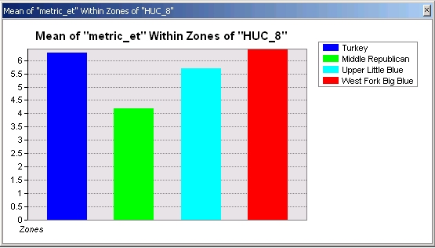

Q 5) Which zone (subbasin) has highest range of ET and highest standard deviation for ET?

Adjusting METRIC ET

Add METRIC ET raster (metric_et) to ArcMap. This is actual ET computed using METRIC (Mapping EvapoTranspiration with High Resolution and Internalized Calibration) program for the August 7, 2005. There are some negative ET values. We will adjust negative values to zero using raster calculator. Click Spatial analyst → raster calculator

Following screen will appear on your window.

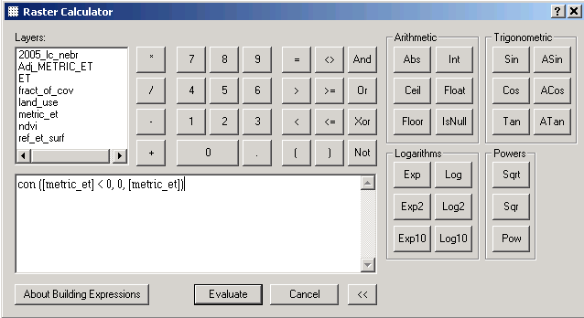

Type following formula in raster calculator to adjust negative values to zero.

con ([metric_et] < 0, 0, [metric_et])

Rename output file as Adj_METRIC_ET.

Q6) State the few types of land uses for which you found METRIC ET values near higher end and lower end of METRIC ET range.

Comparison of Computed Actual ET with METRIC ET

Calculate the difference between computed actual ET with METRIC ET. Click on Spatial analyst → raster calculator

Following screen will appear on your window.

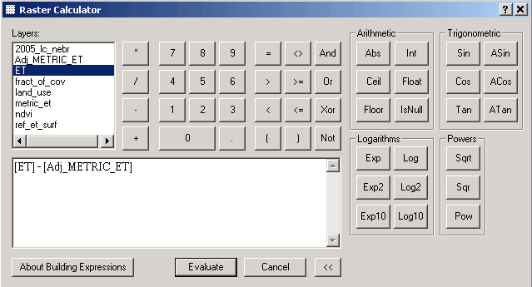

Type following formula as an expression in the raster calculator to compare computed actual ET with METRIC ET

[ET] - [Adj_METRIC_ET]

Rename output raster as ‘Diff_ET’.

Q 7. Perform zonal statistics for METRIC ET using subbasins as zones. Show the output table and compare the statistics with computed ET.

Summary of Items to be Turned in

Q 1. What is the value for irrigated corn, dryland sunflower and wetlands?
Q 2. Which subbasin has the highest reference ET for the most its part?
Q 3. Which subbasin has highest value for fraction of vegetation cover and which subbasin has lowest value for fraction of vegetation cover
Q 4. Which subbasin has highest ET cover and which subbasin has lowest ET? Does any relation occur between ET and fraction of vegetation cover?
Q 5. Which zone (subbasin) has highest range of ET and highest standard deviation for ET?
Q 6. State the few types of land uses for which you found METRIC ET values near higher end and lower end of METRIC ET range?
Q 7. Perform zonal statistics for METRIC ET using subbasins as zones. Show the output table and compare the statistics with computed ET.

REFERENCES
Allen, R. G., Tasumi, M., Morse, A., Trezza, R., Wright, J. L., Bastiaanssen, W., Kramber, W., Lorite, I., and Robison, C. W. (2007). "Satellite-based energy balance for mapping evapotranspiration with internalized calibration (METRIC): Applications." J.Irrig.Drain.Eng., 133(4), 395.
Allen, R. G., Tasumi, M., and Trezza, R. (2007). "Satellite-Based Energy Balance for Mapping Evapotranspiration with Internalized Calibration (METRIC)—Model." J.Irrig.Drain.Eng., 133 380.

Irmak, A. and S. Irmak. (2008). Reference and crop evapotranspiration in south central Nebraska: II. Measurement and estimation of actual evapotranspiration for corn. 2008. J. Irrig. and Drain. Eng.

