Assignment #6
Computing Actual Evapotranspiratoin Using GIS
GIS in Water Resources
Fall 2008

Eleni Pappas

November 6, 2008

Q1: What is the value for irrigated corn, dryland sunflower and wetlands?
Irrigated Corn | 1
Dryland Sunflower | 24
Wetlands | 13

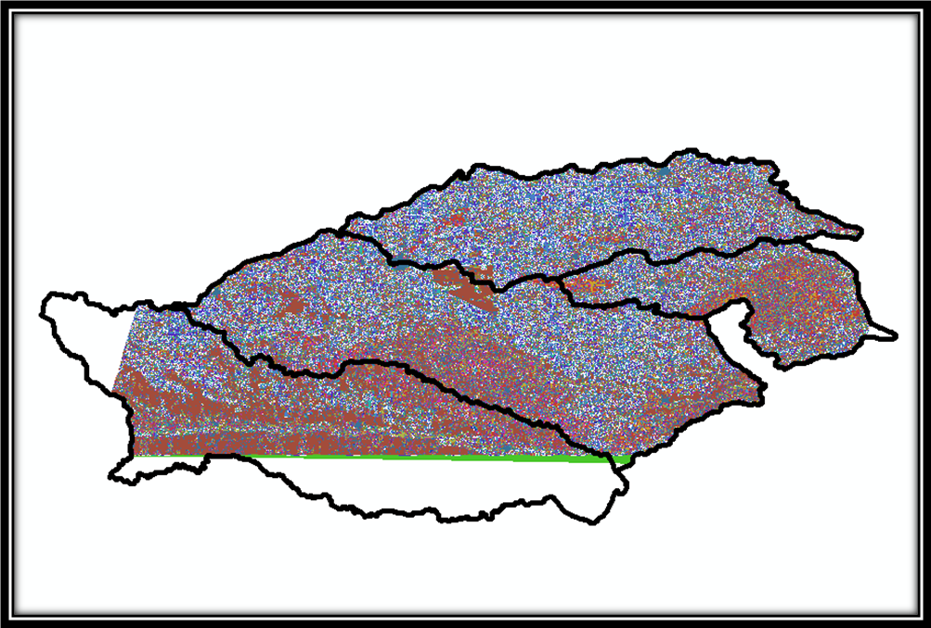

Q2: Which subbasin has the highest reference ET for the most its part?
Middle Republican
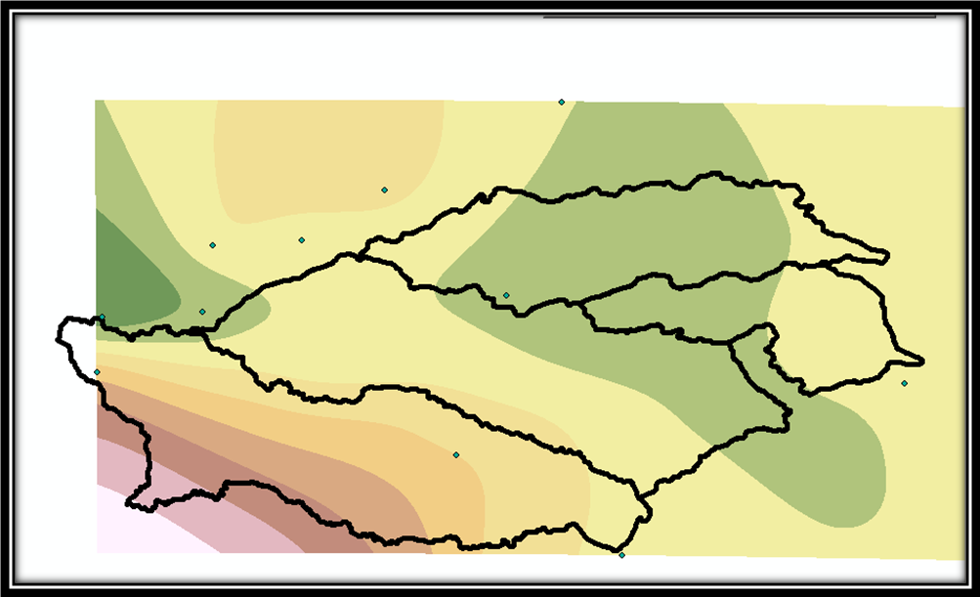

Q3: Which sub basin has the highest value for fraction of vegetation cover and which sub basin has lowest value of vegetation cover?
Highest Vegetation Cover | West Fork Big Blue
Lowest Vegetation Cover | Middle Republic

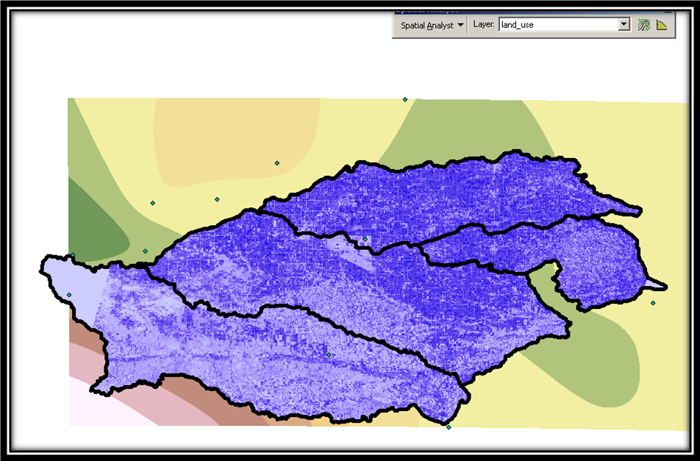
Q4: Which subbasin has highest ET cover and which subasin has lowest ET? Does any relation occur between ET and fraction of vegetation cover?

Highest ET Cover | West Fork Big Blue
Lowest ET Cover | Middle Republic

It appears that the areas with high vegetation cover have high Reference Evapotranspiration (ET) cover and areas with low vegetation cover have low ET cover

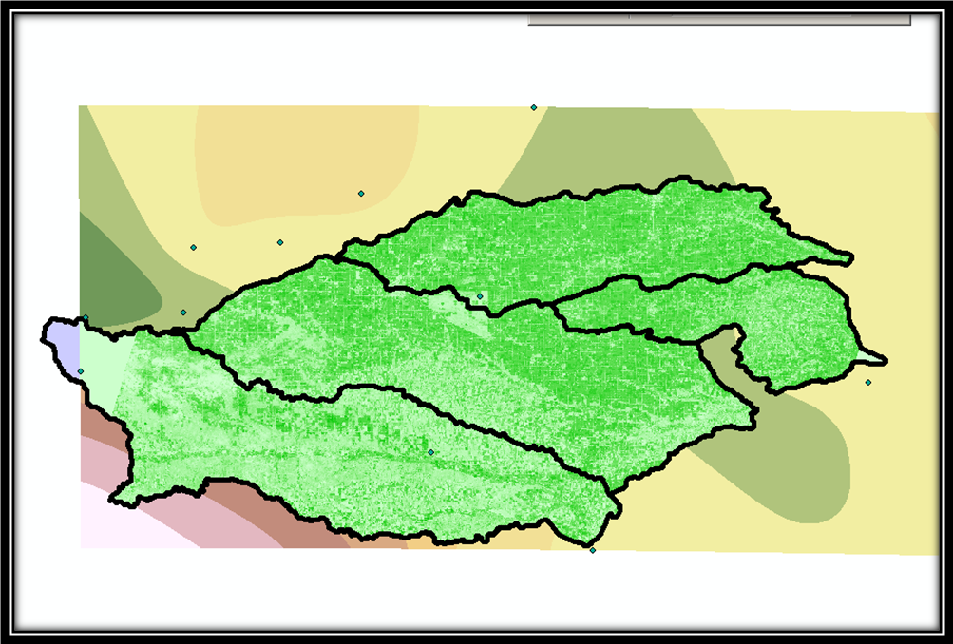

Q5: Which zone (subbasin) has highest range of ET and highest standard deviation for ET?
Highest range of ET | Middle Republic
Highest standard deviation for ET | Upper Little Blue

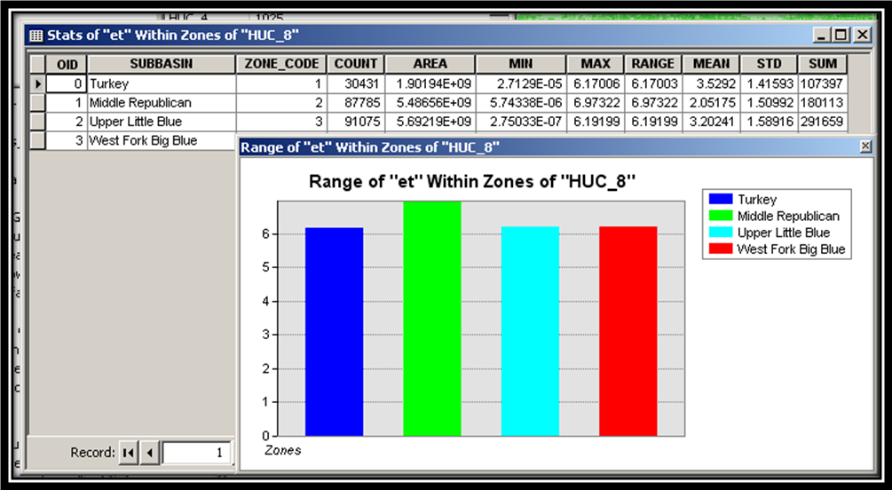
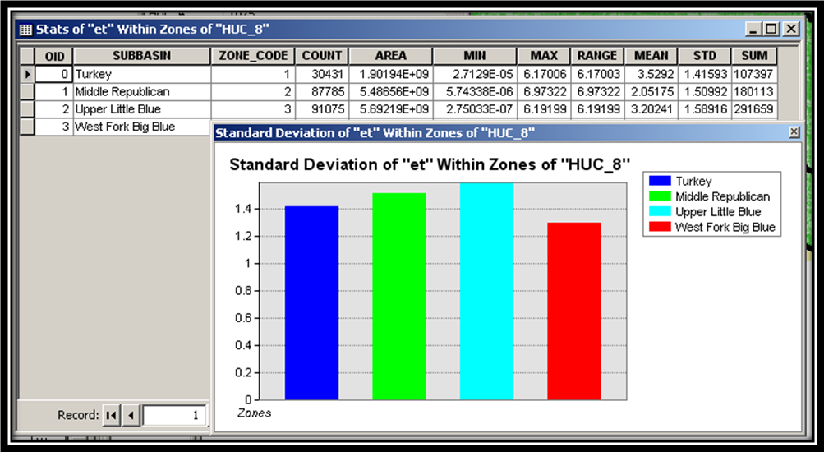
Q 6: State the few types of land uses for which you found METRIC ET values near higher end and lower end of METRIC ET range.
Land Uses near high end of METRIC ET range | Irrigated Corn  Irrigated Soybeans
Land Uses near low end of METRIC ET range | Range, Pasture, Grass

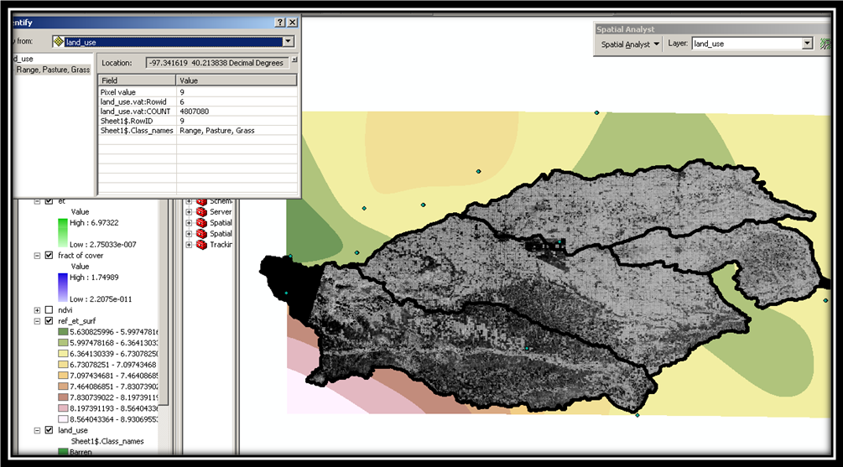

Q7: Comparison of ET and METRIC ET
 | ET |  |  | METRIC
Subbasin | Range | Mean | Sta. Dev. | Range | Mean | Sta. Dev
Turkey | 6.17006 | 3.5292 | 1.41593 | 8.40497 | 6.28249 | 1.21176
Middle Republic | 6.97322 | 2.05175 | 1.50992 | 10.2627 | 4.187709 | 1.98124
Upper Little Blue | 6.19199 | 3.20241 | 1.58916 | 9.40165 | 5.7011 | 1.50027
West Fork Big Blue | 6.21936 | 3.92813 | 1.29736 | 8.46787 | 6.43262 | 1.09699

