ARC HYDRO GROUNDWATER Tutorials
Wells and Time Series
Provided by Courtesy of Gil Strassberg and Norman Jones of Aquaveo http://www.aquaveo.com/
Arc Hydro Groundwater (AHGW) is a geodatabase design for representing groundwater datasets within ArcGIS. The data model helps to archive, display, and analyze multidimensional groundwater data, and includes several components to represent different types of datasets, including representations of aquifers and wells/boreholes, 3D hydrogeologic models, temporal information, and data from simulation models.
The Arc Hydro Groundwater Tools help to import, edit, and manage groundwater data stored in an AHGW geodatabase. This tutorial illustrates how to use the tools to manage well data and time series data (transient water level measurements) associated with wells. A basic familiarity with the AHGW data model is suggested, but not required, prior to beginning this tutorial.

Outline
In this tutorial, we will be working with groundwater data from the Panhandle region of Texas. We will complete the following tasks:
- Import a set of well data into ArcGIS.
- Modify the well attributes.
- Generate time series plots of water level data.
- Generate average water level maps for selected periods.
- Build a geoprocessing model to automate running a tool.
- Generate a flow direction map.

Required Modules/Interfaces
You will need the following components enabled in order to complete this tutorial:
- Arc Info / Arc View
- Spatial Analyst
- Arc Hydro Groundwater Tools
- AHGW Tutorial Files
The AHGW Tools requires that you have a compatible ArcGIS service pack installed. You may wish to check the AHGW Tools documentation to find the appropriate service pack for your version of the tools. Spatial Analyst is required for one portion of the tutorial involving interpolation. If you do not have Spatial Analyst, you can skip that portion of the tutorial. The tutorial files should be downloaded to your computer and saved on a local drive.

Getting Started
Before opening our map, let’s ensure that the AHGW Tools are correctly configured.
- If necessary, launch ArcMap.
- If necessary, open the ArcToolbox window by clicking on the ArcToolbox icon .
- If you have not already done so, add the AHGW Toolbox by right-clicking anywhere in the ArcToolbox window and selecting the Add Toolbox… command. Browse to the C:\Program Files\Aquaveo\Arc Hydro Groundwater Tools directory and select and open the Arc Hydro Groundwater Tools.tbx file.
- Expand the Arc Hydro Groundwater Tools item and then expand the Groundwater Analyst toolset to expose the tools we will be using in this tutorial.
Note that many of the GP tools in the AHGW Toolbox can also be accessed from the AHGW Toolbar. The toolbar contains additional user interface components not available in the toolbox. If the toolbar is not visible, do the following:
- Right-click on any visible toolbar and select the Arc Hydro Groundwater Toolbar item.

Opening the Map
We will begin by opening a map containing county boundaries for the Panhandle region of North Texas.
- Select the File | Open command and browse to the location on your local drive where you have saved the AHGW tutorials. Browse to the Groundwater Analyst | wells and time series folder and open the file entitled lubbock_wells.mxd.
Once the file has loaded you will see a map of the Panhandle region of North Texas. The filled polygon represents the boundary of the Ogallala aquifer in Texas. This data was obtained from the Texas Water Development Board Groundwater Database (http://www.twdb.state.tx.us/publications/reports/groundwaterreports/gwdatabasereports/gwdatabaserpt.htm).

Creating a new AHD File
Before continuing, we need to create an Arc Hydro Document (AHD) file. This file should be created each time a new map document is created for an Arc Hydro project. This file is used by the AHGW tools to save settings, file names, and other user selections in order to streamline the user experience. For example, when a geoprocessing tool is executed, the selections made by the user are saved to the AHD file and presented as defaults the next time the tool is launched.
- Double-click on the Create Arc Hydro GW Configuration tool located in the Arc Hydro Groundwater Tools | Arc Hydro Groundwater Setup toolbox.
- For both the Raster Location Workspace and the Vector Location Dataset options, click on the Open button and browse to the folder containing the files for this tutorial. Select the Rasters folder for the Raster Location Workspace and select the Data Feature Dataset for the Vector Location Dataset.
- Enter Layers for the project name and click on the Open button and enter Lubbock_Wells.ahd for the Arc Hydro Document. At this point, your selections should be similar to those shown in Figure 1.
- Select the OK button to execute the tool.
- Select the Close button when the tool has finished.
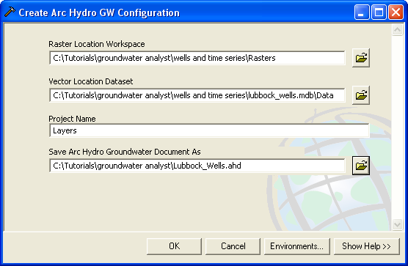
- Settings for the Create Arc Hydro Groundwater Configuration Tool.

Importing the Well Data
Next, we will import the well data for Lubbock County. The well data has been downloaded from the above-referenced website to a comma-delimited text file. The AHGW Toolset includes a tool for automating the import of text data into the AHGW geodatabase.
- In the AHGW Toolbar, select the Arc Hydro GW | Text Import command.
- In the wells and time series folder, select and open the lubbock_well_data.txt file.
- At the top of the File Import Wizard, turn on the Comma toggle and turn off the Space toggle in the column delimiters section.
- Turn on the Treat consecutive delimiters as one toggle.
- Turn on the Heading row toggle. This indicates that the first row contains headers for the data.
At this point, the dialog should look like the example shown in Error: Reference source not foundFigure 2.
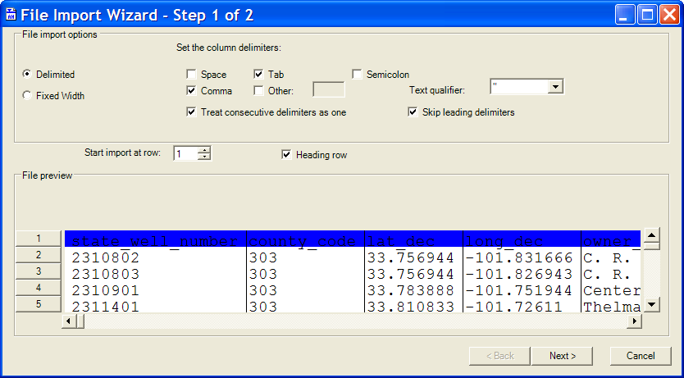
- File Import Wizard, Step 1 of 2.
- Select the Next button to go to the next step of the wizard.
In the next step of the wizard we indicate the type of data we are importing and specify how each of the columns in the file is linked to fields in the target feature class (Well in this case). The contents of the file are shown in the table at the bottom of the dialog. For each column that we wish to import, we will select the appropriate field name in the Type row. By default, <not mapped> is selected for each column indicating that the column will not be imported to a field in the Well feature class.
- Make sure that the Well option is selected in the Create Features/Rows in: combo box.
- In the first column with a Header value = “state_well_number”, double-click on the <not mapped> item in the Type row, and select HydroCode.
- Repeat the previous step to create the following relationships (you will need to scroll to the right to see some of the fields):
Header | Type
lat_dec | Y
long_dec | X
aquifer_id1 | AquiferCode
elev_of_lsd | Elevation
well_type | FType
well_depth | Depth
- Select the Finish button to complete the import process.
- Select OK to confirm the import process.
At this point, you should see some wells appear in the map.
Before continuing, let’s zoom in on the wells.
- Select the Zoom In tool and drag a box around the wells.

Using the Feature Type Filter
Features such as wells include an FType field representing the feature type. For wells, this field is often populated with values such as “irrigation”, “municipal”, etc. The AHGW Toolbar includes a pair of filters than can be used to map only the features in a layer that correspond to a particular type. The Filter creates a simple definition query for the selected value (for example, FType = ‘irrigation’). The Texas Water Development Board uses single character codes to identify well types. The four codes used in the wells in Lubbock County are O, S, T, and W and represent the following well types:
Code | Well Type
O | Observation
S | Spring
T | Test hole
W | Withdrawal

Before using the filter, we will first change the symbology so that the wells are colored by type.
- Right-click on the Well layer and select the Properties command.
- Click on the Symbology tab in the Layer Properties dialog, and change the selected options to match those shown in Figure 3 (Change the Show: option to Categories | Unique values. Choose FType as the value field and click the Add All Values button.).
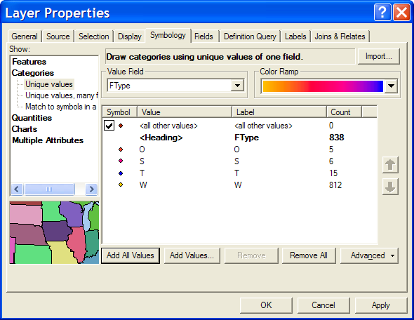
- Symbology Options for the Well Features.
- Click the OK button to exit.
Notice that most of the wells are withdrawal (W) wells. To map wells by type using the Filter:
- Make sure the Well layer is selected in the ArcMap Table of Contents (TOC). The filter will be built for the selected layer.
- Click on the down arrow in the first combo box just to the right of the Field label on the right side of the AHGW Toolbar and select FType.
- Click on the down arrow in the second combo box to the right of the Field label and select W. (note: this sets up a new definition query for the selected layer and overwrites any existing definition queries)
- Repeat the previous step for each of the other types.
- When finished, select the All option to map all wells.
Note that the two Field filters can be used to set up a definition query for any field/value combination for any map layer.

Assigning HydroIDs
Each feature in an Arc Hydro geodatabase should have an identifier that is unique across the entire geodatabase, not just within a feature class. This unique ID is called the HydroID. The HydroID is used to build relationships between feature classes and/or tables. For example, we will use the HydroIDs of the wells to relate the wells to the corresponding water level measurements in the TimeSeries table.
In a typical project, one would normally use the Assign HydroID tool in the Arc Hydro Tools to generate unique HydroIDs for new features. This tool necessitates some additional steps to relate the wells to the time series data we will import in the next step. Therefore, in order to keep this tutorial exercise simple we will copy over the values in the HydroCode field to the HydroID field. This will result in unique integer IDs for this exercise. To copy the values:
- Right-click on the Well layer in the ArcMap Table of Contents window and select Open Attribute Table.
- Right-click on the HydroID field and select the Field Calculator command. Click Yes to get past the warning (if necessary).
- In the Fields section of the Field Calculator, double-click on the HydroCode item.
- Select the OK button.
- Close the Attributes window.

Importing the Time Series Data
Now that we have imported the well features, we are ready to import the transient water level measurements into the TimeSeries table. Each record in the table will represent a water level measurement at a particular well at a particular time. The records in the TimeSeries table will be related to the wells using the HydroID field.
Once again, we will use the Text Import Wizard to import the data.
- In the AHGW Toolbar, select the Arc Hydro GW | Text Import command.
- In the wells and time series folder, select and open the lubbock_water_levels.txt file.
- As before, turn off the Space toggle, turn on the Comma toggle, turn off the Treat consecutive delimiters as one toggle, and turn on the Heading row toggle as shown in Figure 4.
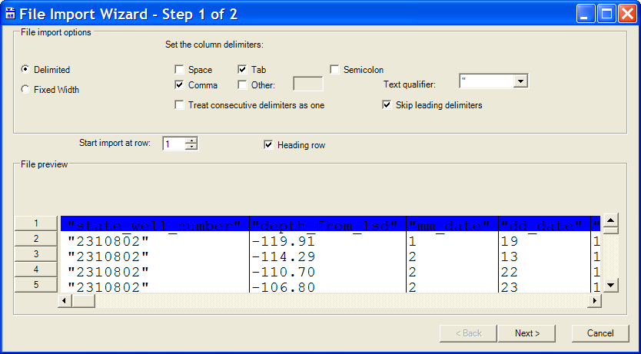
- File Import Wizard Settings, Step 1.
- Select the Next button.
- Make sure that the TimeSeries option is selected in the Create Features/Rows in: combo box.
- Double-click on the <not mapped> items in the Type row and create the following relationships as shown in Figure 5:
Header | Type
state_well_number | FeatureID
depth_from_lsd | TSValue
Date_Time | TSDateTime
- Click Finish to exit the wizard.
- Click OK to confirm the import.
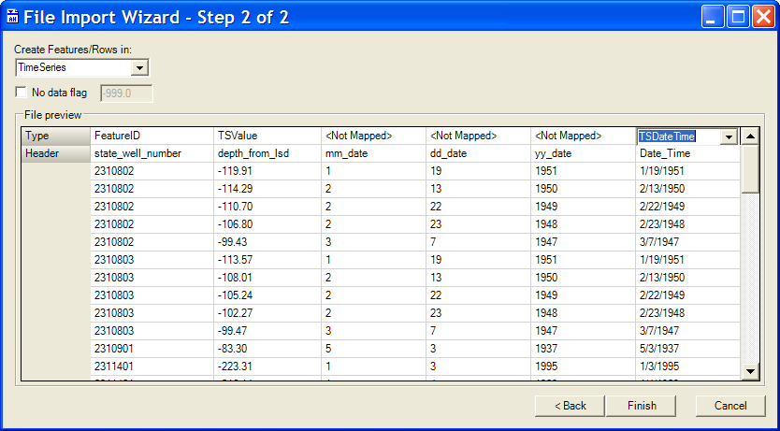
- Import Wizard Settings, Step 2.

Fixing the TimeSeries Table
The water level measurements are stored in the TimeSeries table. Let’s open the table and view the contents.
- Click on the Source tab at the bottom of the Table of Contents (TOC) window.
- Right-click on the TimeSeries table and select Open.
Notice that two of the fields contain null values. We can populate these fields using the Field Calculator. First, we will populate the TSTypeID field. This field is typically used to identify the type of time series and is an index to a separate TSType table. The TSType table includes a record for each of the different types of time series stored in the TimeSeries table (e.g. “Water level measurement”, “TCE Concentration”, etc.) and provides information about the units of measurements. To keep this exercise simple, we will not be using a TSType table and we will just have one type of measurement in our table (water level).
- Right-click on the TSTypeID field in TimeSeries table and select the Field Calculator command.
- Click Yes if necessary at the warning about an edit session.
- In the bottom part of the Field Calculator, enter 1.
- Click OK to exit the Field Calculator.
Next, we will make an adjustment to the water level measurements in the TimeSeries table. The water levels we imported to the TSValue field are actually depths measured from the top of the well and are expressed as negative values. To get a field representing actual elevations, we will use the field calculator and add the negative depths to the well elevations. This will require a temporary join. We will put the adjusted elevation values into a field called TSValue_normalized.
First, we will do the join.
- Close the TimeSeries table.
- Right-click on the TimeSeries table and select Joins and Relates | Join…
- Select the join options shown in Figure 6.
- Click on the OK button to complete the join.
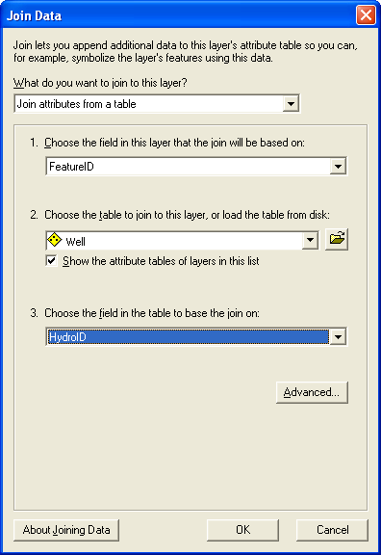
- Join options for joining Well features to the TimeSeries table.
Next, we will compute the proper elevations.
- Right-click on the TimeSeries table and select the Open command.
- Right-click on the TimeSeries.TSValue_normalized field and select the Field Calculator command.
- Click Yes at the prompt (if necessary).
- Enter the expression shown in Figure 7 in the bottom part of the Field Calculator.
- Click OK to complete the operation.
- Click Yes at the prompt (if necessary).
- Close the TimeSeries Table.
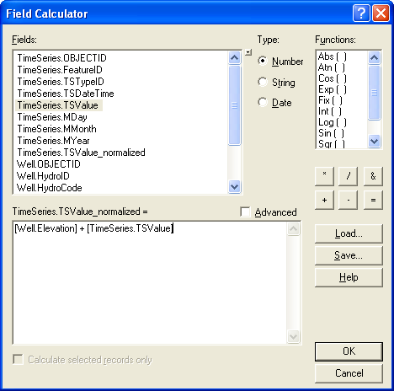
- Computing a normalized elevation for the water level measurements.
Finally, we will remove the join.
- Right-click on the TimeSeries table and select Joins and Relates | Remove Join(s) | Well.

Finding Wells with Transient Data
Some of the wells imported have transient water level measurements and some do not. We can quickly determine which wells have transient data using the Make Time Series Statistics tool in the Groundwater Analyst toolset. This tool can be used to derive a new feature set from an existing feature set with transient data. The new feature set includes a field representing selected statistics of the original transient data (mean, standard deviation, etc.). In this case, we will use the tool to derive a new layer containing only the wells with transient data and with a field representing the average water level over all measurements.
- Double-click on the Make Time Series Statistics tool in the AHGW Toolbox | Groundwater Analyst toolset.
- Enter the input options/selections as shown in Figure 8. For the Output Feature Class option, browse to the location on your local drive where the tutorial files are located and open the Lubbock_wells geodatabase so that the new features are created inside the geodatabase. Type water_level_all as the name of your new feature class.
- Click OK to execute the tool.
- Once the tool has completed its processing, select the Close button to close the GP window.
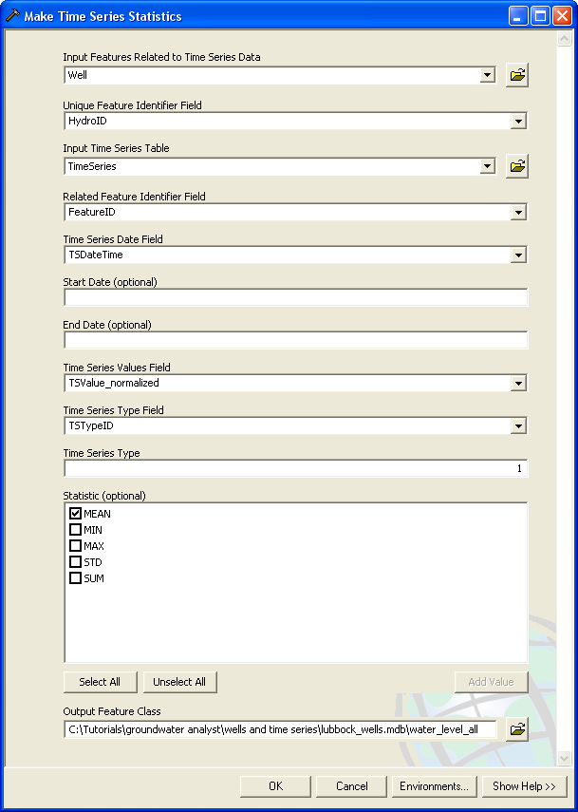
- Input options for the Make Time Series Statistics tool.
You should now see a new set of wells displayed on the map.

Adjusting the Well Display
In addition to the mean water level, the Make Time Series Statistics tool generates a new field containing the frequency of measurements (i.e., the number of transient water level values per well). We can use the ArcMap Symbology to map the sampling frequency.
- Click on the Display tab at the bottom of the TOC window.
- Uncheck the Well layer to hide that layer. Only wells with transient data will still be visible in the map.
- Right-click on the water_level_all layer and select the Properties command.
- Edit the selection in the Layer Properties dialog to match what is shown in Error: Reference source not found. Change the Show: option to Quantities | Graduated Colors; change the Value: field to FREQUENCY and change the Classes setting to 4. To change the symbol sizes, double-click on each of the symbols and edit the Size value. Use 4.0 for the smallest symbol and 6.0, 8.0, and 10.0 for the three larger symbols.
- Click OK to exit.
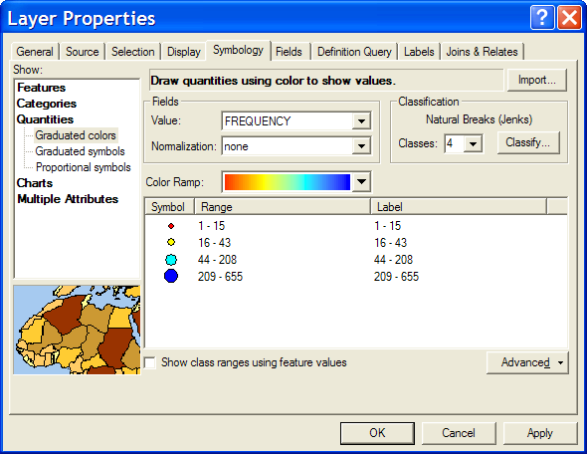
- Symbology settings for the water level frequency data.

Using the Time Series Grapher
When working with transient well data, it is helpful to generate graphs illustrating the change in water level vs. time. The AHGW Toolbar includes an interactive Time Series Grapher tool that can be used to quickly generate time series graphs simply by clicking on wells of interest. We will use this tool to explore the Lubbock county well data.
- Click on the Time Series Grapher icon in the AHGW Toolbar.
- Edit the options in the Time Series Grapher Setup dialog to match those shown in Figure 10.
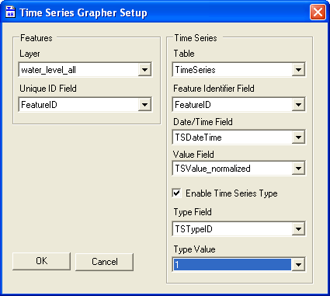
- Time Series Grapher Setup Options.
- Select OK to exit the Setup dialog.
Notice that the cursor has changed. We can now create a new graph simply by clicking on wells.
- Click on one of the light blue wells.
A new plot window should appear. You may wish to reposition the window. You can right-click on the graph to modify the plot using the standard graphing options.
- Click on a second light blue well.
Note that subsequent well data are inserted as additional series to the current graph. To create a new graph, you can simply close the current graph and click on a new set of points. Each graph is stored with the map and can be re-opened using the Tools | Graphs menu command.
- Click on the Select Features tool to deactivate the Time Series Grapher tool.

Time Series Statistics for a Specific Time Interval
Earlier in this tutorial, we used the Make Time Series Statistics tool to derive a new feature class representing the average water levels over the entire set of measurements. The objective of that exercise was simply to identify the wells containing transient water level measurements. Next, we will use the Make Time Series Statistics tool to derive a set of features corresponding to mean water levels measured over a specific interval in time (first quarter of the year 2000). Then we will interpolate these values to a raster to generate a map of water levels for the county for our selected time interval.
- Double-click on the Make Time Series Statistics tool in the AHGW Toolbox | Groundwater Analyst.
- Enter the input options/selections as shown in Figure 11. For the Output Feature Class option, browse to the location on your local drive where the tutorial files are located and open the Lubbock_wells geodatabase. Type wl_q1_2000 as the name of your new feature class.
- Click OK to execute the tool.
- Once the tool has completed its processing, select the Close button to close the GP window.
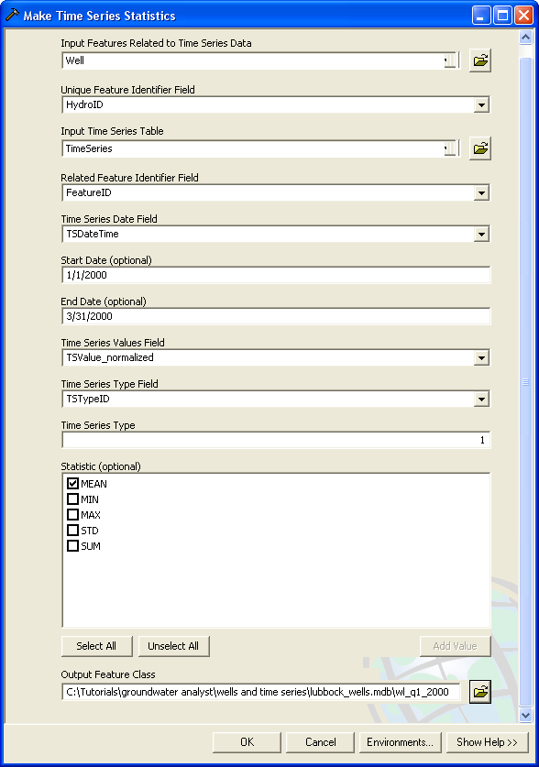
- Input options for the Make Time Series Statistics tool.
You should now see a new set of wells displayed on the map. To simplify the map display:
- Turn off the water_level_all layer in the TOC window.

Interpolating Water Levels
The next step is to interpolate the values from the new layer to a raster to generate a map of water levels for Q1 of 2000. This step requires Spatial Analyst. If you do not have Spatial Analyst installed, you will not be able to complete the remainder of this tutorial. We will use the IDW geoprocessing tool to perform the interpolation and we will set the Environment options such that the resulting raster is clipped to the Lubbock County boundary.
- Double-click on the IDW tool in ArcToolbox (located in the Spatial Analyst Tools | Interpolation).
- Enter the set of options shown in Figure 12. For the Output raster option, change the name of the output raster to q1_2000. Be sure to set the location of the raster such that it is in the folder one level above the geodatabase (i.e., just outside the geodatabase). This ensures that the next step will not result in an error.
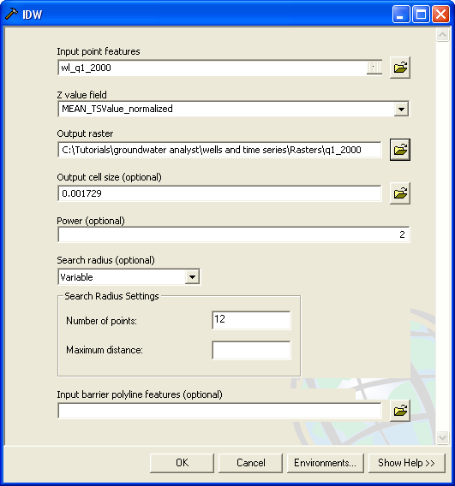
- Input Setting for the IDW GP Tool.
- Click on the Environments… button.
- Expand the General Settings section and change the Extent option to Same as layer lubbock_county. This will cause the interpolation to extend out the limits of a rectangle including all of Lubbock County.
- Scroll down and expand the Raster Analysis Settings section and change the Mask option to lubbock_county. This will clip the raster to the actual boundary of Lubbock County.
- Select the OK button to exit the Environment Settings dialog.
- Select the OK button to execute the IDW tool.
- When the tool has finished, click on the Close button.
- You should see a new map layer called q1_2000 at the bottom of the TOC window. To make it visible on the map, drag it up just above the Counties layer.

Using a Raster Catalog
Now that we have a water level raster, we will store it in a raster catalog. This allows us to archive the raster with the time interval (start date, end date) and other descriptive information that may be useful. Furthermore, a sequence of rasters in a raster catalog can be animated using the Animation tools in ArcMap. A raster can be archived in a raster catalog using the Add to Raster Series tool in Groundwater Analyst. Since our geodatabase already contains an empty raster catalog with the appropriate fields, we are ready to run the tool.
- In ArcToolbox, Double-click Arc Hydro Groundwater Tools | Groundwater Analyst | Add to Raster Series.
- Enter the set of options shown in Figure 13.
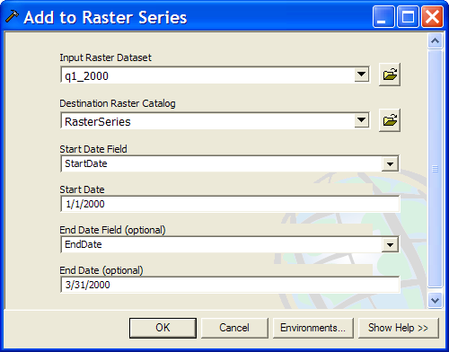
- Settings for the Add to Raster Series Tool.
- Click on the OK button to execute the tool.
- Click on the Close button once the tool has completed.
You should see a RasterSeries layer added to the map and a grayscale version of the raster is displayed. You can right-click on the RasterSeries layer and edit the symbology to select a new color ramp if you wish. To view the contents of the raster catalog:
- Right-click on the RasterSeries layer and select the Open Attribute Table item.
- Scroll to the right to examine the fields.
- When you are finished, close the window.

Creating a Model to Automate Processes
Since generating water level maps for a specific time interval is such a common procedure, it is useful to build a model that automates parts of the process. In this section you will build a model that enables automating the process of running the Make Time Series Statistics tool. It is possible to create fairly complex models (and scripts) to automate common tasks. Some examples are provided in the Sample Utilities toolset of the Arc Hydro Groundwater Tools.
- In Arc Toolbox select the Groundwater Analyst toolbox, right click and select New Model. A new empty model should open in the map.
- Drag the Make Time Series Statistics tool into the model.
You can expose tool parameters as model parameters. In this example we will set the input feature classes, tables, and fields as constants and only expose the start date, end date, and output features as model parameters.
- Select the Make Time Series Statistics tool in the model, right click and select Make Variable | From Parameter | Start Date. The Start Date parameter should appear in the model as a circle
- Do the same to add the End Date parameter to the model
- Select the Stat Date parameter, right click, and select the Model Parameter option. A “P” should appear beside the Start Date parameter. Do the same for the End Date parameter. You model should look like the one shown in Figure 14. Save your model.
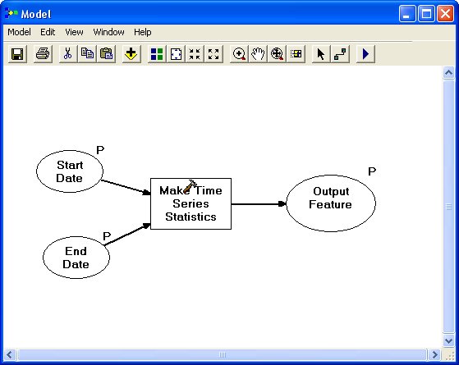
- Creating a model including the Make Time Series Statistics tool
Next, you will set the other tool parameters.
- Double click on the Make Time Series Statistics tool in the model. This should expose the tool parameters.
- Fill in the tool parameters as shown in Figure 15.

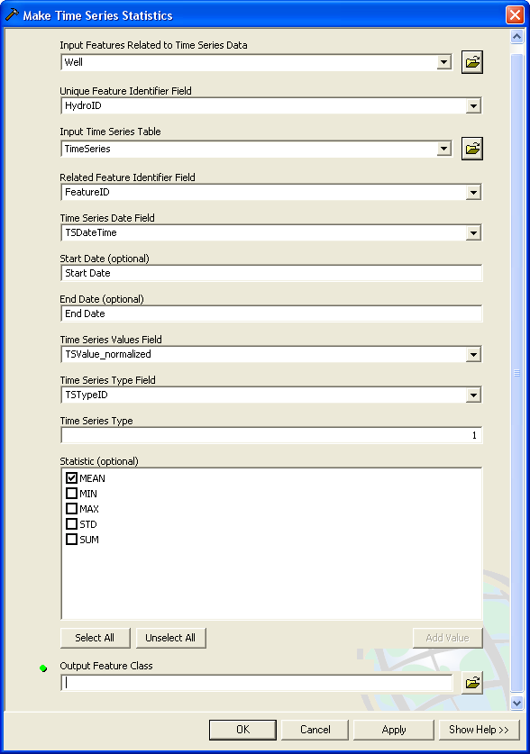
- Make Time Series Statistics parameters

- Save the model and close it and then reopen it from the toolbox (by double clicking on the model) you will see only the Start Date, End Date, and Output Features parameters exposed as input parameters. The rest of the parameters are defined in the model and will remain constant.
- Set the Start Date to 1/1/2001 and the End Date to 3/31/2001.
- Set the Output Feature Class by browsing to the lubbock_wells geodatabase and name the new feature class wl_q1_2001.
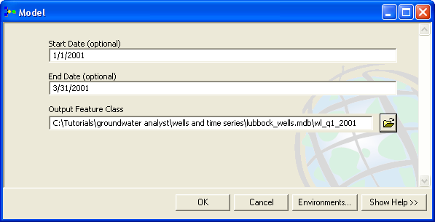
- Make Time Series Statistics parameters exposed as model parameters.

- Select OK to run the model.
A new layer should be added to the map representing the mean water level for the first quarter of 2001.
If you want to run this process for multiple years you can batch process the model.
- Right click on the model and select Batch.
- Specify the input parameters as shown in Figure 17. By running the model in batch mode you will create a new feature class for the first quarter of each year from 2002 to 2005 (to add a new row to the batch grid you simply select the icon).
- Select OK to run the model.
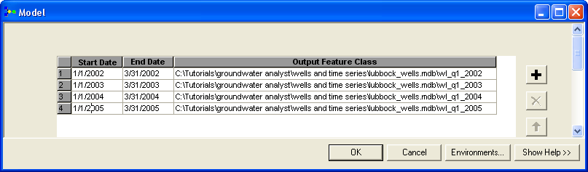
- Model parameters in batch mode
By creating more complex models and scripts you can automate the process of creating water level maps and generate a sequence of maps for different time periods. These maps could then be animated using the Animation tool. See the Arc Hydro Groundwater Tools | Sample Utilities and Arc Toolbox | Samples for sample models and scripts.

Generating a Flow Direction Map
As the final step of the tutorial, we will generate a flow direction map using the Flow Direction Generator command in the AHGW Toolbar. This tool generates a set of flow arrows on top of a water level raster. The arrows are generated as graphic elements and can be managed/deleted using the standard ArcMap drawing tools. The arrows are generated such that they point in the direction of maximum downward gradient in the water level elevations (i.e. “downhill”).
To generate the map:
- Turn off the RasterSeries map layer.
- Select the q1_2000 raster in the TOC window.
- In the AHGW Toolbar, Select Arc Hydro GW | Flow Direction Generator.
- Enter a value of 7 for the Arrow Spacing.
- Click on the Generate button.
At this point, the arrows should be added to the raster. To experiment with the settings, you can click the Clear button to remove the current arrows and Generate to build new arrows.
- Click on the Quit button when you are finished.

Conclusion
This concludes the tutorial. Here are some of the key concepts in this tutorial:
- The Text Import Wizard is used to quickly import wells and time series data into an AHGW geodatabase.
- The Make Time Series Statistics tool is used to identify wells with transient data and to illustrate the frequency of the data.
- The Time Series Grapher is used to explore transient data.
- The Make Time Series Statistics tool is used to map statistics (e.g. mean, min, max) values for a specific time intervals. This output can then be interpolated to a raster to generate water level maps.
- Raster catalogs are useful for managing raster series.
- Models are used to automate processes.
- The Flow Direction Generator can be used to create a map of flow directions.

