Name:_Solution____

GIS in Water Resources
Homework#1

1. The way that data is represented within a geographic information system enables the analysis that can be performed. Discuss, based upon the lectures to date and your reading of Arc Hydro pages 1-31 and the ArcGIS and Spatial Analyst handouts, how the data representations you have learned about enable useful analyses. Please limit your writing to no more than 300 words."

In the Essay I was looking for writing that presented a thoughtful evaluation of the material you had learned regarding the representation of data and how it enabled analysis. I penalized essays that seemed to just try to fill space. ArcGIS provides a way to represent spatial objects as points, lines and polygons with associated attribute information, and spatial fields as rasters. This enables the following functions and analysis capability that I was looking out for you to mention:
- Spatial superposition to visualize geographic connections and spatial patterns
- Geographic objects have attributes that describe their properties
- Connection of information and establishing relationships through unique identifiers and key fields in the database tables. These connections link objects such as drainage lines, watersheds, junctions, monitoring points and time series of data collected at monitoring points.
- Creation of new information from geospatial analysis
ArcGIS also facilitates
- Organizing large amounts of data
- Sharing data with others
- Integrating spatial information through superposition, as well as data base relationships (joins and relates)
I was looking for some thoughtful consideration of how these conceptual features of GIS data representations enable the analysis capability that it provides

2. The map below shows Utah and the display parameters of the State Plane coordinate system for the Utah Central Zone.
(a) Sketch on the map the standard parallels, the central meridian and the latitude of origin of this projection.
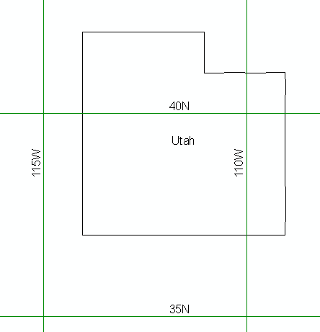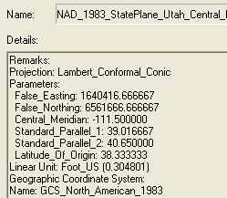
111.5 W Central Meridian
38.333N
Latitude of origin
40.65N
Std_2
39.0167N
Std_1

(b) For this projection, the coordinates of the origin (φ_{o}, λ_{o}) = (38.33,-111.5)

and the corresponding (X_{o}, Y_{o}) = (1640416.67,6561666.67)

(c) What earth datum is used in this coordinate system?
NAD_1983 (North American Datum of 1983)

(d) What map projection is used in this coordinate system?
Lambert Conformal Conic
3. Following are the geographic coordinates of the 3 cities involved in this class.

a) Calculate the great circle "curved earth" distance between each combination of cities (i.e. Logan to Austin, Austin to Lincoln and Lincoln to Logan). Assume a spherical earth with radius 6370 km.

The following embedded Excel Spreadsheet gives the inter-city distances computed using the great circle formula.

b) Use ArcGIS to display these cities using the USA Contiguous Equidistant Conic projection. For this projection report the following parameters:
Central_Meridian: -96 or 96 W
Standard_Parallel_1: 33 or 33 N
Standard_Parallel_2: 45 or 45 N
Latitude_Of_Origin: 39 or 39 N
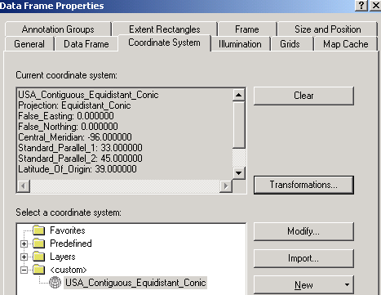

c) Calculate the X and Y coordinates of each city using the USA Contiguous Equidistant Conic projection. Report your results in a table.

The Point_X and Point_Y fields below are from the Add XY coordinates tool:
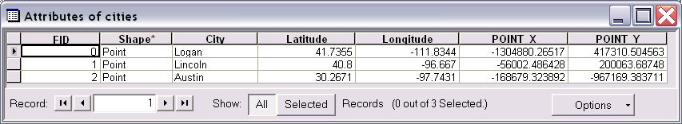

d) Calculate the distance between each combination of cities from the USA Contiguous Equidistant Conic projection X and Y coordinates.

The following Embedded Excel spreadsheet used Pythagoras's theorem to calculate the distance based on the coordinates.

e) The earth is better approximated as an ellipsoid than a spheroid. MATLAB script exchange includes an implementation of a function for calculating distances on the WGS84 reference ellipsoid. This is given at http://www.mathworks.com/matlabcentral/fileexchange/loadFile.do?objectId=5379&objectType=FILE.

Evaluating the inter-city distances using this function in MATLAB I get

Logan_to_Austin=vdist(41.7355, -111.8344, 30.2671, -97.7431)
Logan_to_Austin = 1793523.63 m

Logan_to_Lincoln=vdist(41.7355, -111.8344, 40.8, -96.667)
Logan_to_Lincoln = 1273511.90 m

Austin_to_Lincoln=vdist(30.2671, -97.7431, 40.8, -96.667)
Austin_to_Lincoln = 1172679.08 m

f) We see that depending on the method used, calculated distance between these cities can vary up to about 5 km. I believe that the MATLAB distances computed using the WGS84 Ellipsoid are most accurate. The spherical earth great circle approximations in (a) do not account for the ellipsoidal nature of the earth. The distances in (c) involve the distortions of a projection.

