Name:___David Tarboton______

GIS in Water Resources Midterm Exam Fall 2008
There are 4 questions on this exam. Please do all 4.

1. Basic Concepts [20 points]

Find the letter with the best answer for each term:

1.__C___ | Datum |  | A. | Area(s) where a projection’s scale is 100%–not enlarged or shrunken.
2.__G___ | Parallels |  | B. | Model(s) that approximates the earth’s shape as a flattened sphere
3.__A___ | Standard parallels |  | C. | Any potential model of the earth–the basis for a coordinate system.
4.__D___ | Meridians |  | D. | Line(s) of longitude
5.__E___ | Secant, tangent |  | E. | Variation(s) on geometric projections in which the applied shape either rests on top of the earth’s surface or cuts through the earth’s surface
6.__B___ | Ellipsoid |  | F. | Geometric type(s) of projections
7.__F___ | Cylindrical, conic |  | G. | Line(s) of latitude

(b) Consider the following information types relevant to GIS in water resources. Indicate the data type for each of the data layers below which best represents the spatial entity and/or variable in GIS from (A) Vector, (B) Raster, (C) Triangulated Irregular Network, and (D) vector and time series graph (E) NetCDF file. Indicate the data source (i.e. organization) that provides datasets for each of these information types. For each information type, indicate whether or not the data can be obtained through web services.

Catchment: A (vector). USGS or EPA (NHDPlus). Can be obtained on website but not "web services" Web services refer to direct machine to machine functions, distinct from web sites.
River reaches: A (vector). USGS or EPA (NHDPlus). Can be obtained on website but not "web services"
National Elevation Dataset: B (raster). USGS seamless data server. Can be obtained on website but not "web services"
Rainfall: D (time series), or E (NetCDF). NCDC or Unidata. Yes through "web services"

Streamflow: D (time series), USGS or CUAHSI. Yes through "web services"
2. [25 points] Land Cover Change in the San Marcos Basin

The image below shows land cover change in the San Marcos basin from 1992 to 2001 obtained from http://www.mrlc.gov/multizone_map2.php in a file for Region 10. The numbers 1 through 7 define the principal land use categories in the San Marcos basin and the two-digit categories refer to land cover change from one of the basic categories to another.

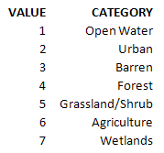 | 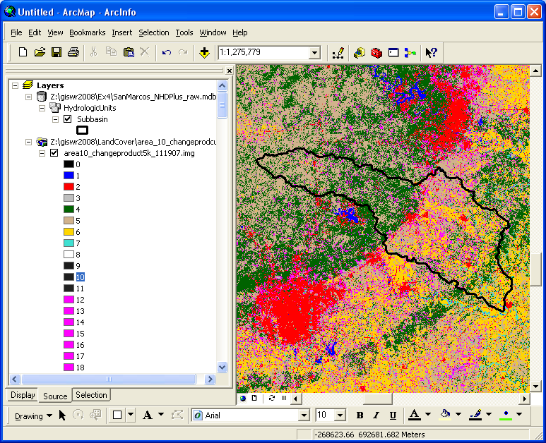

(a) The coordinate system for Land Cover Change raster image is shown below. To the right of each entry in this table, please describe what this entry specifies.
Description
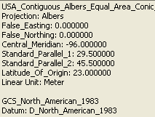
Name of spatial reference
Name of projection used
East-west (X) coordinate origin offset
North-south (Y) coordinate origin offset
Longitude of meridian through origin
Latitudes of parallels where cone intersects sphere and minimal distortion
Latitude of parallel through origin
Units used for projected coordinates

Name of the geographic coordinate system upon whcih projection is based
Horizontal datum name

(b) The SubBasin feature class is in geographic coordinates using the NAD 83 datum. Describe how you would use ArcGIS to project this feature class to the above coordinate system.

Use the Toolbox Project function. Select the USA Contiguous Albers Equal Area Conic projection from the Projected coordinate systems for North America as the output coordinate system

Alternative: Export or Import this to a feature dataset that already has the USA Contiguous Albers Equal Area Conic projection.

(c) To select the land cover change data only for the San Marcos basin, the Subbasin feature class is converted to a raster SubBasin2 whose values are 1 inside the San Marcos Basin and NODATA elsewhere. Complete the expression in the Raster Calculator window below that will produce a Calculation result that is just the land cover change values within the San Marcos Basin
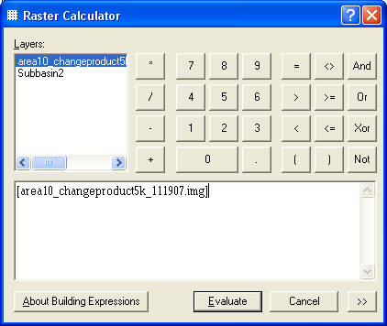
* [Subbasin2]
Or
* ([Subbasin2] = 1)

(d) The Calculation result is shown below

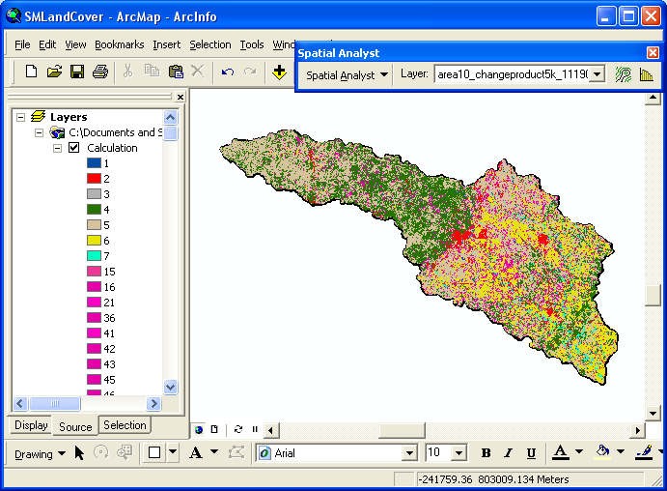
If the Attribute Table of the Calculation is exported and edited, the result below is produced. Count refers to the number of cells in each category. Cells with Values 1-7 had the same land cover in 1992 and 2001. Cells with values 15 to 67 had changed land cover, where the first digit refers to their land cover in 1992 and the second digit to their land cover in 2001.

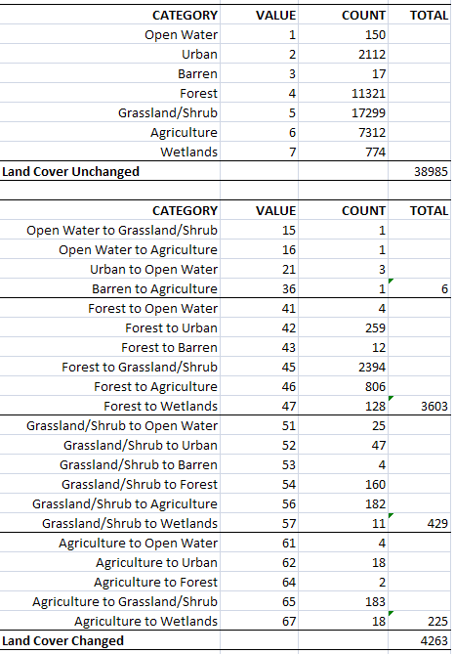
What percent of the land cover changed between 1992 and 2001 in the San Marcos Basin?
Total no of cells = 38985 + 4263 = 43248. Percent change = (4263/43248)*100 = 9.86%

What was the distribution of land cover in 1992 and 2001 measured in number of cells? Enter your answers in the table below.
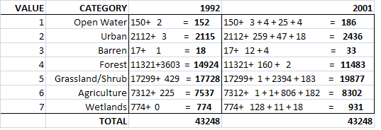
3. [25 points] Distances on a Curved Earth

Salt Lake City, Utah is located at 40°45'39"N, 111°53'28"W.
San Francisco, California is located at 37°46'30"N, 122°25'10"W.

a) Convert these coordinates to decimal degrees and indicate which of these numbers represents longitude and which represents latitude by filling the corresponding decimal degree longitude and latitude into the following table

Cities | Longitude | Latitude
Salt Lake City | -(111+53/60+28/3600)  = - 111.891111 | 40+45/60+39/3600  = 40.760833
San Francisco | -(122+25/60+10/3600)  = - 122.419444 | 37 + 46/60+30/3600  = 37.775000

b) Assume a spherical earth with radius of 6370 km. Calculate the distance from Salt Lake City (Utah) to San Francisco (California).

$$R{\text{cos}}^{−1}(\text{sin}φ_{1}\text{sin}φ_{2}+\text{cos}φ_{1}\text{cos}φ_{2}\text{cos}(λ_{1}−λ_{2}))$$
$$=\text{6370}{\text{cos}}^{−1}(\text{sin}\text{40}\text{.}\text{760833}\text{sin}\text{37}\text{.}\text{775}+\text{cos}\text{40}\text{.}\text{760833}\text{cos}\text{37}\text{.}\text{775}\text{cos}(\text{122}\text{.}\text{419444}−\text{111}\text{.}\text{891111}))$$
= 964.32 km

c) Discuss some other ways that you have learned for calculating the distance between locations that are not limited to assuming a spherical earth and describe how you would go about calculating this distance more precisely. (What we are looking for here is a description of how you would do this, using the GIS knowledge and tools you have learned. You are not expected to do it in this question.)

Use the matlab function that calculates distance on a spheroid.
Convert the points to a feature class in ArcGIS and project to a projection that preserves length, then use the coordinates from that feature class with the pythagorus theorem to compute distance.

4. [30 points] Hydrologic Variables derived from DEM’s

Following is a grid of elevations. Because in general it is not possible to unambiguously determine flow directions around the edges, these have been specified for you as indicated.

Fill to elevation of 17.5

- On the above grid, determine which grid cells are pits and indicate the elevation to which they need to be raised to fill them.

- For the grid cell labeled A determine the slope and flow direction using the 8 direction pour point model

Assume cell size 10 m. Slope = (17.6-17)/(10 sqrt(2)) = 0.0424
Flow direction diagonally up to right, or NE encoded as 128
- For the grid cell labeled A determine the slope and flow direction using the D∞ method.

Assume cell size of 10 m. The steepest slope is in the facet with center, adjacent and diagonal cells indicated

$$\begin{aligned}S=\sqrt{{\left(\frac{e_{\text{adj}}−e_{\text{diag}}}{Δ}\right)}^{2}+{\left(\frac{e_{\text{center}}−e_{\text{adj}}}{Δ}\right)}^{2}} \\ \sqrt{{\left(\frac{\text{17}\text{.}5−\text{17}}{\text{10}}\right)}^{2}+{\left(\frac{\text{17}\text{.}6−\text{17}\text{.}5}{\text{10}}\right)}^{2}}=0\text{.}\text{0509}\end{aligned}$$

$$α_{1}=\text{atan}\left(\frac{e_{\text{adj}}−e_{\text{diag}}}{e_{\text{center}}−e_{\text{adj}}}\right)=\text{atan}\left(\frac{\text{17}\text{.}5−\text{17}}{\text{17}\text{.}6−\text{17}\text{.}5}\right)=\text{78}\text{.}7\text{deg}$$

Since the angle is not within the range 0 to 45 deg outwards from the center, water will actually flow along the diagonal and the D∞ slope and direction are the same as D8

Slope along diagonal = 0.0424
Angle = 45 deg = 0.7854 rad.

- Determine the flow direction grid using the 8-direction pour point method (D8) for the 9 internal grid cells. Indicate the flow direction by using an arrow in each cell on the grid below.

Alternative directions due to flat topography

- Determine the flow accumulation grid corresponding to the D8 flow directions. Label each cell on the grid below with the number of upstream cells draining into it (ESRI convention).

