CE 394K.3 Final Exam Fall 2008
GIS in Water Resources

There are three questions on this exam. Do all three questions. For the first two questions, prepare a 2-page typed theme paper. For the third question use ArcGIS (and Excel/Word) to prepare the map and answers requested. Staple all three solutions together in the order of the questions, and turn in the result to the EWRE secretary (Rebecca Christian) or to Dr Maidment in ECJ 8.612, by 5PM on Thursday, December 11. This is a take-home exam. You are honor bound not to discuss this exam with your colleagues in the class. Your answers should be the result of your work and thought alone. Be assured that if essentially the same idea appears in answers from more than one person, it is fairly easy to recognize that when the grading is being done. If that happens, it is not clear from whom the idea originated and who is just using somebody else’s knowledge. So, keep your ideas to yourself!

The term papers that you choose to describe in answering Questions 1 and 2 should be mutually exclusive, that is, if you focus on particular term papers in answering one of the questions, don’t focus on the same papers when answering the other question. The Texas class term project listing can be found at: http://www.ce.utexas.edu/prof/maidment/giswr2008/docs/termprojlist.htm. The Utah class term project listing can be found at: http://www.engineering.usu.edu/dtarb/giswr/2008/students.html. The Nebraska class term project listing can be found at:
http://www.snr.unl.edu/airmak/termproject.htm. You are encouraged to use projects from the three locations in preparing your answers since this will give you a greater body of information to speak from.

What we are looking for in grading your answers to the first two questions is:

- Knowledge of the facts. Make sure you lay out the facts of what has actually been done before you start offering opinions about what could have or should have been done. This particularly applies to the discussion of term papers. Make sure you discuss what was actually done in the term paper not just about the general subject itself.
- Thoughtful evaluation. How do you evaluate the advantages and limitations of the principles, methods and data that have been used? How does the knowledge you’ve learned in this class relate to the world around us? I am looking for a sense of reflection here, of seeing you set individual situations and facts in a larger context in an intelligent way.

Questions

1. Compare and Contrast Two Papers Dealing with the same Theme

Choose two term papers that deal with the same or similar themes or topics. Neither of these papers should be your own term paper. Briefly summarize the contents of the papers (the problem examined, the method of analysis, the results achieved). Compare and contrast the approaches to the problem that the two papers took. Which technical approach do you think was more effective? Why? Which paper does a more effective job of communicating its results? Why? Suppose you were undertaking a study of this same subject. Having studied these two papers, what have you learned about how to go about your investigation effectively? What would you do differently from what the authors of these papers did?

2. Write an Assessment of the Utility of GIS in a Particular Application Area

Student term papers on a range of topics have been presented. Select four papers that fall within a similar subject area and present a critique of how effective GIS is in its application in this subject area. What is the scope of the application area? How has GIS been used? What types of problems have been solved effectively? What limitations exist that have yet to be overcome in the application of GIS in this area? In your answer, you must refer specifically to work presented in term papers prepared in this course. In other words, I am not looking here just for a general statement about your opinions in the field but rather a deduction based on the term papers presented in this class of what has been done and how you judge the effectiveness of that. You are encouraged to use term papers from each of the participating Universities in answering this question.

3. San Marcos Basin Geomorphology

Background and Context. Digital elevation models provide the opportunity to explore the geomorphology of a region. This problem will use the ArcGIS and ArcHydro tools to perform some geomorphologic analyses on the San Marcos digital elevation model.

Question. The zip file (http://www.ce.utexas.edu/prof/maidment/giswr2008/exam/final.zip) contains the DEM and a geodatabase with monitoring points. This data is similar to that used in the class, except that the DEM is projected onto a 30 m resolution grid and a Texas Albers projection is used for both the DEM and the monitoring points which are a subset of those used in class.

- Use the ArcHydro tools to delineate the watersheds draining to each of the monitoring points in the provided MonitoringPoints feature class. Note that here watershed refers to the entire area draining to a monitoring point as illustrated.
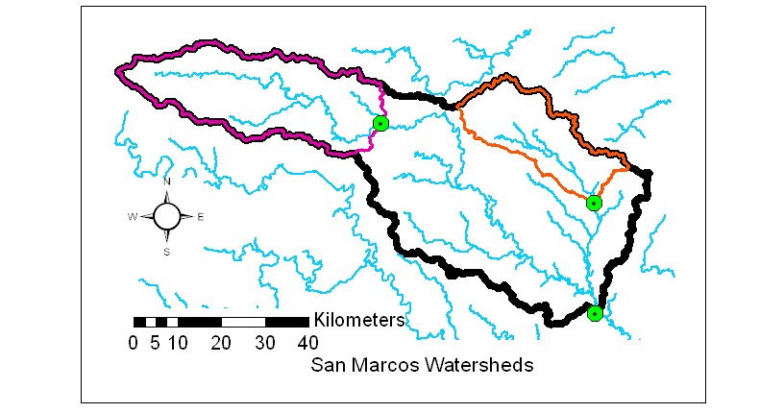
You do not need to burn in existing streams for this exercise, rather streams should be delineated based on the DEM alone. Prepare a table that for each watershed reports the following:
  - Name
  - Drainage area (km²)
  - Mean slope
  - Mean elevation (m)
  - Elevation range (Max elevation – Min elevation in m)
  - Relative relief (This is elevation range divided by the square root of the drainage area. Express this in dimensionless terms)
In summarizing this information over watersheds ensure that in the methods and functions that you use that you obtain results that pertain to each entire watershed recognizing the overlap, with the two smaller watersheds being contained within the larger one. The relative relief provides a dimensionless measure of the ruggedness of the topography. Prepare a layout where you depict the topography and watershed boundaries. Label the watershed with the highest and lowest relative relief and indicate whether these relative relief measures make sense given the topography.

- How does drainage density depend upon stream definition threshold? To address this question identify the most downstream monitoring point and use the watershed draining to this point to clip the DEM so that it contains only the area within this watershed.

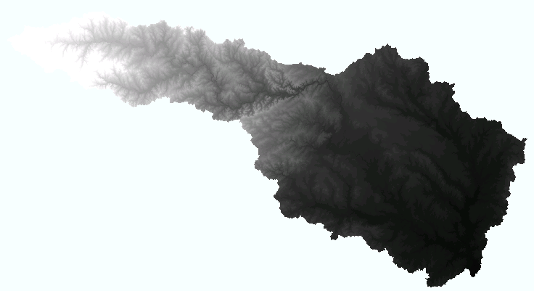

Delineate drainage lines over the clipped DEM for each of the following stream definition thresholds (in numbers of grid cells): 200, 500, 2000, 10000, 40000. Prepare a table that gives for each stream definition threshold the following:
  - Stream definition threshold (number of cells)
  - Stream definition threshold area (km²)
  - Total drainage line length
  - Number of drainage lines
  - Drainage area (km²)
  - Drainage density (km⁻¹)
Prepare a log-log plot of Drainage density, Dd, (y-axis) versus stream definition threshold area, Ac, (x-axis). Fit a power law relationship to this data and report the coefficients a and b in the equation (). Comment on whether the fitted equation is consistent with the dimensions (units) of the quantities plotted.

