Addendum to Exercise 2. Building a Base Map of the San Marcos Basin

GIS in Water Resources
Fall 2009
Prepared by David R. Maidment
During the presentation of Exercise 2 to the class on Thursday Sept 10, 2009, there were several questions raised during the section on Selecting the San Marcos Flowlines that led to some improvisation during the class. I thought that the path of enquiry we embarked on at that time is useful, and it is worth recording how to do these things properly. The point we had reached during the class was with a map appearing as follows. The green Basin boundary is produced by Dissolving the HUC12 watersheds using the single HUC8 = 12100203 attribute field which is common to all polygons in the San Marcos Basin.

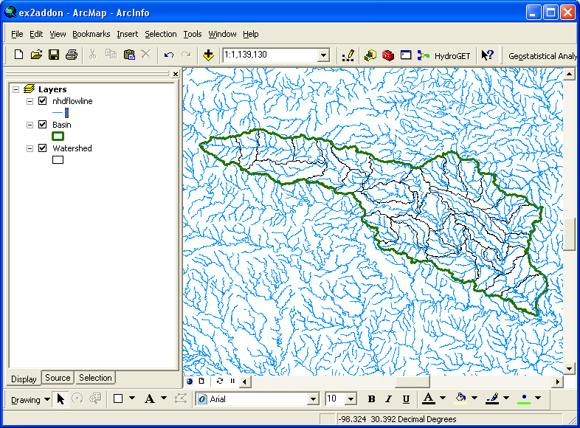

HUC8, HUC10 and HUC12 watersheds.

It is apparent by inspection of the Attributes of Watershed table, that the single HUC8 is broken down into five HUC10 units. One of these is HUC10 = 1210020301, that describes the upstream end of the San Marcos basin, and this in turn is broken into five subunits HUC12 = 121002030101, 121002030102, …. as illustrated below:

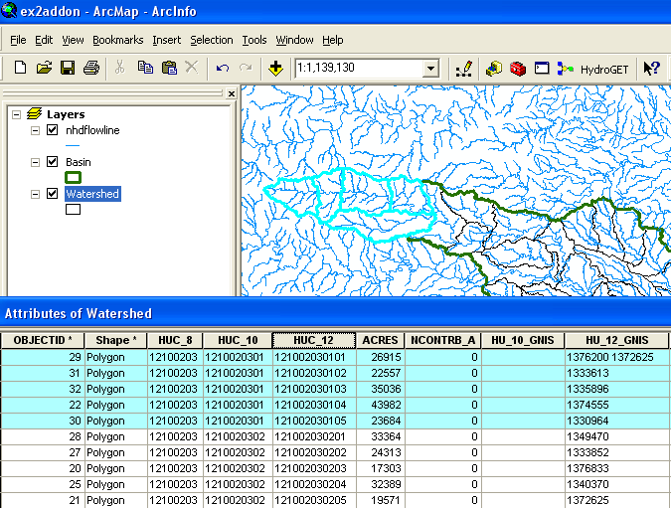

These HUC10 watershed units can be distinguished by shading them differently using the Symbology properties of the Watershed feature class:

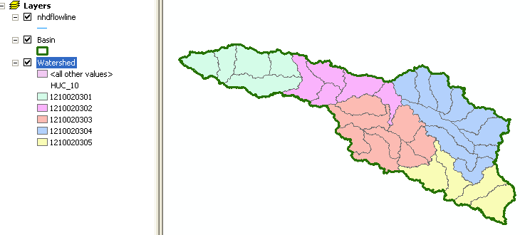

Strictly speaking, there are different terms for each level of HUC units, as given below, so HUC8 watersheds are called “Subbasins” and there are 2149 of them in the continental US, HUC10 units are called “Watesheds” and there are about 22,000 of them in the continental US, and HUC12 units are called “Subwatersheds” and there are about 160,000 of them in the continental US http://www.ncgc.nrcs.usda.gov/products/datasets/watershed/facts.html For our purposes, they are all variants on watershed definition, so perhaps its just best to call them “HUC.. watersheds” with the appropriate number like 8, 10 or 12 added in.

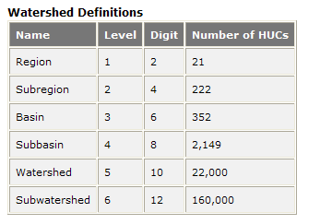

Using the Clip Function

In Exercise 2, the method of selection of the Flowlines within the San Marcos basin was to use a “Select by Spatial Location” to find all the nhdflowlines which have their center within the Basin feature class. Another way to do this is to use the Clip function. In Arc Toolbox, if you use the Index tab, and type Clip in the available window, you can choose the Clip (Analysis) option. I’ll call the resulting feature class Flowline1 to distinguish it from the one created originally:

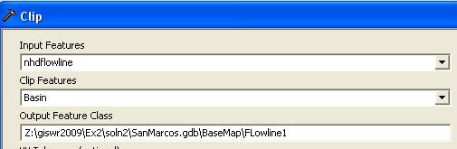

And this will Clip out only the flowlines within the San Marcos Basin. If there are portions of those lines falling over the Basin boundaries, they will be clipped off in this operation (as they were not when the alternative procedure using spatial selection was used).
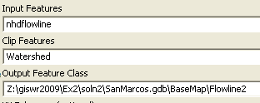

-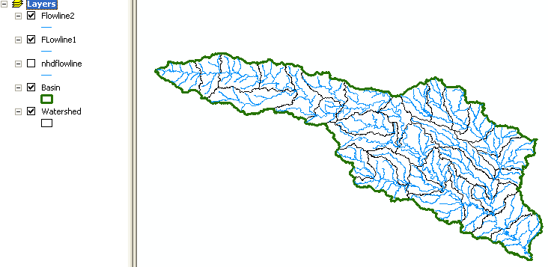
And if the Watershed feature class were used instead of the Basin feature class, the same result appears except that now all the Flowlines are also clipped at the boundary of each HUC12 watershed instead of just at the basin boundary.

I did some additional investigation of the Spatial Join functions that we briefly explored in class with the goal of being able to assign the attributes of the watersheds that surround a set of flowlines to the lines within them, but I was not able to do this with complete satisfaction. I think the Spatial Join method works best with a set of points that lie completely within a set of polygons. When there are lines involved, there are enough ambiguities where lines touch polygon boundaries that just which lines are connected to which polygons becomes a bit complicated.

