GPS EXERCISE
GIS in Water Resources
Fall 2009
Prepared by Ayse Irmak
Dept of Civil Engineering
University of Nebraska
The purpose of this exercise is to bring GPS data into the ARCGIS environment and also to display this data in Google earth. For this exercise, I collected the coordinates of Mabel Lee Hall where our class is conducted. The figure below shows a map of the city campus of the University of Nebraska, Lincoln. Our classroom is located in Mabel Lee Hall, room 128.
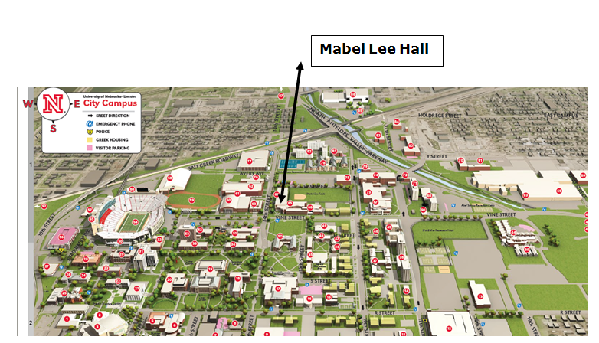

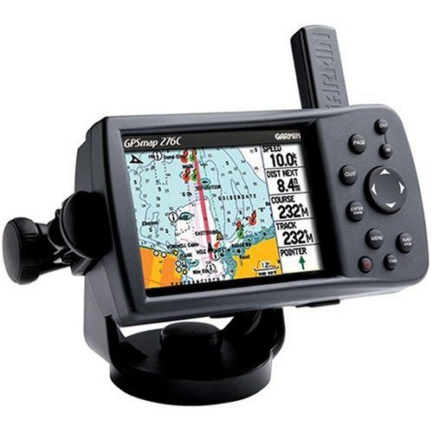
The GPS points of the four corners of Mabel Lee Hall were collected with a Garmin GPSMAP 276C GPS Receiver, as shown above, and the data are as follows:
ID | LATITUDE | LONGITUDE
N1 | 40.8223370 | -96.7010490
N2 | 40.8223370 | -96.7006550
S3 | 40.8213370 | -96.7010370
S4 | 40.8213410 | -96.7006460

Bringing the data into ARCGIS and converting it to a Shapefile
Create an Excel 2003 file containing the coordinates of the desired location in decimal degree format. In ArcGIS, from the “TOOLS/Add X-Y data” menu add the spreadsheet table to your map display.
Select “Coordinate system Geographic Coordinate system World WGS 1984.prj” This will display the co-ordinates in the current ArcGIS frame.
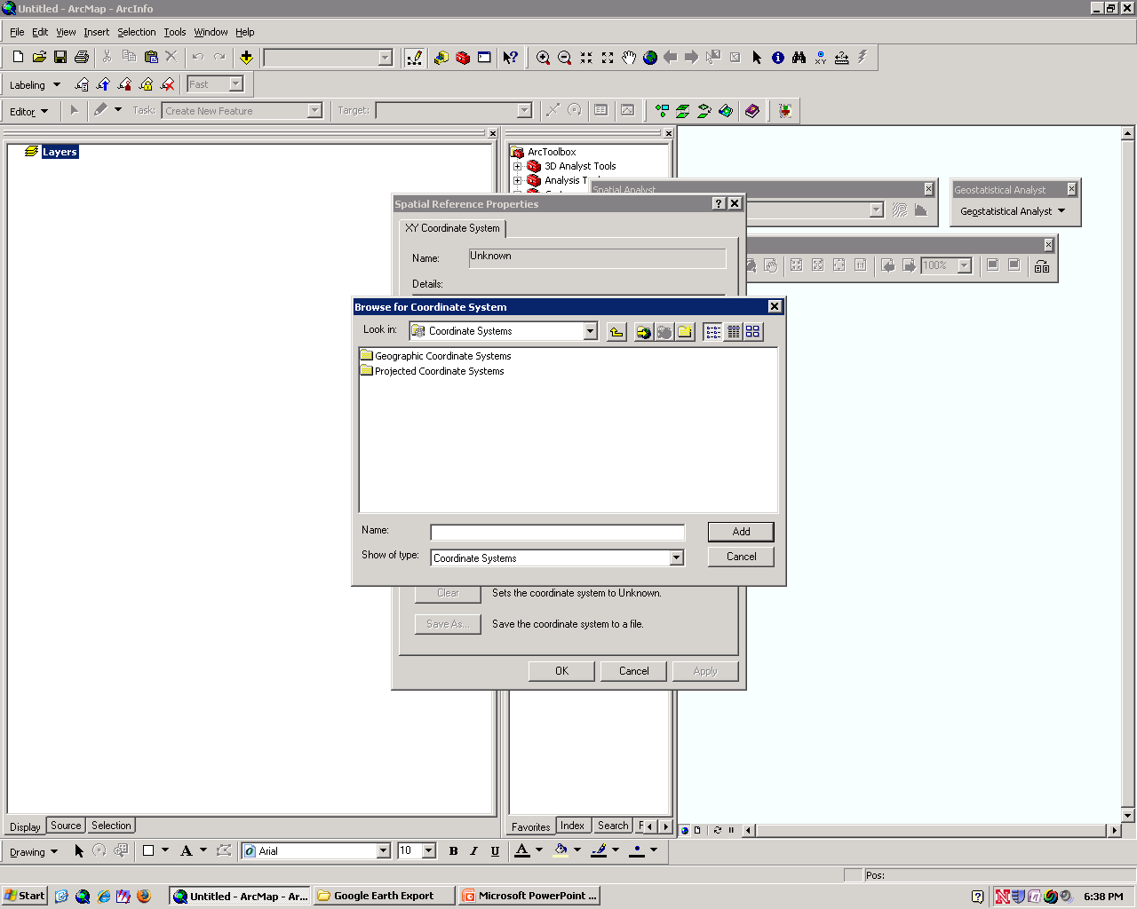
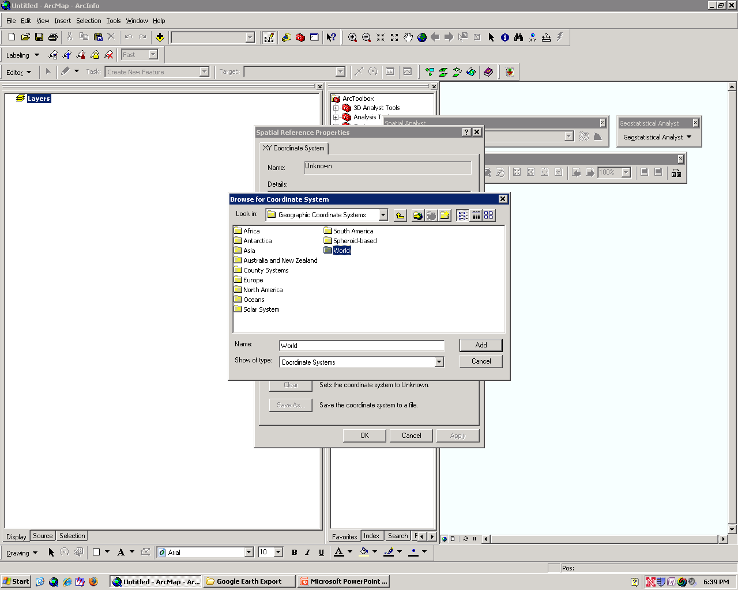
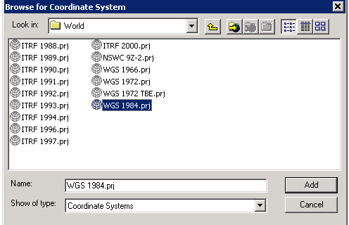

Export this to shapefile format by using Data/Export data tool, and call the resulting shape file Coordinates. Add this shape file to your ArcMap display
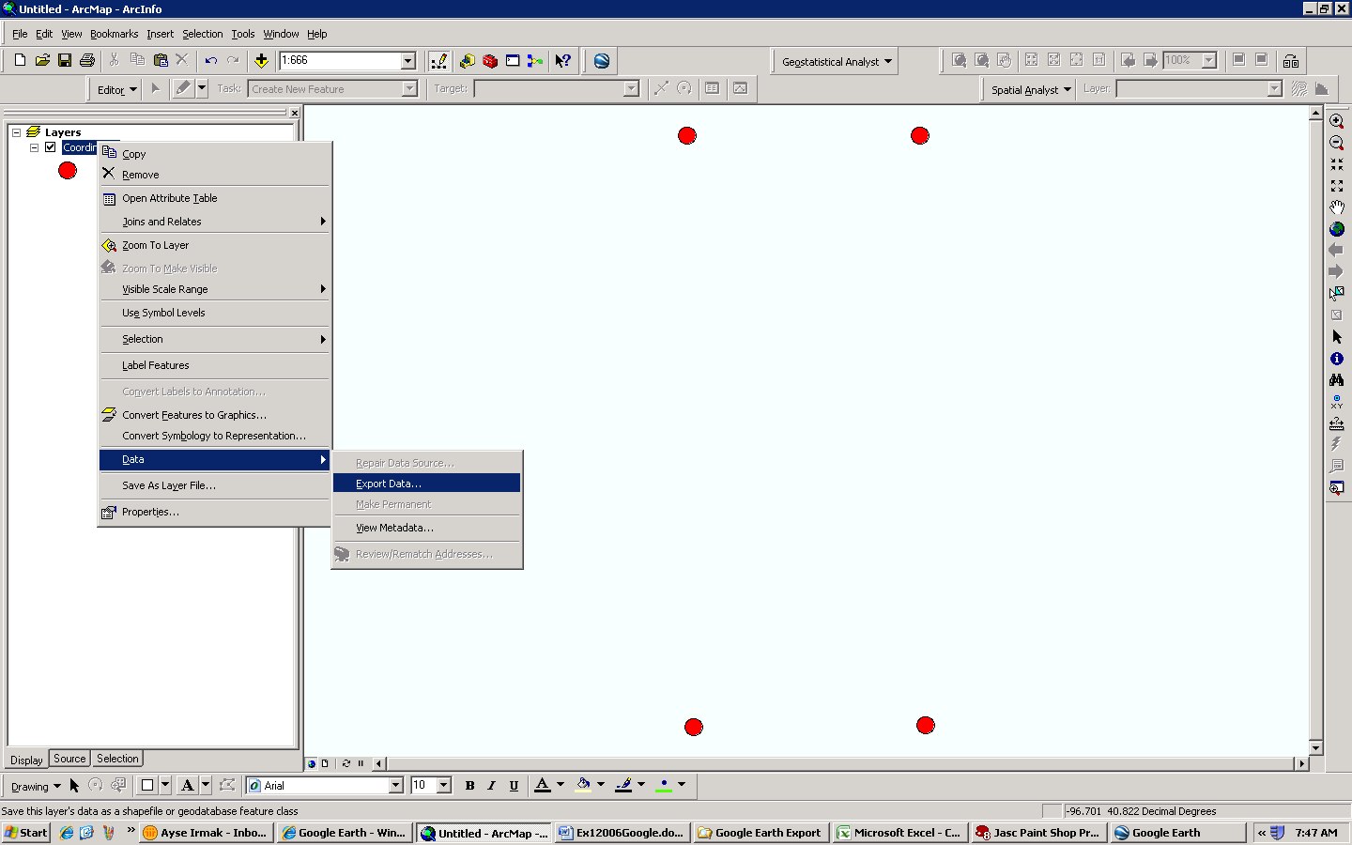
Once your Coordinates points are displayed, Use File/Add Data from ArcGIS Online to add World Imagery to your map display, and you’ll see your points displayed over an image of Mabel Lee Hall!

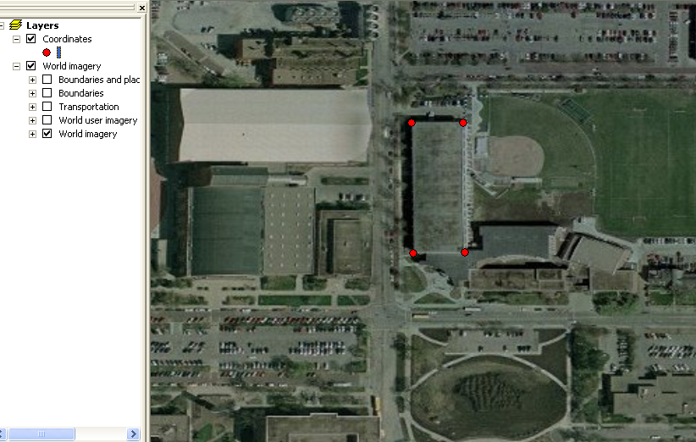

Converting the Shapefile to a KML file
Open that shapefile and export it as “KML” format using Conversion tools (Layer to KML) under the Analysis toolbar. Use “Mabel-Lee_UNL” for the Output file Name. Use”1” for the Output file scale.
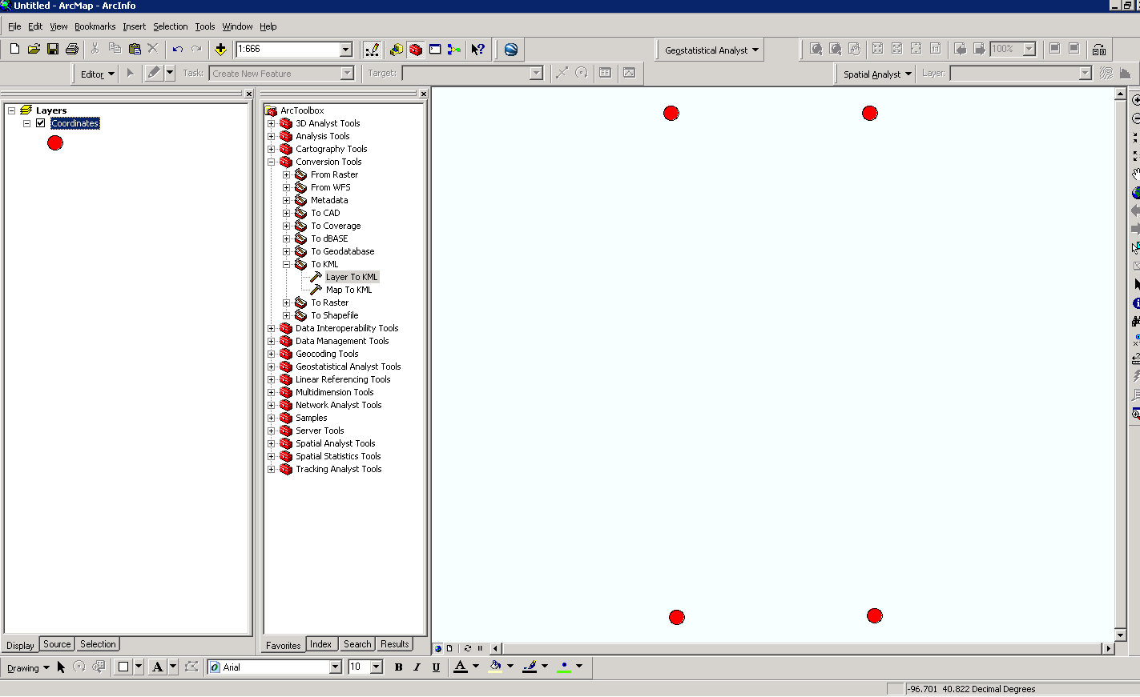
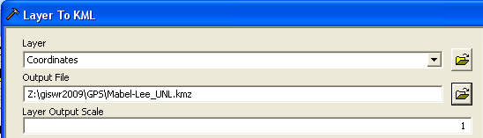
This conversion will create the KML file, Mabel-Lee_UNL. Kmz This file is not too comprehensible but it refers to an XML file called Coordinates.kml that has the data in it in a readable form:
Content of Coordinates.kml
<?xml version="1.0" encoding="UTF-8"?>
<kml xmlns="http://www.opengis.net/kml/2.2" xmlns:gx="http://www.google.com/kml/ext/2.2" xmlns:kml="http://www.opengis.net/kml/2.2" xmlns:atom="http://www.w3.org/2005/Atom">
<Document>
<name><![CDATA[Coordinates]]></name>
<open>1</open>
<Snippet maxLines="0"><![CDATA[]]></Snippet>
<description><![CDATA[Exported from Coordinates on 9/14/2009]]></description>
<Style id="FEATURES">
<IconStyle>
<color>FF00ABA5</color>
<scale>0.333333333333333</scale>
<Icon>
<href>root://icons/palette-4.png</href>
<x>32</x>
<y>128</y>
<w>32</w>
<h>32</h>
</Icon>
</IconStyle>
<LabelStyle>
<color>00FFFFFF</color>
</LabelStyle>
<BalloonStyle>
<text>
</text>
</BalloonStyle>
</Style>
<Folder>
<name>Features</name>
<open>0</open>
<Placemark>
<name><![CDATA[1]]></name>
<Snippet maxLines="0"><![CDATA[]]></Snippet>
<styleUrl>#FEATURES</styleUrl>
<Point>
<extrude>0</extrude>
<altitudeMode>clampedToGround</altitudeMode>
<coordinates>
-96.701049,40.822337,0
</coordinates>
</Point>
</Placemark>
<Placemark>
<name><![CDATA[2]]></name>
<Snippet maxLines="0"><![CDATA[]]></Snippet>
<styleUrl>#FEATURES</styleUrl>
<Point>
<extrude>0</extrude>
<altitudeMode>clampedToGround</altitudeMode>
<coordinates>
-96.700655,40.822337,0
</coordinates>
</Point>
</Placemark>
<Placemark>
<name><![CDATA[3]]></name>
<Snippet maxLines="0"><![CDATA[]]></Snippet>
<styleUrl>#FEATURES</styleUrl>
<Point>
<extrude>0</extrude>
<altitudeMode>clampedToGround</altitudeMode>
<coordinates>
-96.701037,40.821337,0
</coordinates>
</Point>
</Placemark>
<Placemark>
<name><![CDATA[4]]></name>
<Snippet maxLines="0"><![CDATA[]]></Snippet>
<styleUrl>#FEATURES</styleUrl>
<Point>
<extrude>0</extrude>
<altitudeMode>clampedToGround</altitudeMode>
<coordinates>
-96.700646,40.821341,0
</coordinates>
</Point>
</Placemark>
</Folder>
</Document>
</kml>

If you click on this Mable-Lee_UNL.kmz file, it will take you to the location of the Mabel-Lee building on the Google Earth. This requires that you have Google Earth installed on your computer, and that the computer recognize .kml as requiring Google Earth. If you don’t have Google Earth, you can get it from http://earth.google.com/ Then you can just activate Google Earth and select File/Open to get the Mable-Lee_UNL.kmz file and you’ll see your map display zoom in on Mabel Lee Hall! Pretty cool!

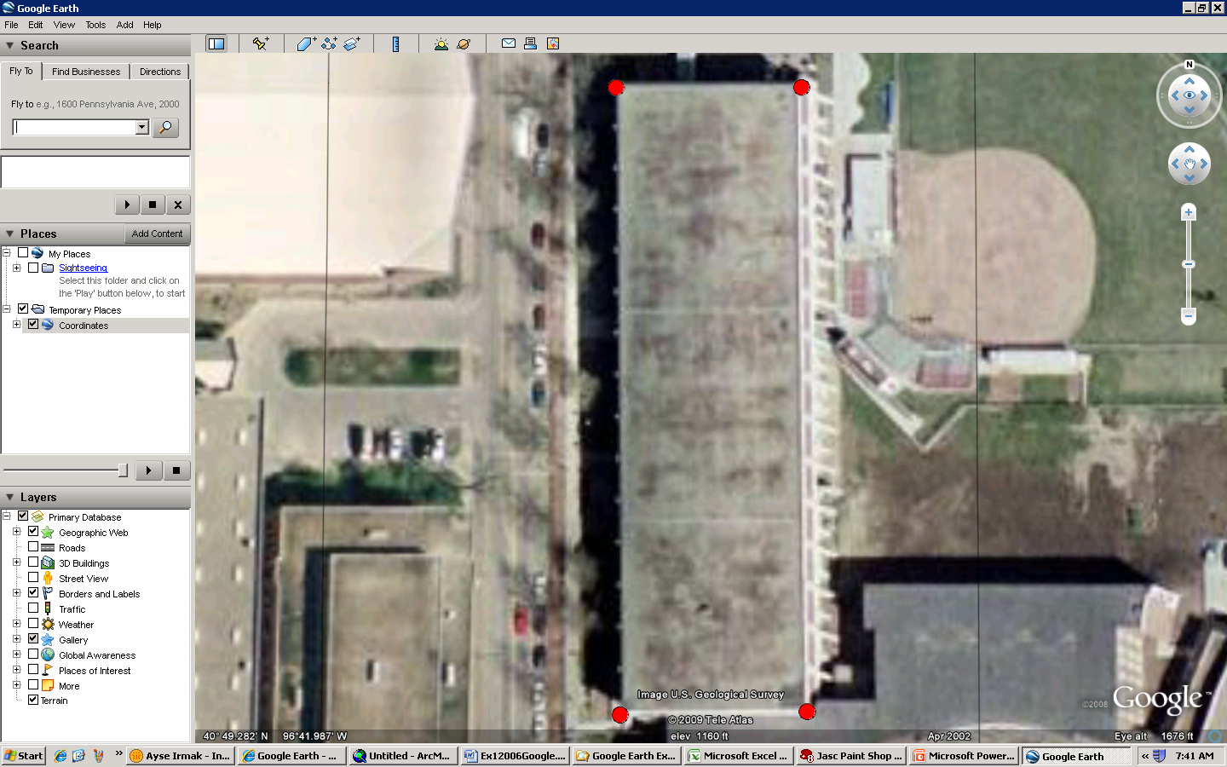

To be turned in: Two images of Mabel Lee Hall showing the GPS points of its corners, one created from ArcMap and the other from Google Earth.

