HIS Demo Steps

Introduction
Methods for programmatically acquiring observations data from WaterOneFlow web services are new. Therefore, CUAHSI HIS has developed several applications that provide a user-friendly interface for accessing WaterOneFlow. These applications are written for many of the software packages commonly used by hydrologists, including web browsers, Excel, ArcGIS, and MATLAB. These demo's introduce a few of these applications.

Links:
All HIS components
http://his.cuahsi.org/components.html

HydroSeek
HydroSeek is a data discovery tool that provides integrated federated search capability across multiple data sources (universities and federal agencies) that have WaterOneFlow web services through a single interface. It combines spatial, temporal and thematic aspects of search in order to make it possible to more effectively discover data despite heterogeneity issues among data repositories. It allows data discovery using keywords from an ontology which maps variables as defined by each data source to higher level searchable concepts. In short, HydroSeek is designed to provide a one-stop search center in which a user can query for specific data groups across a large data inventory regardless of the storage and description conventions used by the respective warehouses.

Links:
HydroSeek
http://his.cuahsi.org/hydroseek.html

Procedure:
In this demo, the user queries for turbidity data in the Great Basin Region with Hydroseek. The user demonstrates intellisense-style variable searches, and the identification of specific instances of a variable across observation networks.
- Open a web browser.
- Navigate to http://www.hydroseek.net/.
- For keyword, type Turbidity.
- Change watershed to Great Basin Region.
- Press ENTER.
- Show variables on the right.
- Hover mouse and see details.
- Add data to cart.
- Change the keyword to Streamflow, and press ENTER.
- Add a couple sites to the cart.
- Show data cart.
- Download cart.

HydroExcel
HydroExcel is an Excel spreadsheet programmed with macros and HydroObjects so that it can communicate with WaterOneFlow web services. To give the audience an idea of how web services can be used, the presenter will download data from web services using HydroExcel.

Links:
HydroObjects
http://his.cuahsi.org/hydroobjects.html

HydroExcel
http://his.cuahsi.org/hydroexcel.html

Procedure:
In the demo, the user downloads site, variable, and time series data for a few academic observation networks. Google Earth capability is also demonstrated.
- Open HydroExcel. Briefly show that Introduction worksheet gives instructions.
- Switch to Data Source worksheet. Show that national and academic investigator data sources are provided.
- Click Get Capabilities.
- Click Open Web Service Page.
- Click the page for more information.
- Click Get Variables.
- Switch to Sites worksheet. Set show sited in Google Earth after download to TRUE. Click Get Sites to get sites for the Little Bear River.
- Click around Google Earth. Show simple site information for each placemark.
- Turn off network in Google Earth.
- Switch to Site Info worksheet. Use LittleBearRiver:USU-LBR-Mendon. Click Get Site Info.
- Switch to Series Catalog worksheet.
- Set to get site list from worksheet, and to show result in Google Earth.
- Click Get Site Catalog.
- Make sure Excel is active, and show site catalog.
- Switch to Google Earth, and show extended site information for placemarks.
- Show sites by Temperature variable. Show timing of network buildout with time simulation.
- Switch to Site Summary worksheet. Filter sites by Temperature. Show that USU-LBR-Mendon has lots of Temperature data.
- Switch to Time Series worksheet. Click Get Values for USU-LBR-Mendon.
- Switch to Statistics and Charts worksheet. Show chart with Hour of Day. Switch back to DateTime.
- Switch to Data Source worksheet. Change source to COTCsnow.
- Click Get Sites.
- Switch to Data Source worksheet. Change source to CC Bay.
- Click Get Sites.
- Switch to Data Source worksheet. Change source to NWIS Unit Values.
- Switch to Time Series worksheet. Set parameters as:
nwis:08158000
nwis:00060
7/1/2008
7/17/2008
- Click Get Values.
- Switch to Statistics and Charts worksheet. Show chart with DateTime and Hour of Day.

HIS Server
HIS Server is a computer server that contains a collection of datasets, web services, tools, and software applications that allow data producers to store, publish, and analyze space-time hydrologic datasets. HIS Server is designed to permit local control of the data, while still being part of a distributed, national/international system allowing universal access to the data.

Links:
http://icewater.usu.edu/map. Show capabilities of HIS Server map server. The full contents of this map are dynamically generated from HIS Server capabilities database. The display combines points from ODM and two spatial data services from ArcGIS server

http://littlebearriver.usu.edu/ This is an example of a HIS Server website. Show monitoring sites, current conditions, data applications

Some ArcGIS Server spatial data services
http://maps.usu.edu/arcgis/rest/services

HydroDesktop
HydroDesktop is a local application that accesses and acquires data from web services, allows for the addition of local files that the user already has available, and provides an open source platform for hydrologic scientists to build hydrologic analysis applications and links to hydrologic models.

Links:
Software
http://hydrodesktop.codeplex.com

Development Project Description
http://his.cuahsi.org/hisdesktop.html

Procedure:
- Launch HydroDesktop
- Search and Download data
  - Search HIS Central
  - Select County (Cache - Utah)
  - More Options – Select Keyword (Streamflow, Turbidity)
  - More Options – Select date range
  - More Options – Select Web Services (Selections below)
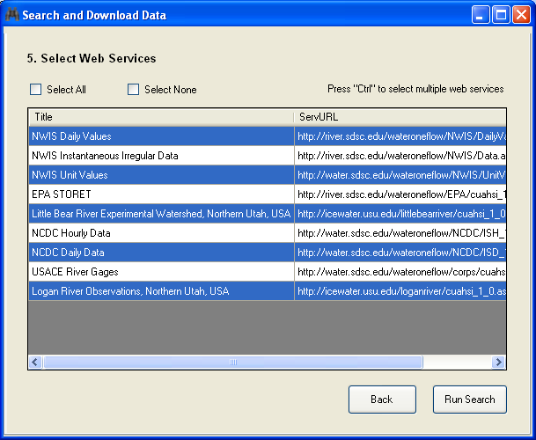
  - Run Search
  - Once results are returned, switch to table, to download data
  - Select series
  - Select theme name and download data
- Zoom in map and see feature data
- Switch to graph view and plot data
- Switch to table view and see data
- Show turning on and off Graph View as an Extension/Plugin.
.

