GIS in Water Resources

Fall 2009

Homework #1

Assigned reading

ArcGIS Desktop 9.3 Online Help

- Fundamentals of GIS: http://webhelp.esri.com/arcgisdesktop/9.3/index.cfm?TopicName=Three_views_of_GIS
- Map projections and coordinate systems: http://webhelp.esri.com/arcgisdesktop/9.3/index.cfm?TopicName=An_overview_of_map_projections

1. GPS Mapping

Go through the GPS Exercise and complete the items to be turned in, which are: two images of Mabel Lee Hall showing the GPS points of its corners, one created from ArcMap and the other from Google Earth.

2. Map Projection Parameters

The map below shows Utah and the display parameters of the State Plane coordinate system for the Utah Central Zone.

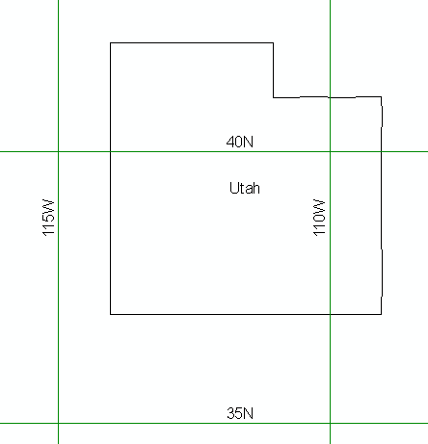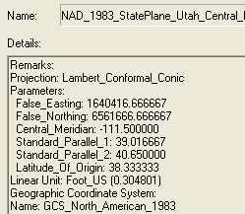

(a) Sketch on the map the standard parallels, the central meridian and the latitude of origin of this projection.

(b) For this projection, what are the coordinates of the origin (φ_{o}, λ_{o}) and the corresponding (X_{o}, Y_{o}) ?

(c) What earth datum is used in this coordinate system?

(d) What map projection is used in this coordinate system?

3. Distances on the Earth

Following are the geographic coordinates of the 3 cities involved in this class.
City | Latitude | Longitude
Logan | 41.7355 | -111.8344
Lincoln | 40.8000 | -96.6670
Austin | 30.2671 | -97.7431

a) Calculate the great circle "curved earth" distance between each combination of cities (i.e. Logan to Austin, Austin to Lincoln and Lincoln to Logan). Assume a spherical earth with radius 6370 km.

b) Use ArcGIS to display these cities using the USA Contiguous Equidistant Conic projection. For this projection report the following parameters:
Central_Meridian:
Standard_Parallel_1:
Standard_Parallel_2:
Latitude_Of_Origin:

c) Determine the X and Y coordinates of each city using the USA Contiguous Equidistant Conic projection. Report your results in a table.

d) Calculate the distance between each combination of cities from the USA Contiguous Equidistant Conic projection X and Y coordinates.

e) Optional extra challenge: If you are familiar with MATLAB use the script from MATLAB file exchange linked on the last page of the EarthDistance.doc handout to compute the distance between each pair of cities on the WGS84 Ellipsoid.

f) Comment on the differences in distances between the cities calculated using different methods and assess which set of distances is most accurate.

