Exercise 2 Solution
GIS in Water Resources
Fall 2010
Prepared by David R. Maidment
- A screen capture of the NHDFlowlines and WBD watersheds is shown below. I used the Draw tools in ArcMap to draw a box around the features, and then I noted the coordinates of the lower left and upper right corners of the box by moving the cursor to those locations and reading the values from the display in ArcMap. Notice how the coordinates in decimal degrees are given as signed numbers without any N or W labels. So, we can say that the map extent is defined by a box whose horizontal extent is from 108.061°W to 92.903°W and whose vertical extent is from 37.301°N to 25.468°N.
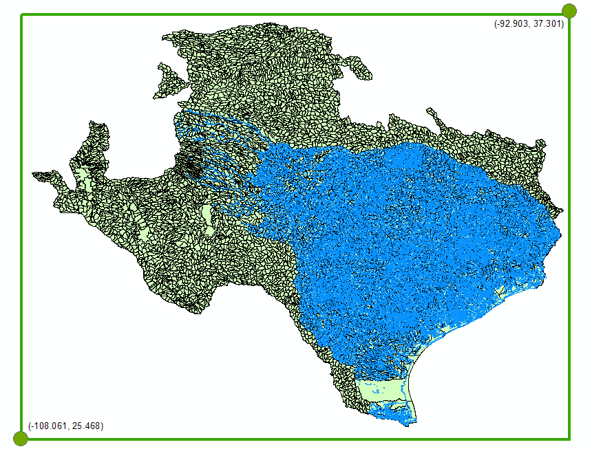

- The HUC12 Subwatersheds in the San Marcos Basin are shown below.
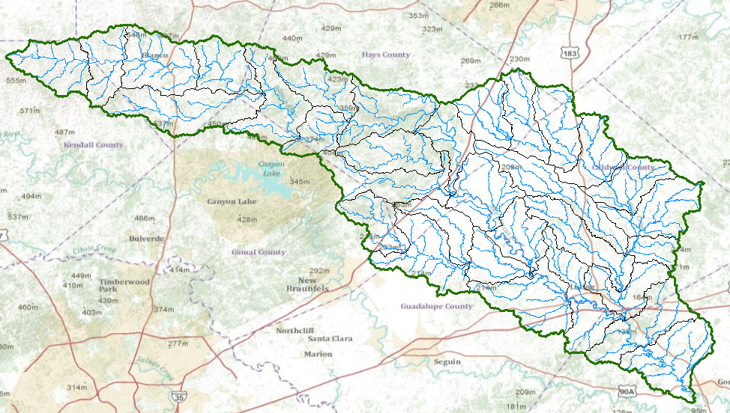
If we open the Attribute Table of the Watershed feature class, we’ll find there are 32 HUC 12 Subwatersheds in it.
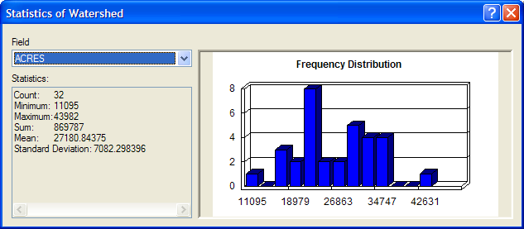
The Statistics summary of the ACRES attribute of this feature class is shown above, and the average area is given by the Mean statistic as 27180 acres, or 27180 * 0.0040469 km² = 109.99 or 110 km². The total area of the San Marcos Basin is given by the Sum statistic, which is 869787 acres, or 3519.9 km². A similar Statistics computation on the Flowline feature class shows that the Sum or Total Length of flowlines is 1888.4 km . Hence the Drainage Density = 1888.4/3519.9 = 0.536 km⁻¹. This means that there is about half a kilometer of streams to each square kilometer of watershed in these 1:100,000 scale stream data. There is a greater length of streams in more detailed 1:24,000 stream data, which we are not using for this exercise.
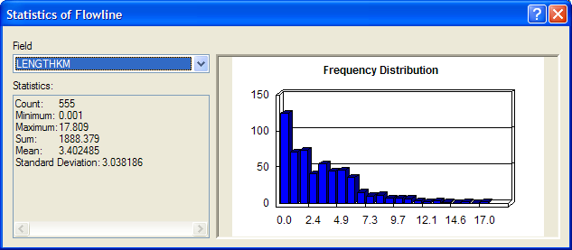

- A screen capture showing the San Marcos Basin and streams sized according to mean annual flow, with labels for the Blanco River, the San Marcos River and Plum Creek, is shown below.
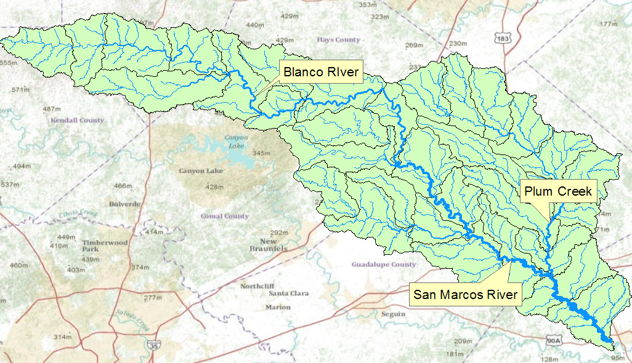

- A layout showing the base map and chart for the San Marcos River flows is shown below
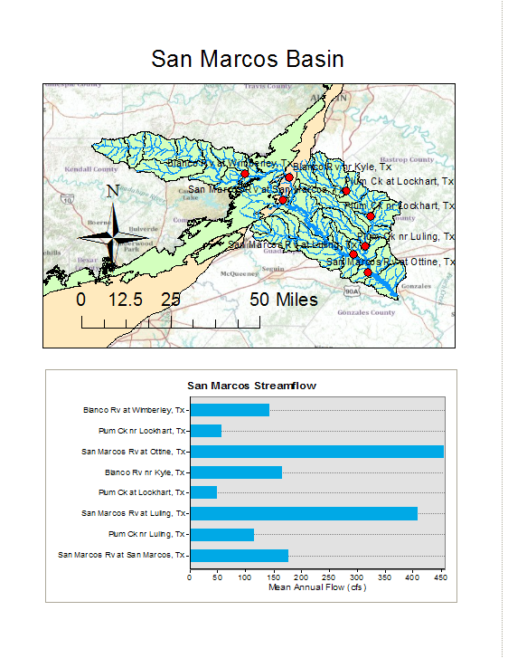
- The outcrop area of the Edwards Aquifer crosses the Blanco River between the gages at Wimberley and Kyle. The mean annual flows and drainage areas for these gages are shown below
Gage | Mean Annual Flow (cfs) | Drainage Area (Sq. Miles) | Mean Annual Flow (cfs) for period of record to 2009
Blanco River at Wimberley | 142 | 355 | 143.3
Blanco River at Kyle | 165 | 412 | 164.0
I looked up some statistics of these two gages on the USGS water web site “Streamflow Statistics Retrieval Site” http://water.usgs.gov/waterwatch/?m=sitempnn&r=us&w=real%2Cmap In doing so, I found the drainage area in square miles for each gage site, and also an updated mean annual flow to 2009, whose figures differ little from the ones given in the exercise that I got from a USGS streamflow data book many years ago. Now, with these data, we can say that the flow per unit drainage area for the Blanco River at Wimberley is 143.3/355 = 0.403 cfs/sq mile. On this basis, we should expect that the mean annual flow at Kyle would be approximately equal to 412 * 0.403 = 163 cfs. The actual mean annual flow at Kyle is 164 cfs! So, we really can’t see any impact of the Edwards Aquifer on the flows between these two gages.

