Student Installation of ArcGIS 10.1 for GIS in Water Resources
University of Texas at Austin

Prepared by David R. Maidment
September 2012

There are five steps to this process:
(1) Get an ESRI Global Account
(2) Prepare your computer and download the software
(3) Obtain and register a software authorization number
(4) Install the software and validate your authorization number
(5) Start using the software

Here are the instructions for these steps:

(1) ESRI Global Account

If you already have a Username and Password for your ESRI Global Account, then skip this step.

If not, go to https://webaccounts.esri.com/CAS/index.cfm and choose Create an Account. You’ll be presented with a large screen with a lot of information that needs to be filled in. Fill out this screen and choose Create Account at the bottom. This will establish your User Name and Password for ArcGIS Online and for validating your software. If you have not yet emailed me your ESRI Global Account username, please do so now.

(2) Prepare Your Computer and Download the Software

(a) Check the ESRI System Requirements to make sure your computer has the required hardware and software to support the installation of ArcGIS http://resources.arcgis.com/content/arcgisdesktop/10.0/arcgis-desktop-system-requirements
Requirement Be careful to ensure that your computer has the right operating system and also the necesssary Service Packs installed for that operating system. If you’ve had your computer for a long time and not installed any Service Pack updates, your operating system might not be up to date enough to run ArcGIS Desktop.

(b) If necessary, install the Microsoft .NET Framework. http://www.microsoft.com/NET/

(c) If you already have a previous version of ArcGIS Desktop installed on your computer, you’ll need to Uninstall it before installing the new one. To do this, Go to Control Panel/Programs and Features and right click on the icon for ArcGIS and follow the Uninstall instructions.

(d) Enable your UT EID for Engineering Resources: You will need to enable your UT EID for Engineering resources to access this folder. You need to do same thing to access the CAEE Learning Resource Center. If you already have access to the CAEE LRC, then you won’t need to do this. Here is the link to enable your EID: https://apps.engr.utexas.edu/dnapps/EnableAccount

Install VPN: Once you have enabled your account, you will need to install VPN.
In Internet Explorer, enter the following URL: https://vpn.utexas.edu
- Log in with your UT EID and password.
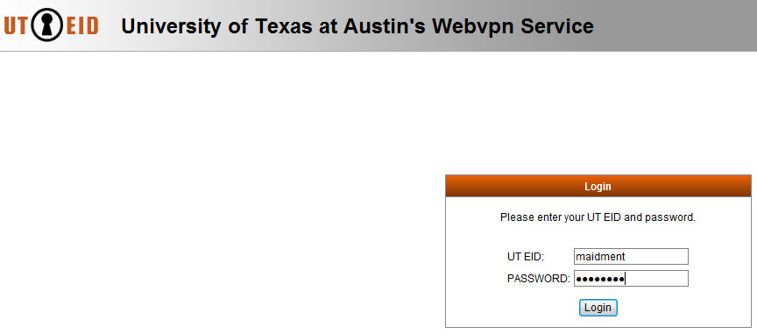
- Follow the instructions for the AnyConnect Secure Mobility Client. It will need to install some software on your computer.
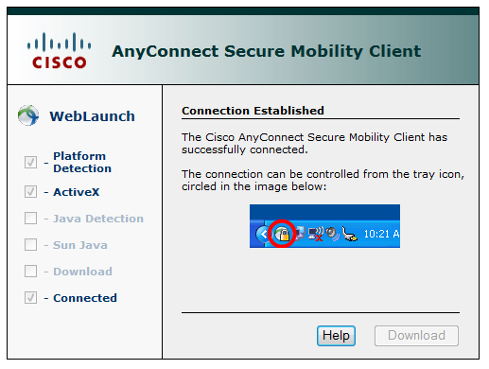

Connect to the File Server and Download the ArcGIS software
- Right-click on Computer (Start>Computer Right-click)
- Select Map Network Drive. (Left-click)
- Enter Folder: \\austin.utexas.edu\disk\engrstu\ class\CAEE\GISWR
- Select the checkbox: Connect using different credentials.
- You will be asked for a username and password.
  - Username: austin.utexas.edu\yourEID
  - Password: <Enter your EID password>

Copy the folder, ArcGIS Desktop, to your computer
This consists of a single file:

If you don’t succeed in mapping the network drive and finding this file, then download the ArcGIS Desktop software directly from ESRI Education as indicated in Step 3.

(3) Obtain and Register a Software Authorization Number

I will send you a software authorization number with the form EVA123456789. This allows you to use one copy of the ArcGIS Desktop software and its extensions for one year on your own computer. Go to ArcGIS for Desktop Student Trial
http://www.esri.com/landing-pages/software/arcgis/arcgis-desktop-student-trial.html

and login with the Username and Password for your ESRI Global Account. You’ll be asked to input your Authorization Number and then Activate ArcGIS.

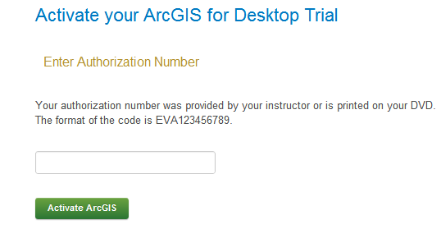
You’ll be presented with a screen which allows you to download the ArcGIS Desktop software directly from ESRI, but they prefer that it be downloaded from a local source at UT Austin, as is explained in Step 2.

If you did not succeed in downloading the software in Step 2, download it from the ArcGIS for Desktop Trial:

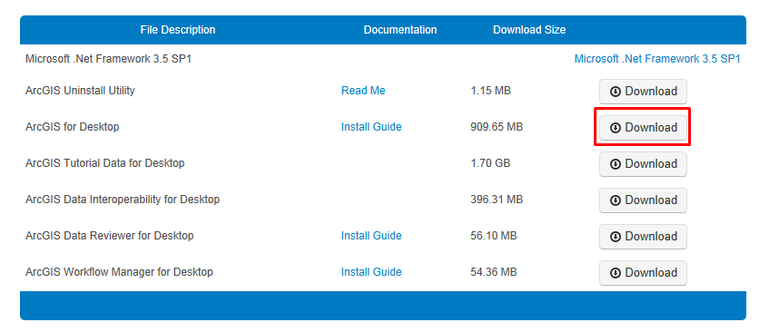

(4) Install the Software and Validate your Authorization Number

Double click on the file ArcGIS_Desktop_101_129796.exe and install it on your computer. This takes quite a while, so you might want to get a cup of coffee or do something while the installation goes on.

Immediately that your software installation has been completed, you’ll be presented with a ArcGIS Administrator Wizard screen. Select Advanced (ArcInfo) Single Use and you’ll see the button, Launch the Authorization Wizard for Single Use Products be activated.

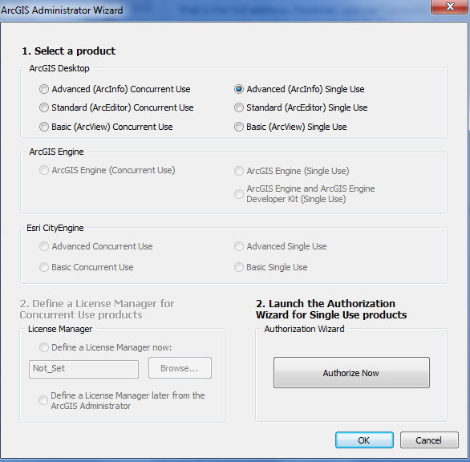

Hit Authorize Now and enter your Authorization Number

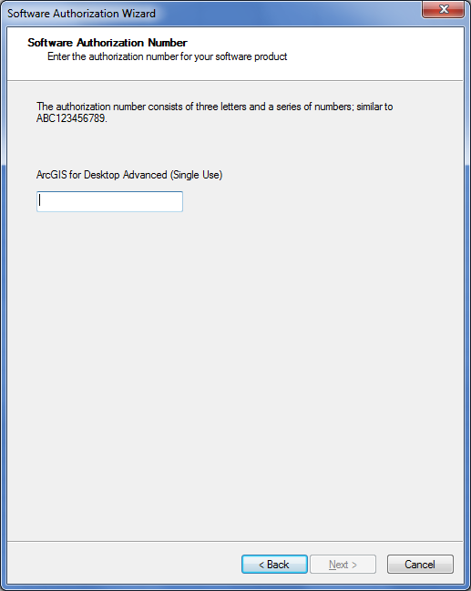

Enter the same Authorization Number to license the extensions to ArcGIS Desktop. You can license all the extensions if you want to. We’ll use Spatial Analyst and 3D Analyst in the class exercises.
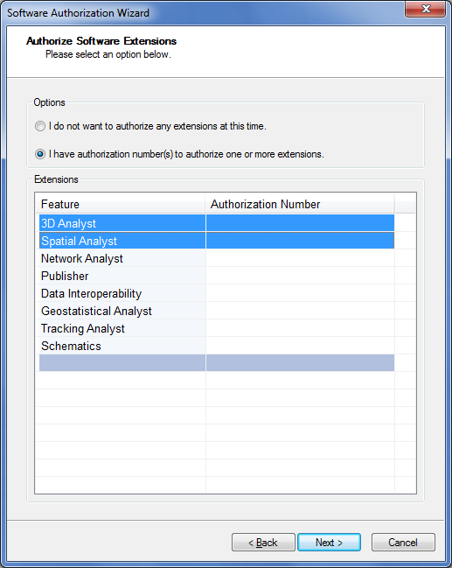

Finish this process and you are done!

5. Start Using the Software

If you use the Windows button and access All Programs, you’ll see a section for ArcGIS, within which you can launch ArcMap, which is the main interface to ArcGIS Desktop. You’ll learn how to use this in Exercise 1 of the class.
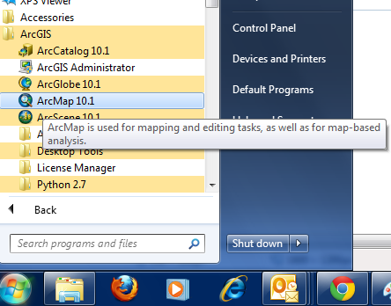

Ok, you are good to go now!

