Exercise 2. Building a Base Dataset of the San Marcos Basin

GIS in Water Resources
Fall 2012
Prepared by David R. Maidment and David G. Tarboton
- Goals of the Exercise
- Computer and Data Requirements
- Procedure for the Assignment
  - Getting started
  - Selecting the Watersheds in the San Marcos Basin
  - Creating a San Marcos Basin Boundary
  - Soil information for the San Marcos Basin
  - Selecting the San Marcos Flowlines
  - Adding Attributes to the Flowlines
  - Creating a Point Feature Class of Stream Gages
  - Overlaying the Edwards Aquifer
- Summary of items to be turned in

Goals of the Exercise
This exercise is intended for you to build a base data set of geographic information for a watershed using the San Marcos Basin in South Texas as an example. The base dataset comprises watershed boundaries and streams from the National Hydrography Dataset Plus (NHDPlus) and soils from the SSURGO soils database. A geodatabase is created to hold all these primary data layers. In addition, you will create a point Feature Class of stream gage sites by inputting latitude and longitude values for the gages in an Excel table that is added to ArcMap and the geodatabase. You also compare the locations of the San Marcos basin surface boundaries, and the Edwards aquifer subsurface boundaries.

Computer and Data Requirements
To complete this exercise, you'll need to run ArcGIS 10.1 from a PC. You will download map packages of hydrologic and soils information to do this exercise from ArcGIS Online. If you have trouble accessing these packages, there is a backup at http://www.caee.utexas.edu/prof/maidment/giswr2012/Ex2/Ex2Data.zip

NHDPlus data for the United States that can be downloaded over the internet: http://www.horizon-systems.com/nhdplus/ The current status of available information is depicted in this map:

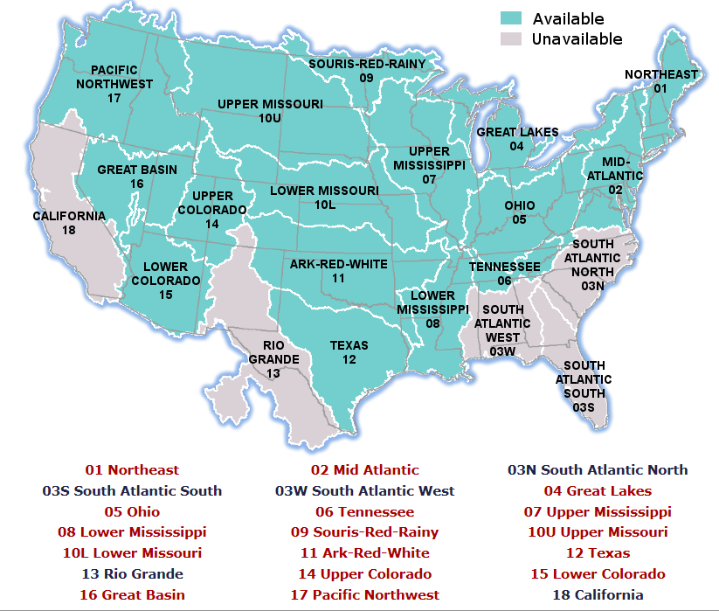

In this instance, we need information from Water Resource Region 12 that covers most of Texas. We are going to use information from the NHDSnapshot, NHDPlusAttributes, and WBDSnapshot datasets.

http://www.horizon-systems.com/NHDPlus/NHDPlusV2_12.php

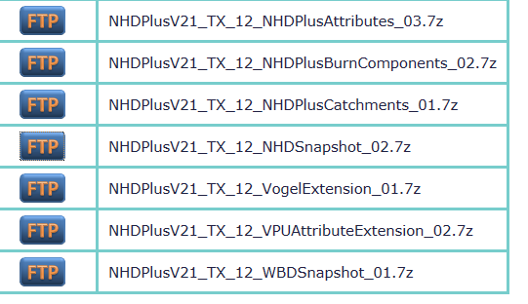
The needed files can be accessed as a Map Package called Region12NHDPlus that is indexed by the tag giswr2012ex2 in ArcGIS Online. Make sure when you search for this, that you have “Show:All Content” rather than Show: Web Content Only in ArcGIS Online.

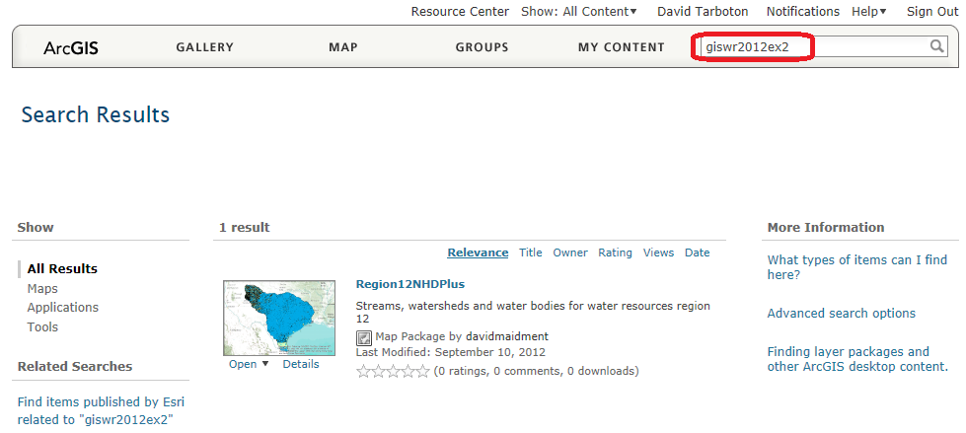

Procedure for the Assignment

Getting Started
We’ll begin by getting the input data for Water Resource Region 12, and creating a new, empty geodatabase into which you’ll put data for the San Marcos basin, which is a small drainage area within this region.

Once you have located the map package Region12NHDPlus in ArcGISOnline using the tag giswr2012ex2 open it in ArcGIS
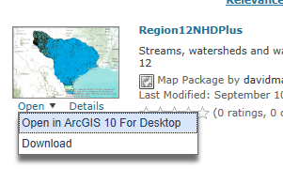
and you should see a display like this
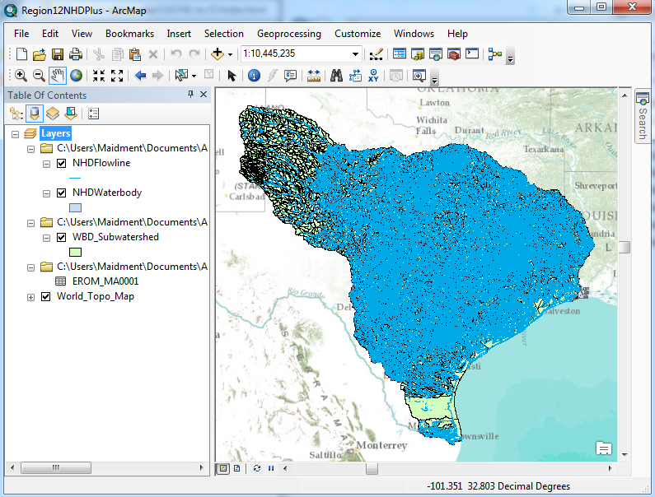
From ArcMap, open ArcCatalog, navigate through Folder Connections to a place where you want to have a workspace,
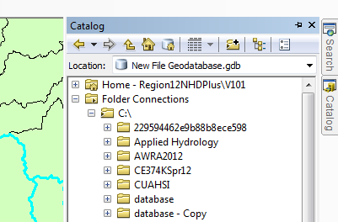
and create a new File Geodatabase:
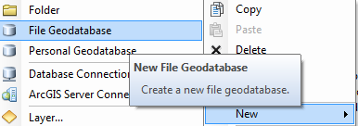
And call this SanMarcos.gdb. Within this, create a new Feature Dataset
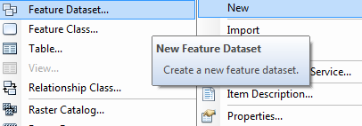
and call it BaseData
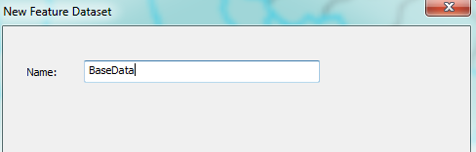
choose a Geographic Coordinate System
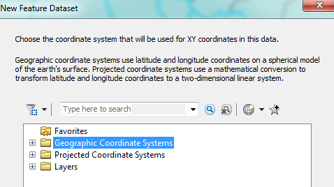
within North America,
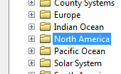
select the NAD83 coordinate system
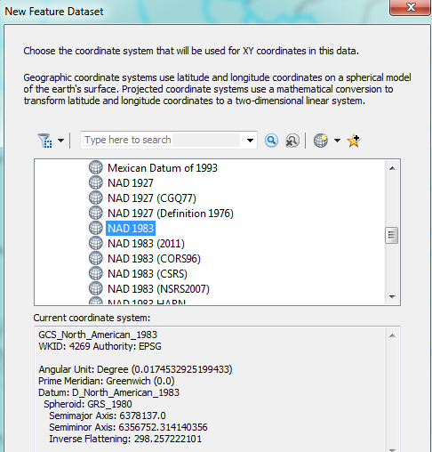
Hit Next, and Next again to bypass having a Vertical Coordinate system, and then Finish to complete creating the Feature Dataset, leaving the tolerance information at the default values.
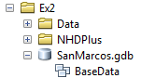
This BaseData feature dataset within the SanMarcos geodatabase will hold the data that you create for the San Marcos Basin.

Selecting the Watersheds in the San Marcos Basin
Turn off all the layers except the Watershed Boundary Dataset (WDB_Subwatershed)
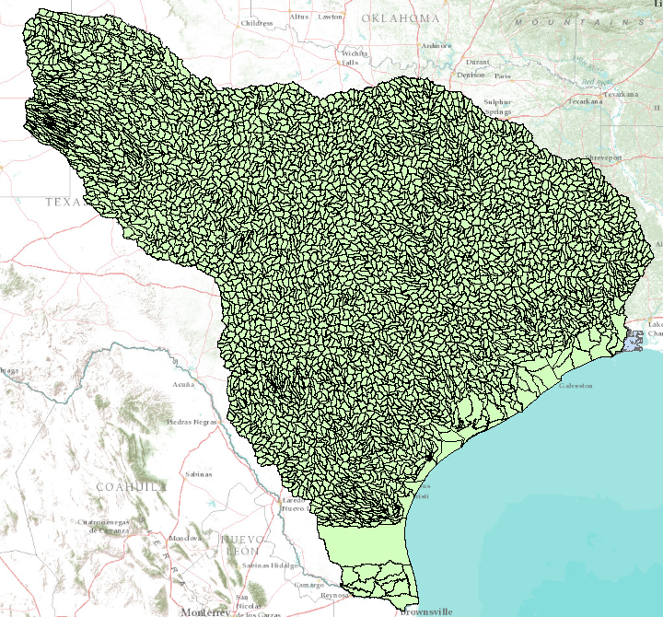
Let’s zoom into the San Marcos basin.
We want all the HUC12 subwatersheds that lie within the San Marcos subbasin, which has a HUC8 value of [HUC_8 = 12100203].
Open the Attribute Table of the Watershed Boundary Dataset (WDB_Subwatershed)
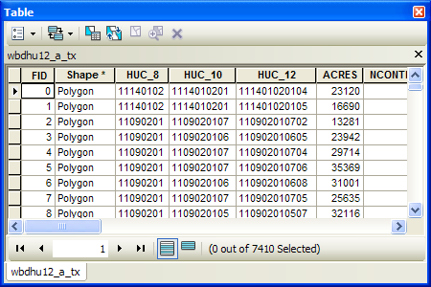
At the top left corner of the Table, click on the Select by Attributes tool
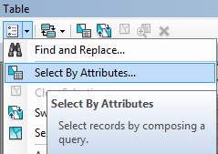
Click on “HUC8”, “=”, Get Unique Values and then type 12100203 in the Go To box, double click on the resulting ‘12100203’ to form the expression
"HUC_8" = '12100203'
In the selection window. Be careful about how you do this since the form of the expression is important. Click Apply and Close the Select by Attributes window.
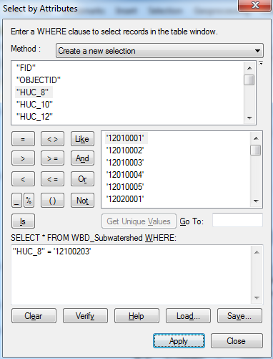
You’ll see that this selects 32 of the HUC-12 Subwatersheds that lie within the San Marcos basin (one HUC-8 Subbasin). If you hit the Selected button at the bottom of the Table, you’ll see the selected records, and also their highlighted images in the map.
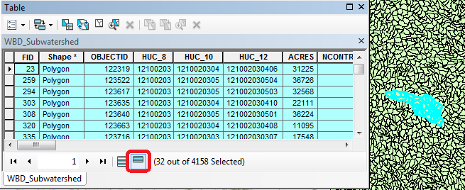
Use Selection/Zoom to Selected Features:
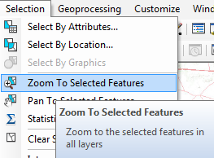
Close the WBD_Subwatershed table to get it out of the way. Right Click on the watersheds layer (WBD_Subwatershed) and select Data/Export Data to produce a new Feature Class.
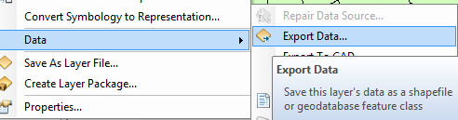

Be sure to navigate to where you established the SanMarcos geodatabase earlier and don’t just accept the default geodatabase presented to you, which is somewhere deep in the file system that you may never find again! Browse inside the SanMarcos geodatabase you created to the BaseData Feature dataset and name this new feature class as Watershed and click Save. (Note that you may have to change the Save as Type to File and Personal Geodatabase feature classes).
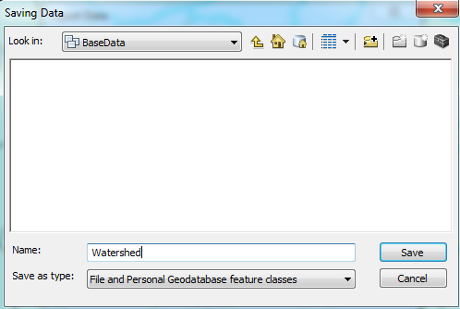
At the next screen click OK
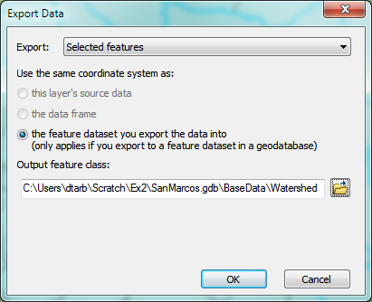
You will be prompted to whether add this theme to the Map, click Yes. In ArcMap, Use Selection/Clear Selected Features to clear the selection you just made.
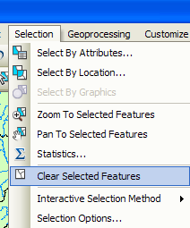
And then Zoom to Layer to focus in on your selected Watersheds. You can click off the little check mark by the WBD_Subwatershed layer and Basemap so that you just see the watersheds displayed.
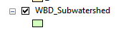
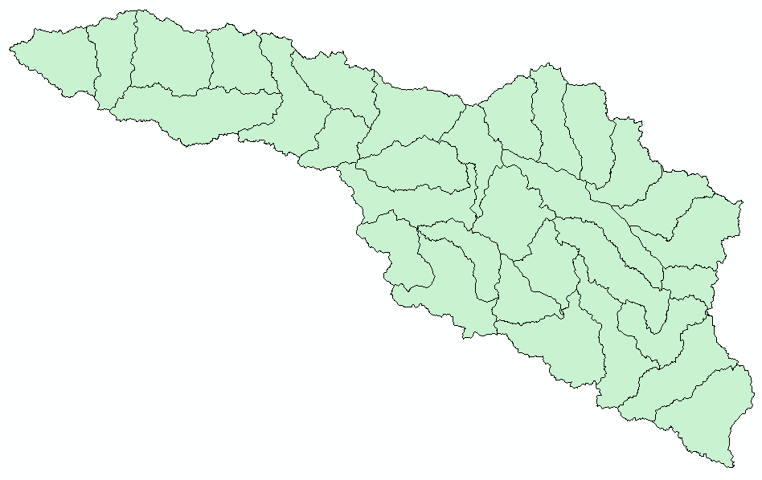
Lets make our basin a bit more interesting. Right click on the Watershed feature class, and select Properties/Symbology. Select Categories Unique values and use HUC-10 as the Value Field, hit Add All Values to give each HUC-10 watershed a different color. Hit Apply and OK to get this color scheme applied to the map.
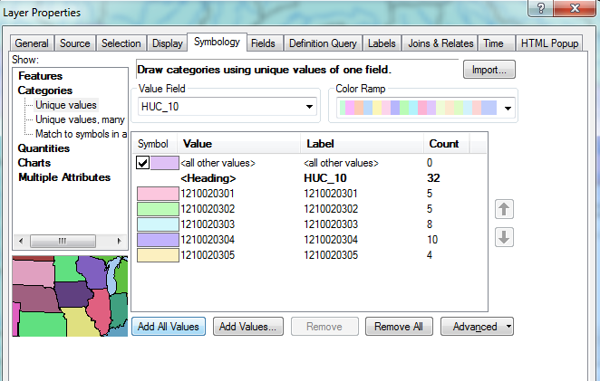
Lets focus on the Watersheds feature class by turning off the display of the other feature classes using the check box in the Table of Contents.
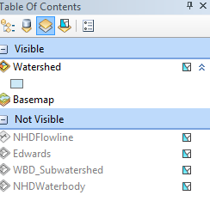
And you’ll get this nicely colored map of the watersheds and subwatersheds of the San Marcos basin.
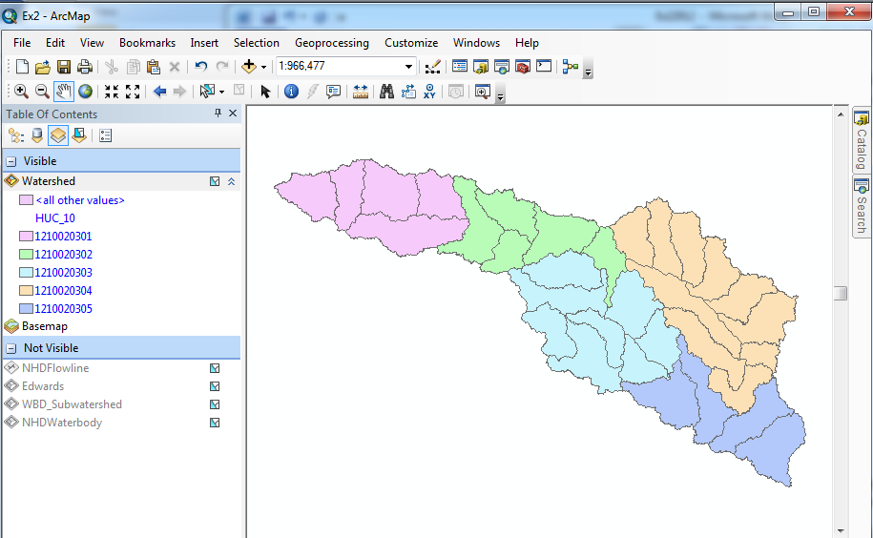
Notice that the 32 HUC-12 subwatersheds have been grouped into five watersheds within the San Marcos subbasin (I am here using the Watershed Boundary Set nomenclature to refer to the drainage area hierarchy in its formal sense).
Select the Identify tool, go up near the top of the San Marcos Basin, and click on one of the HUC-12 subwatersheds. You’ll see its attributes pop up. Notice the hierarchy of numbers for the HUC_8, HUC_10, and HUC_12 attributes.
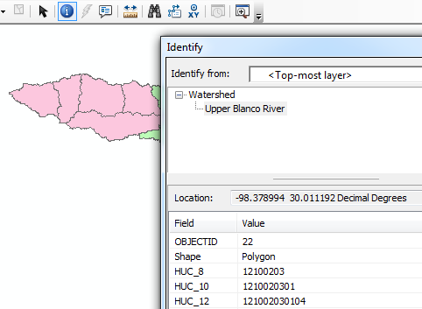
Use File/Save As to save your map file as Ex2.mxd with the new information that you’ve created (and to keep it distinct from the Map Document Region12NHDPlus.mxd opened from ArcGIS Online).

Where is My Stuff
Right click on Watershed and select Propeties and select the Source tab. Notice that this Feature Class you created is in the BaseData Feature Dataset in the SanMarcos.gdb Geodatabase in the location where you created it.
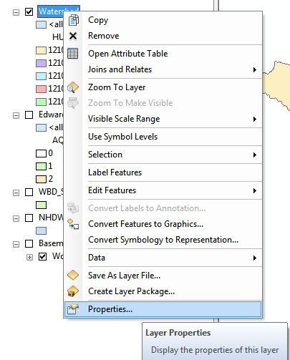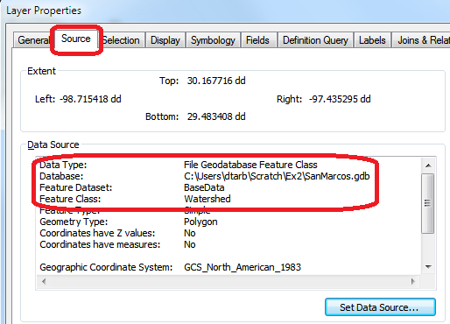
Now right click on NHDFlowline and select Propeties and select the Source tab. This is one of the layers from the Map Document Region12NHDPlus.mxd opened from ArcGIS Online. Notice that this is a Shapefile stored in your Documents\ArcGIS\Packages folder. This is where stuff goes when you download a map document from ArcGIS Online. This becomes important if you want to move your map document to another computer. This downloaded data will not go along with your map document automatically so its keeping needs to be managed.
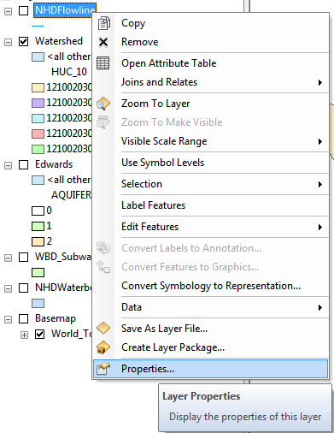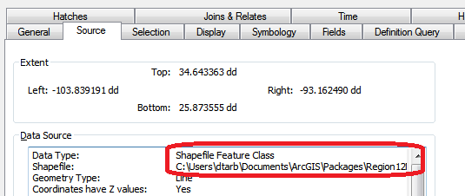

Creating a San Marcos Basin Boundary
It is useful to have a single polygon that is the outline of the San Marcos Basin. Click on the Search button in ArcMap and within the Search box that opens up on the right hand side of the ArcMap display, click on Tools and then type Dissolve. You will see the autocomplete tool gives you several options and select Dissolve (Data Management)
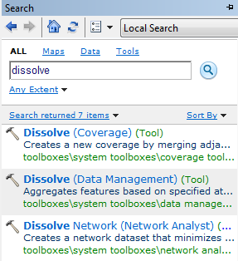
You’ll see a Dissolve tool window appear. You can drag and drop the Watershed feature class from the Table of Contents into the Input Features area of this window. For the Output Feature Class, navigate to the BaseMap feature dataset and type Basin as the name. Click on HUC_8 as your Dissolve_Field. This means that all Watersheds with the same HUC8 number (12100203) will be merged together. Hit Ok to execute the function.
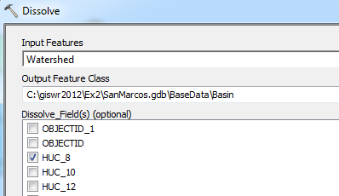
There’ll be no apparent activity for a while and then you’ll see some blue scrolling text at the bottom right and a pop up indicating completion and the Basin feature will appear.
Lets alter the map display to make the Basin layer just an outline. Click on the Symbol for the Basin layer 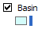 and select Hollow for the shape, Green for the Outline Color and 2 for the Outline Width.
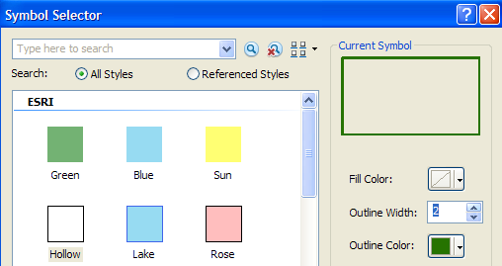
And you’ll get a very nice looking map of the San Marcos Basin with its constituent subdrainage areas.
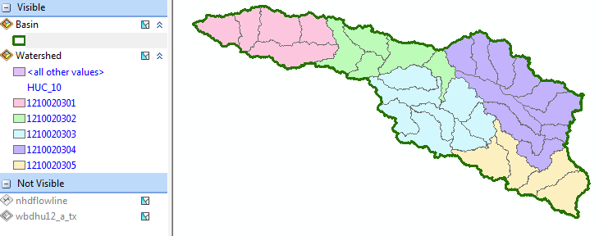
Click on the Catalog window in ArcMap and navigate to your BaseData feature dataset. Notice how you’ve now got the Watershed and Basin feature classes that you’ve just created stored inside it.
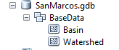
Save your ArcMap document to the file Ex2Basin.mxd. Note that this is a different name than used earlier, so you can retrieve the former configuration or this one separately. Close ArcMap.
To be turned in: A screen capture of the San Marcos basin with its HUC-10 and HUC-12 watersheds and subwatersheds.
Soil Information for the San Marcos Basin
Go to the Hydro Resource Center on ArcGIS.com http://resources.arcgis.com/en/communities/hydro/ (Use the Firefox or Chrome browser as this application does not work properly in Internet Explorer). Scroll across the Gallery at the bottom of the page until you see the SSURGO Data map (left end of the Gallary ribbon below).
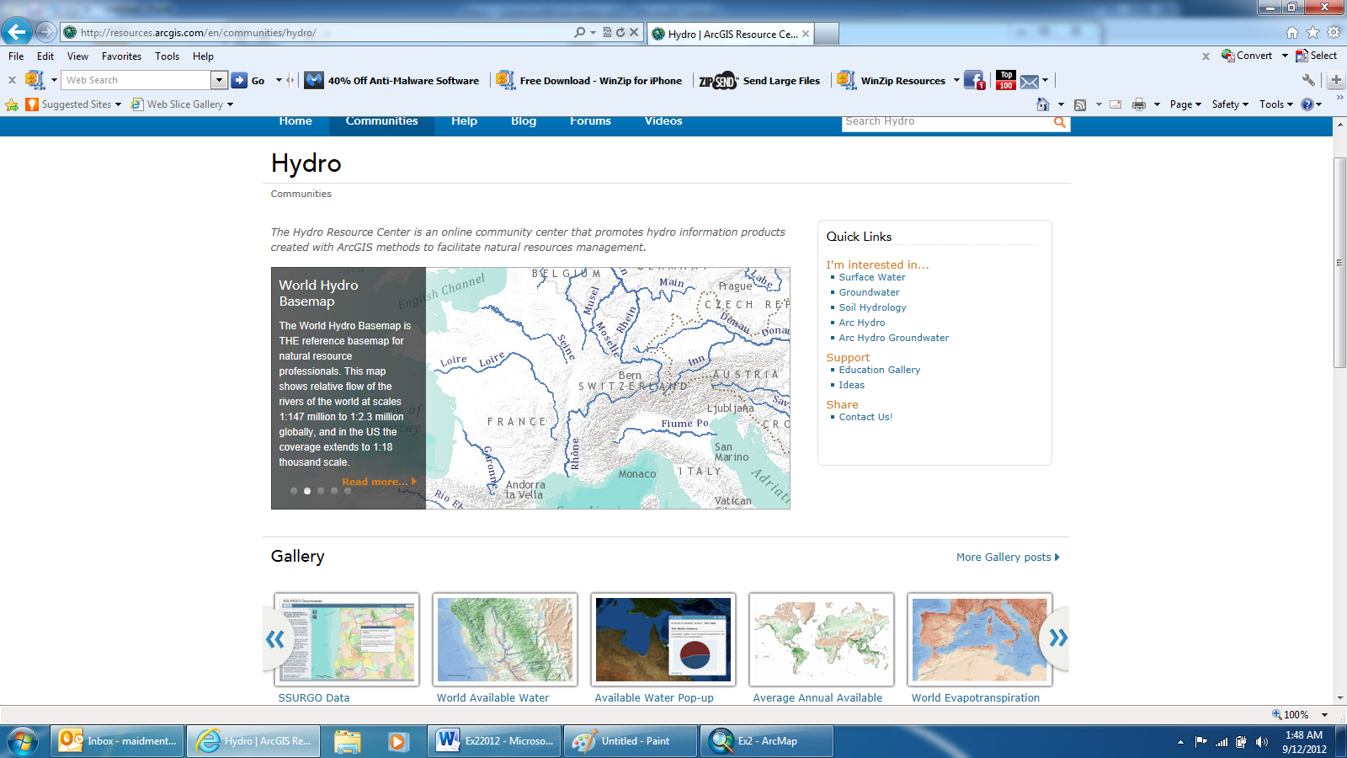
Open the SSURGO Data Downloader (beta) application
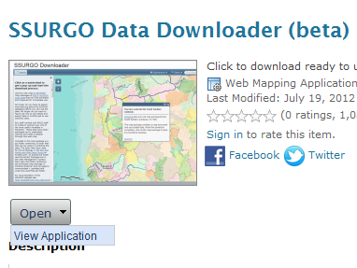
In the map that appears, enter San Marcos, Texas as the place to search in the top right corner
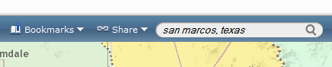
Zoom back a bit and you’ll see the San Marcos Basin. Pretty nice map!
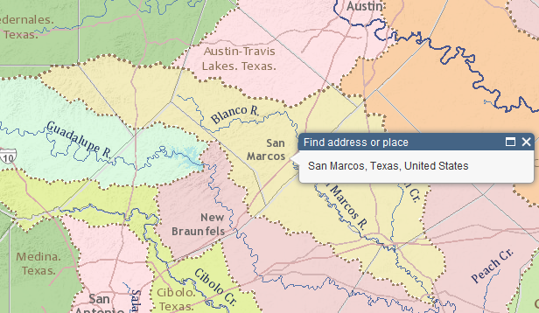
Click on the San Marcos Basin to highlight it, and select Download to get the soil map package for this basin
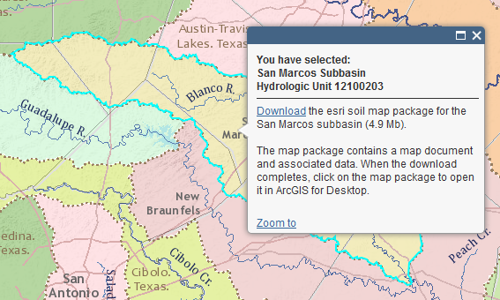
Select Open with the ArcGIS File Handler (make sure ArcMap is closed before you do this).
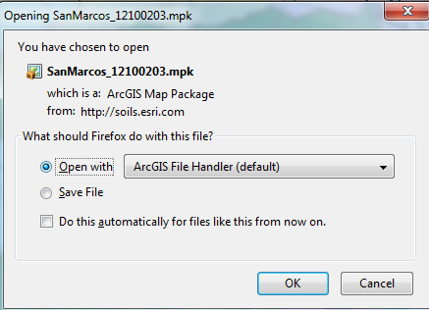
ArcMap will open and you’ll get a map that shows SSURGO soil map data for this basin. ESRI has simplified access to the SSURGO soil database produced by USDA and made a map package like this for each HUC-8 Subbasin in the US.
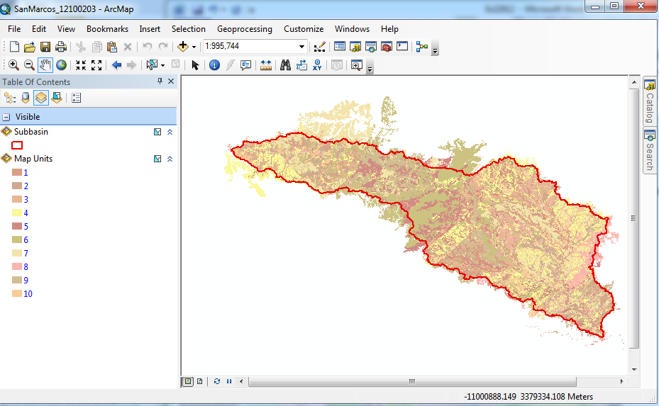
The numbers 1-10 refer to different soil classes in the basin.
If you use the Identify button, zoom into a particular area in the map, make Map Unit the layer to be identified and query some features, you can see some characteristics of the soils. Make the Identify window wider if you can’t see any numerical values. We are going to focus on one attribute, Available Water Storage 0-100cm – Weighted Average This specifies the number of cm of water that can be stored in the top 1m of soil, only 2.91 cm in the example shown below. Wow! We have really thin soils overlying shallow surface rocks at this location!
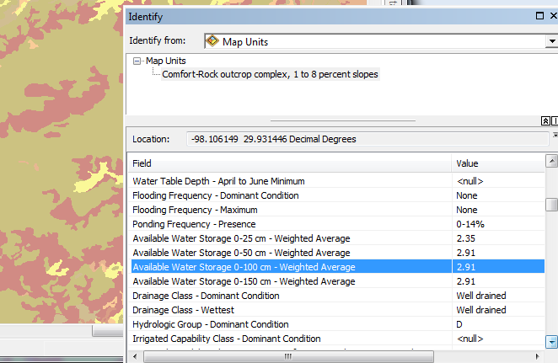
Select the Clip (Analysis) tool (using Search as before)
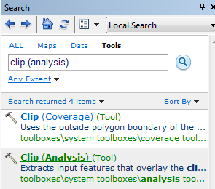
With input features Map Units, clip features Subbasin, and output features Soils in your BaseData feature dataset for the San Marcos Basin.
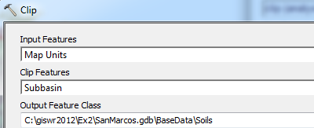
And if you make invisible all the layers except for Soils and open the Arc Catalog, you’ll see that you’ve now got a feature class of soil information in the San Marcos Basin. Pretty cool!
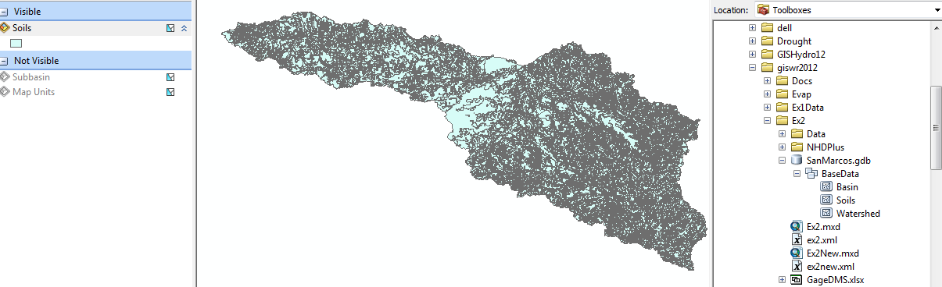
If we want to make a map of the San Marcos basin Available Water Storage 0-100 cm - Weighted Average, you’ll find there are too many features to symbolize with the default settings

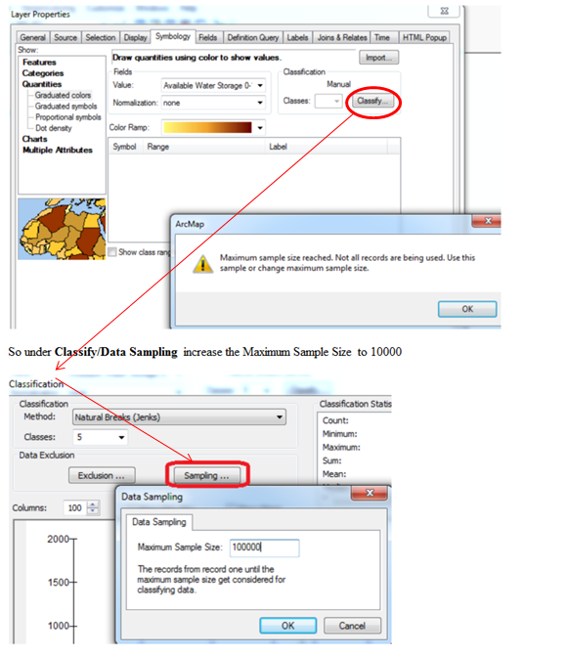
And put “No color” in all the Outline symbols, by clicking on Symbol/Properties for All Symbols
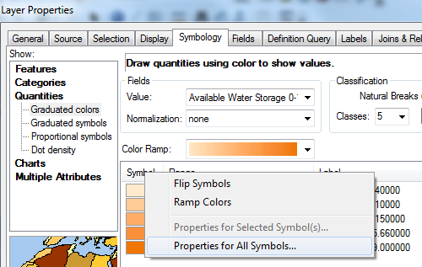
And select Outline Color as No Color
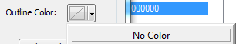
you’ll get a really remarkable map that shows how the Available Water Storage increases significantly as you go east in the basin across IH-35 and off the thin rocky soils of the Balcones Escarpment to the west and in the deeper more agriculturally productive soils to the the east. You can also see the presence of the streams in the eastern side of the basin and the deeper more alluvial soils that have been deposited around them. I’ve added the Roads Basemap to highlight the demarcation of soil properties along IH-35
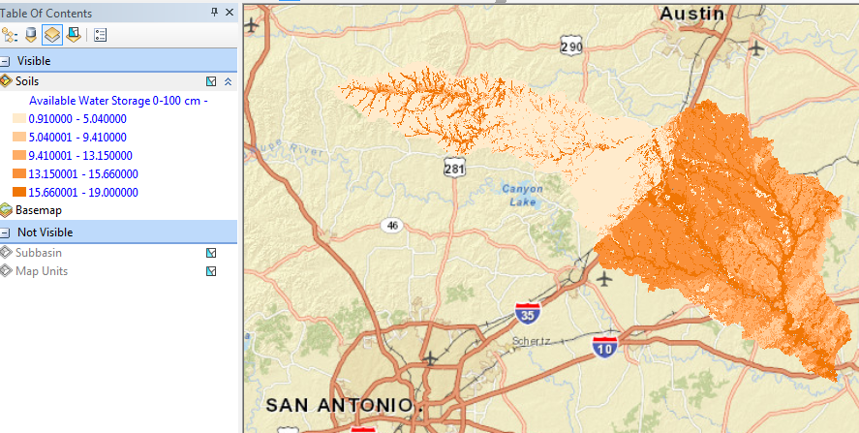
If you open the attribute table of the Soils feature class, right click on the 0-100 cm Available Water Storage field and select Statistics
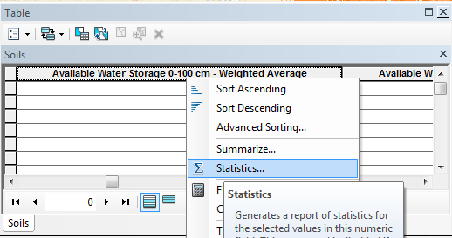
And you’ll get a summary of the Statistics of this field.
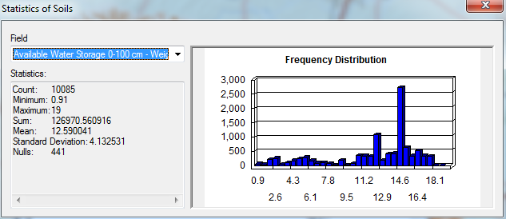
Note that care is needed in interpreting these statistics as the soil polygons involved have different sizes. To be really precise about the computation below we should area-weight the polygons rather than just computing the statistical average. Lets just use the statistical average for now.
Save your map as Ex2Soils.mxd and close ArcMap.
To be turned in: What is the average available water storage (cm) in the San Marcos basin? If the area of the basin is 3520 square kilometers, what volume of water (km³) could potentially be stored in the top 1m of soil in the San Marcos basin if the soil were fully saturated with water?

Selecting the San Marcos Flowlines

Open ArcMap using the Ex2Basin.mxd file that you saved earlier. Click on the symbol to the left of nhdflowline in the Table of Contents to make the flowlines visible again.

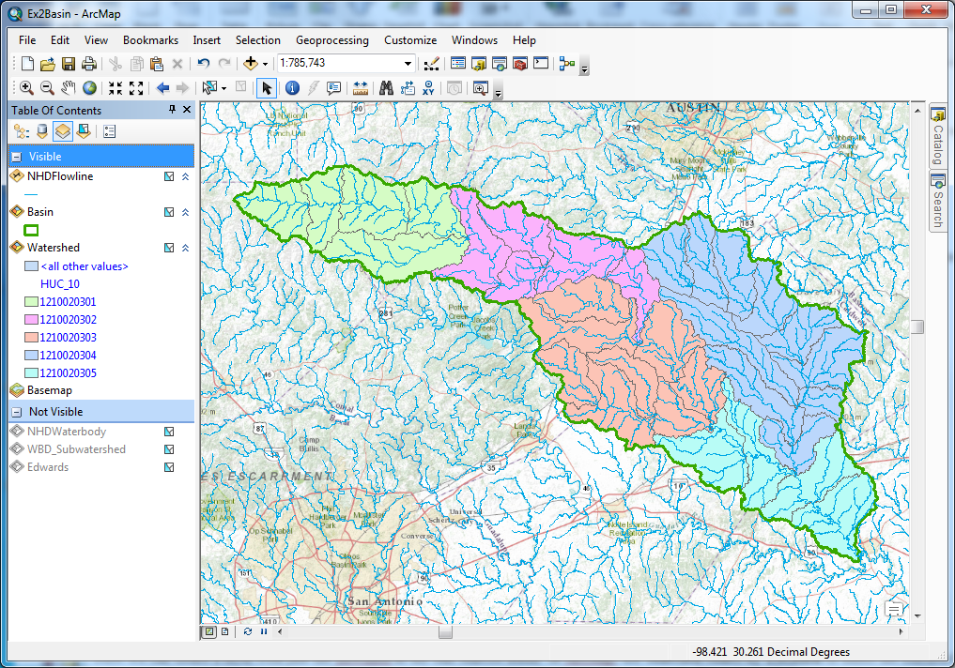
Now we can create a layer with just the flowlines in the San Marcos Basin. In ArcMap, use Selection/Select by Location to select the features from nhdflowline as the Target Layer and Basin as the Source Layer, and use the Spatial Selection Method “Target layer(s) features are within the Source layer feature”. This selects all the streams in the San Marcos Basin.
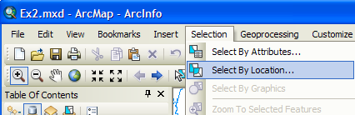
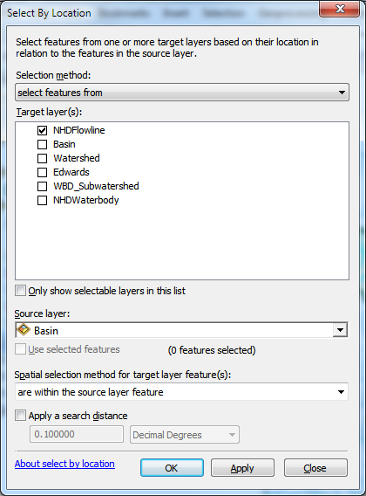
Hit OK and you’ll see the flowlines within the basin selected.
Right click on the NHDFlowline feature class and select Data/Export Data
Save the selected features as Flowline in the BaseData feature dataset and add it as a layer to the map. Remove the old NHDFlowline, WBD_Subwatershed and NHDWaterbody themes from your map display by right clicking on the Layer name and selecting Remove.
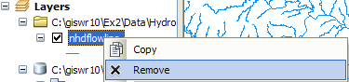
Right click on the Watershed feature class and under Properties/Symbology, assign a Single Symbol for the features and select that Symbol to be Hollow
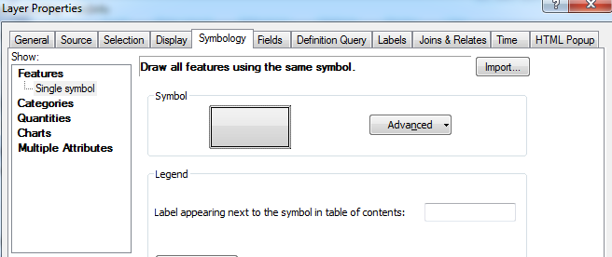
If necessary, change your symbology so that your flowlines are colored in blue. We want to have our streams looking liking real map streams!
Now you’ve got a map where you can see your flowlines within the areas they drain. Very nice!
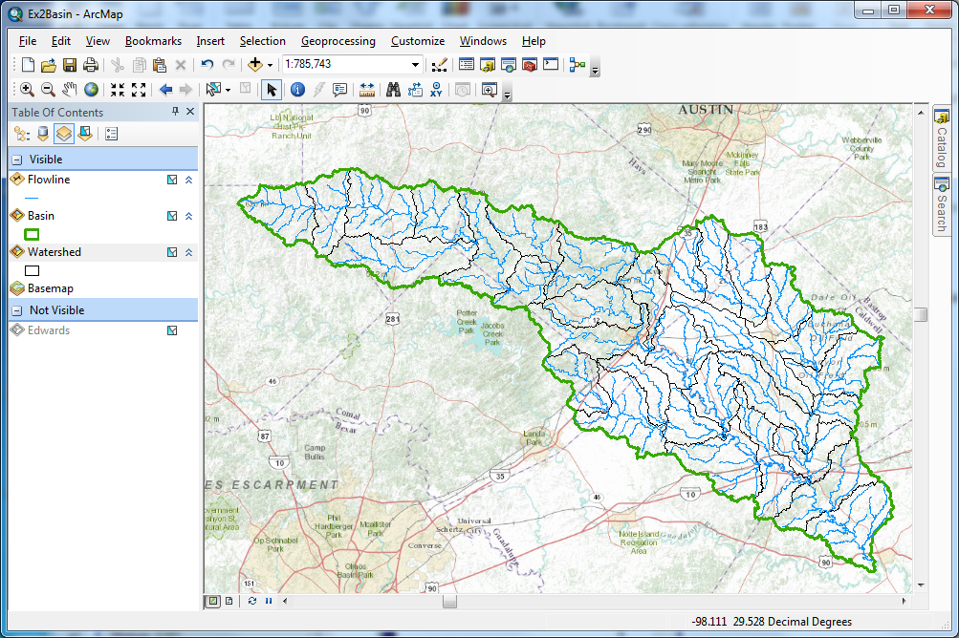
That looks very cool!! You can see how the slope of the topography changes between the east and west of IH-35. East is flatter and West is steeper. This is another reflection of the different underlying geology of the two parts of the basin that you saw earlier reflected in the soil map properties.
Save the Ex2Basin.mxd file again.
Now let’s look at some summary statistics of the flowlines. Open the Attribute table Right click on the LengthKm field and select Statistics
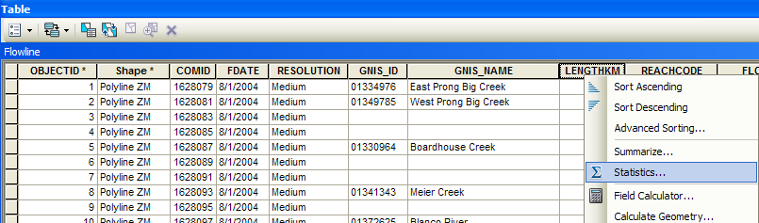
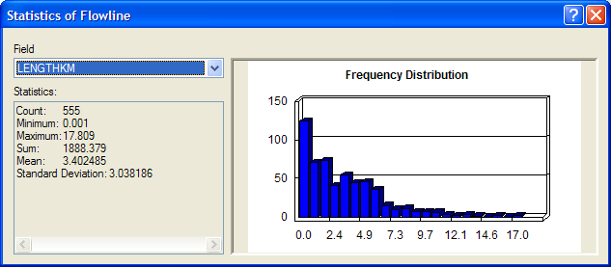
From this display, you can see the statistics of the LengthKm of the Flowlines. There are 555 flowlines whose average length is 3.40 km and the total length is 1888 km. You can do the same query on the Acres attribute of the Watershed feature class to get watershed areas. (1 acre = 0.0040469 km²).
To be turned in: How many HUC12 subwatersheds are there in the San Marcos Basin? What is their average area in acres and in km²? What is the total area of this basin in km²? What is the ratio of the length of the streamlines to the area of the HUC12 subwatersheds (called the drainage density) in km⁻¹?

Adding Attributes to the Flowlines
Now we will use the flowline attributes table to symbolize the flowlines based on their mean annual flow.
Change the Table of Contents display to List by Source
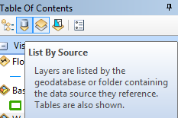
And you’ll see that you’ve got a table near the bottom of the set of listed layers called EROM_MA0001. EROM stands for “Extended RunOff Method” and contains data from a fairly complicated method of estimating mean annual flow on the NHDFlowlines that you can read details about in the NHDPlus Version 2 User Guide if you are keen to understand this further.
ftp://ftp.horizon-systems.com/NHDPlus/NHDPlusV21/Documentation/NHDPlusV2_User_Guide.pdf
Right click and Open the table EROM_MA0001. You’ll see there is a field for COMID which is a key field identifying each NHDPlus flowline feature and enabling it to be linked to attributes of that feature held in separate tables, such as this one.
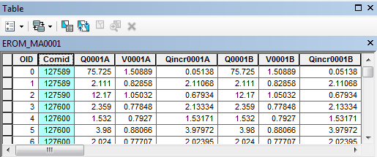
Lets zoom into our Flowlines and use the Inquiry button in the Tools menu to see the attributes of one of them. You’ll also see there the COMID that uniquely identifies each flowline feature in the NHD. In this case, COMID = 1628231. You’ll also see the ReachCode = 12100203000200 in this case. This means that this is segment 200 within HUC8 Subbasin = 12100203. You’ll also see reference here to GNIS, which is the Geographic Names Information System, the official set of names for things in the United States. We have systems for everything!
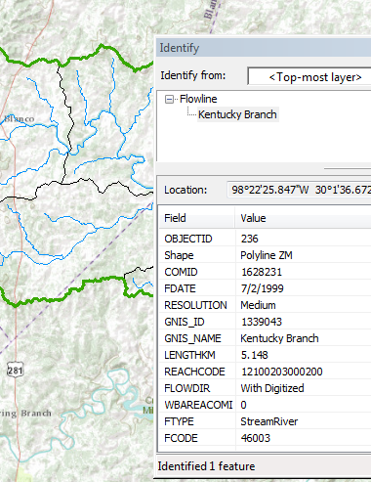
We’ll use COMID as a key field to link the two attribute tables and transfer mean annual flow attributes to the Flowline feature class. Just for fun, I’ve use the “Select by Attributes” tool in the Table to select the record in the EROM_MA0001 table that tells us more about this particular stream with ‘COMID’ = 1628231. It has a Mean Annual Flow of (Q0001E) of 4.87 cfs. This is very useful for water flow computations. The other estimates (A, B, C, D, etc refer to earlier steps in the Mean Annual Flow estimation process).
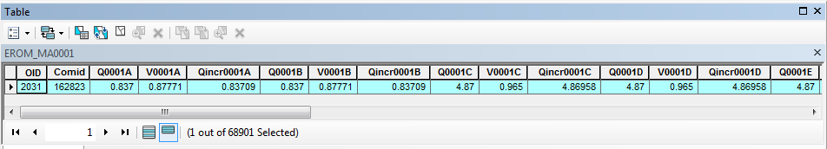
Notice that there are 68,901 records in the EROM_MA0001 table. This corresponds to the attributes for all the blue lines streams in the water resource region 12 in Texas, and that is a lot more than what we need to describe flow just in the San Marcos basin. What we’d like to do is to transfer the information about Mean Annual Flows from the EROM_MA0001 table to the Flowline feature class just for those flowline features within the San Marcos basin.
In the Table, use Clear Selection to unselect the record that we’ve been looking at.
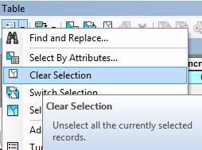
Open the attribute table for the feature class Flowline and select Table Options/Add Field.
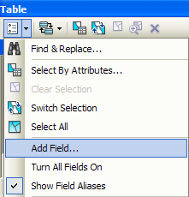
Name the field Mean_Annual_Flow and make it of the type Double and click OK.
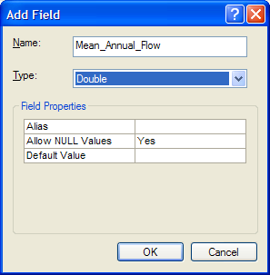
This creates a new field at the right hand end of the attributes table that has <null entries> in it for the moment. Notice that there are 555 features in the flowline feature class.
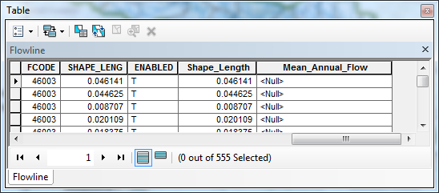
Now we will join the Flowline layer with the EROM_MA0001 table based on COMID. Right click on the Flowline layer and select Joins and Relates/Join.
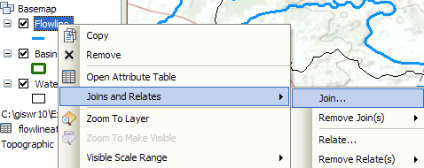
Select the COMID field and the EROM_MA0001 table as the one you are going to join to
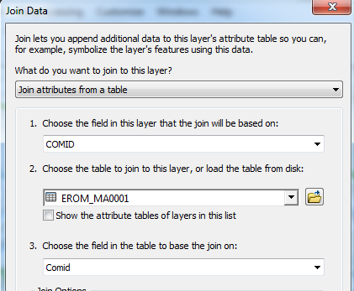
Say no to creating an index.
Now when you open the Flowline attribute table, at the right hand end of the table, you will find the information contained in the EROM_MA0001 table has been joined to the existing features. Scroll over to the column labeled Q0001E. This field contains the Mean Annual Flow for each reach that we are going to use. It is estimated by averaging the mean annual runoff over the drainage area above this reach. Notice that in this joined table, we’ve only got 555 records with flow values in them, not the 68,901values we had earlier.
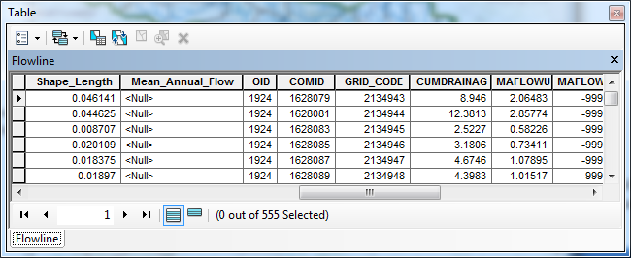
We can set the value of our new field Mean_Annual_Flow by using the field calculator. Scroll back to the column we created, called Mean_Annual_Flow, and right click on the column label to select the field calculator.
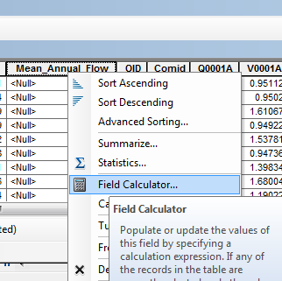
Click Yes to the warning. Scroll down the Fields list and double click on [EROM_MA0001.Q0001E] to set the entry in the Flowline.Mean_Annual_Flow= box
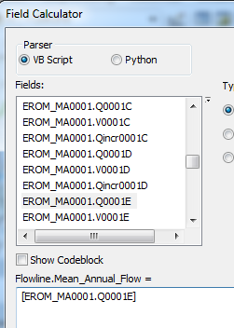
Click OK. This populates the Mean Annual Flow field with the appropriate value.
Now we can remove the join by right clicking on the Flowline feature class and selecting Joins and Relates/Remove All Joins.
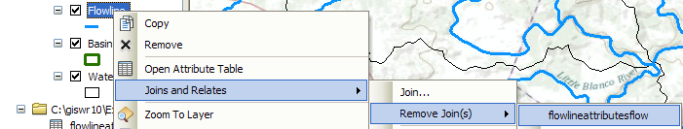
Now our attribute table for SanMarcos_flowlines has a field called Mean_Annual_Flow with the values populated.
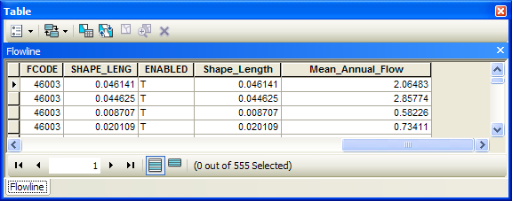
We can use this field to symbolize the flowlines. Right click on Flowline and select properties. In the properties menu, select the Symbology tab. Change the Symbology to display Quantities/graduated symbols with Mean_Annual_Flow for the Value field. Click on the Template symbol to change the color of the lines from the arbitrary one selected by the symbol editor to blue and hit OK.
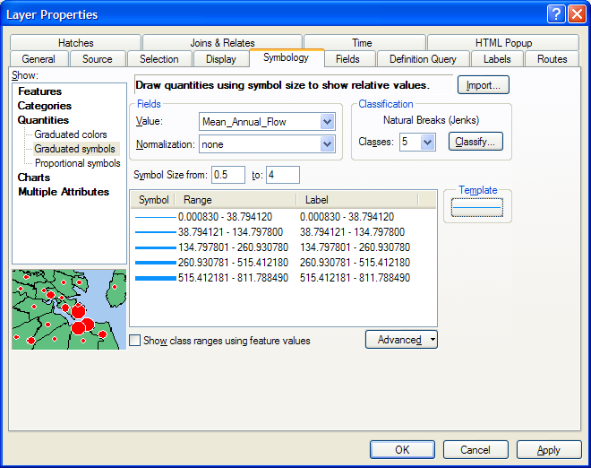
The result is a map displaying the relative flow of the streams and rivers in the San Marcos basin. This is a much more instructive map that shows the main rivers of the San Marcos basin, the Blanco, San Marcos Rivers along the main steam, and Plum Creek, a tributary coming in from the North near the downstream end of the basin.
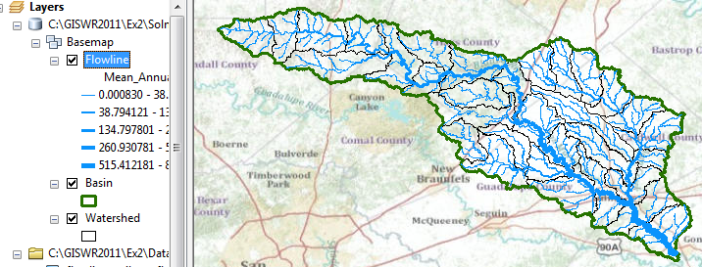
Use the Inquiry tool to find out the names of the various rivers in the map display.
Right click in the grey area to the right of the existing toolbars to open the Draw toolbar
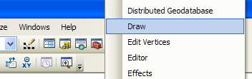
and select a label:
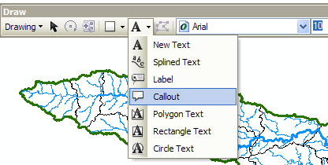
And add a label to show Plum Creek:
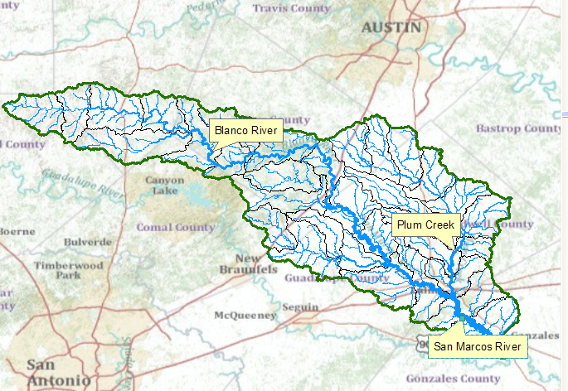
To be turned in: A map (a screen capture is ok) of the San Marcos Basin and streams. Add labels to show the San Marcos River, the Blanco River and Plum Creek.
Resave your Ex2Basin.mxd file.

Creating a Point Feature Class of Stream Gages
Now you are going to build a new Feature Class yourself of stream gage locations in the San Marcos basin. I have extracted information from the USGS site information at http://waterdata.usgs.gov/tx/nwis/si
SiteID | SiteName | Latitude | Longitude | DASqMile | MAFlow
08171000 | Blanco Rv at Wimberley, Tx | 29⁰ 59' 39" | 98⁰ 05' 19" | 355 | 142
08171300 | Blanco Rv nr Kyle, Tx | 29⁰ 58' 45" | 97⁰ 54' 35" | 412 | 165
08172400 | Plum Ck at Lockhart, Tx | 29⁰ 55' 22" | 97⁰ 40' 44" | 112 | 49
08173000 | Plum Ck nr Luling, Tx | 29⁰ 41' 58" | 97⁰ 36' 12" | 309 | 114
08172000 | San Marcos Rv at Luling, Tx | 29⁰ 39' 58" | 97⁰ 39' 02" | 838 | 408
08170500 | San Marcos Rv at San Marcos, Tx | 29⁰ 53' 20" | 97⁰ 56' 02" | 48.9 | 176
(a) Define a table containing an ID and the long, lat coordinates of the gages
The coordinate data is in geographic degrees, minutes, & seconds. These values need to be converted to digital degrees, so go ahead and perform that computation for the 8 pairs of longitude and latitude values. This is something that has to be done carefully because any errors in conversions will result in the stations lying well away from the San Marcos basin. I suggest that you prepare an Excel table showing the gage longitude and latitude in degrees, minutes and seconds, convert it to long, lat in decimal degrees using the formula
Decimal Degrees (DD) = Degrees + Min/60 + Seconds/3600
Remember that West Longitude is negative in decimal degrees. Shown below is a table that I created. Be sure to format the columns containing the Longitude and Latitude data in decimal degrees (LongDD and LatDD) so that they explicitly have Number format with 4 decimal places using Excel format procedures. Format the column SITEID as Text or it will not retain the leading zero in the SiteID data. Add the additional information about the USGS SiteID, SiteName and Mean Annual Flow (MAF). Note the name of the worksheet that you have stored the data in. I have called mine latlong.xlsx. Close Excel before you proceed to ArcMap.
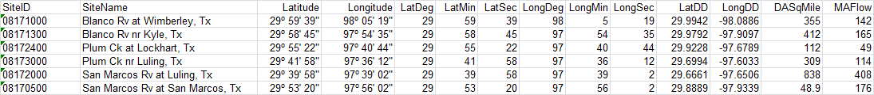
(b) Creating and Projecting a Feature Class of the Gages
(1) Open ArcMap and the Ex2.mxd file you created in the first part of this exercise. Select the add data button and navigate to your Excel spreadsheet
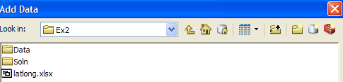
Double click on the spreadsheet to identify the individual worksheet within the spreadsheet that you want to add to ArcMap (it’s a coincidence that they have the same name in this example and that is not necessary in general).
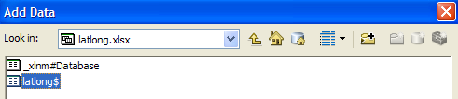
Hit Add and your spreadsheet will be added to ArcMap. Pretty cool!! Its always been a struggle to add data from spreadsheets before and it seems like at ArcGIS 10, they have gotten this right.
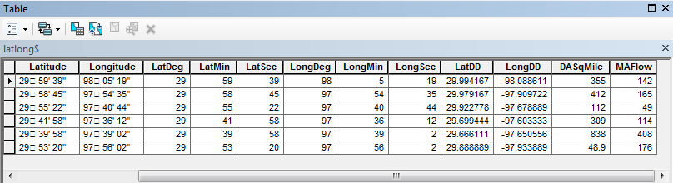
Now we are going to convert the tabular data in the spreadsheet to points in the ArcMap display.
(2) Right click on the new table, latlong$, and select Display XY Data
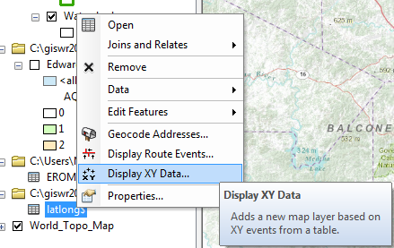
(3) Set the X Field to LongDD (or Longitude), the Y Field to LatDD (or Latitude), Hit Edit to change the spatial coordinate system. Scroll to the folder Layers at the bottom of the list to see the Spatial References of the Layers in the Map. Expand the folder to see that NHDFlowline, Watershed and other layers have the Spatial Reference GCS_North_American_1983. Click on this and hit OK. Don’t use the default spatial reference system that initially shows up, because it’s the Web Mercator Projection of the basemap and that is a projected not geographic coordinate system.
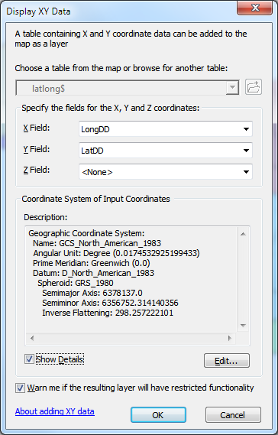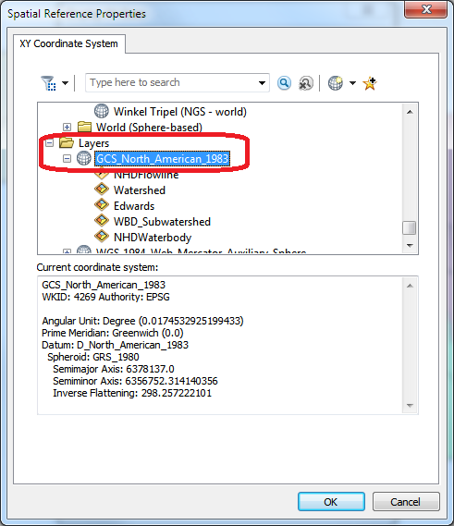
Click on the Show Details button to see details of the Geographic Coordinate System. We’ll learn about these in our next lecture!
Hit OK, to complete it and you’ll get a warning message about your table not having an ObjectID. Just hit Ok and and voila! Your gage points show up on the map right along the San Marcos River just like they should. Magic. I remember the first time I did this I was really thrilled. This stuff really works. I can create data points myself! If you don’t see any points, don’t be dismayed. Check back at your spreadsheet to make sure that the correct X field and Y field have been selected as the ones that have your data in decimal degrees.
Click on the point symbol under the legend label latlong event and recolor and resize the points so that they show up more clearly. You’ll see that you have 3 sites on Plum Creek, 3 sites on the San Marcos River, and two sites on the Blanco River, an upstream tributary of the San Marcos River.
What you have created is called an “event” which means that it is a graphical display in the ArcMap window of latitude and longitude points that are stored in a table. It is not a real feature class yet.
Resave your Ex2Basin.mxd file.
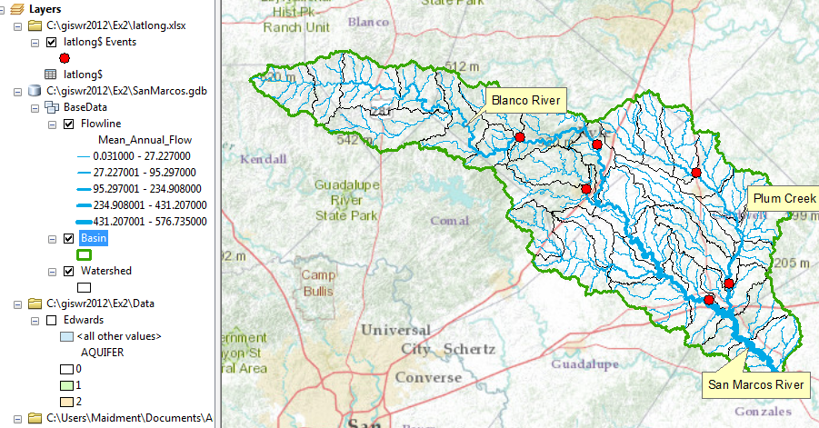
(4) Now, we’ll make a feature class out of the points. Right click on the latlong$ Events layer
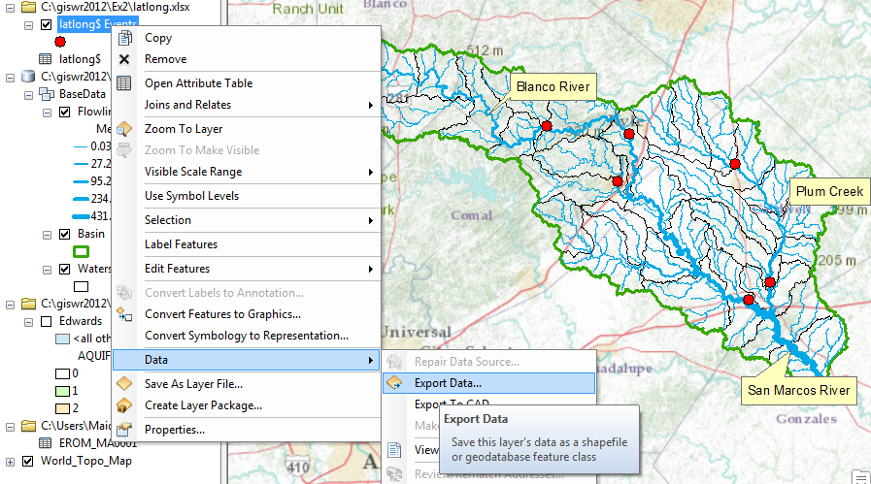
And export the data into the BaseData feature dataset as the feature class MonitoringPoint. Say Yes when you are asked if you want to add the points to your map, and now you’ve got a new feature class in the BaseData feature dataset with your points in the same projection as the other features in BaseData (ArcGIS does the map projection automatically as part of the data export process).
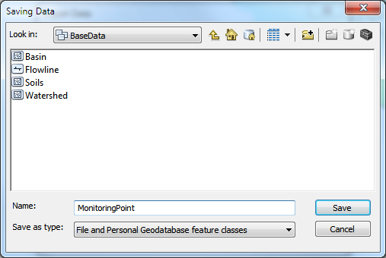
Remove the Latlong table and the Latlong Event layers from the ArcMap display and recolor and resize the MonitoringPoint features so that you can see them easily.
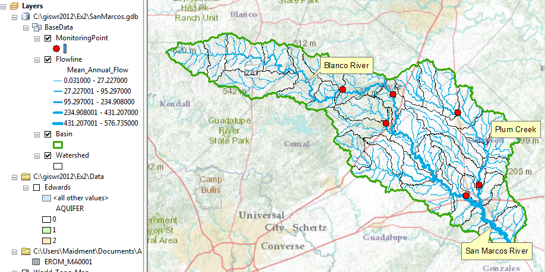
Open the attribute Table of the new MonitoringPoint feature class, and you can see on the right hand side, a new field called Shape that was added when the feature class was formed. This is where the geographic coordinates of the points are stored in a way that ArcMap can readily visualize them.
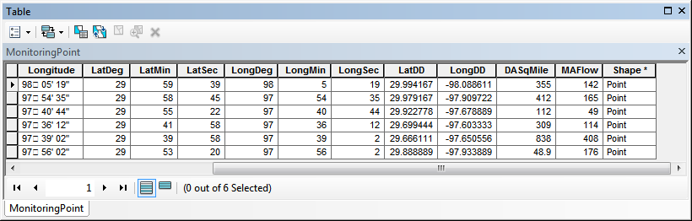
In ArcMap, open an ArcCatalog window using the button and expand the contents of your BaseData feature dataset. The MonitoringPoint feature class now resides there.
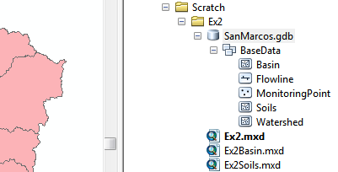
(5) Save your Ex2Basin.mxd ArcMap document.
Labeling the Gages in View
Right click on the MonitoringPoint feature class and select Properties.
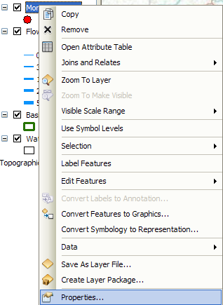
Click on the Labels tab and from the drop down menu select the label field name to be SiteName. Change the size of your font to 12 point type.
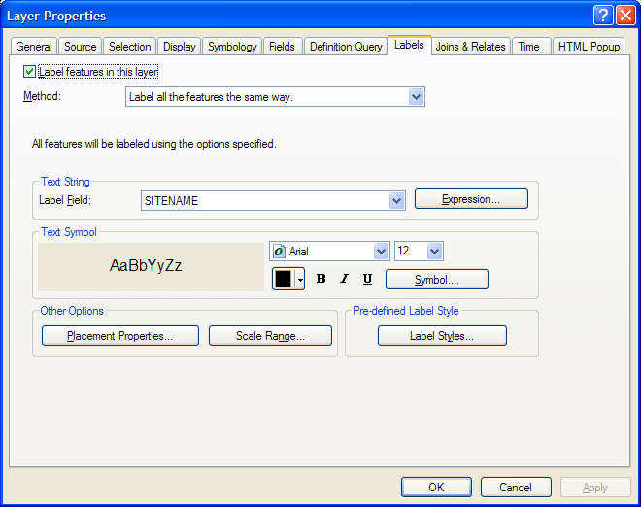
Right click on the MonitoringPoint feature class again and select Label Features.
You can now create a view like this:
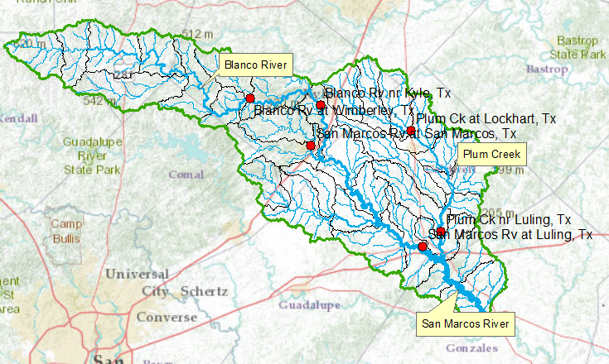
Resave your Ex2Basin.mxd file.
To be turned in: a map showing the labeled streams and streamgages for the San Marcos Basin

Overlaying the Edwards Aquifer
The Edwards aquifer is one of the most critical water resources of Central Texas. It is the main source of water supply for San Antonio, the 10th largest city in the United States. The Edwards aquifer is recharged by infiltration from rivers crossing its outcrop area. To determine where the San Marcos River crosses, the outcrop area, I obtained a coverage of the Edwards aquifer from the Texas Natural Resource Information System (http://www.tnris.state.tx.us/)
The Edwards aquifer coverage from TNRIS is in Decimal Degree coordinates. This is contained in the map package that you downloaded from ArcGIS Online at the beginning of the exercise. Click on the layer name Edwards to display the aquifer and Zoom to Layer to see the extent of the Edwards Aquifer.
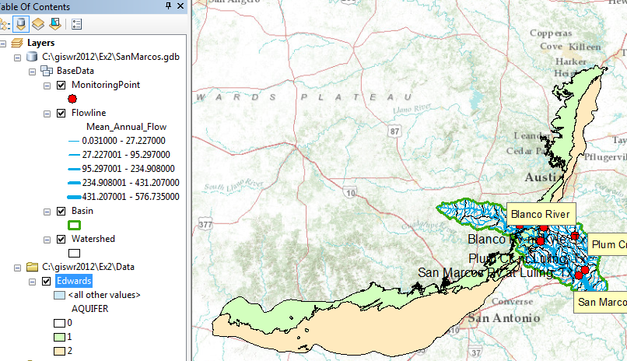
You'll see that as the San Marcos River flows South East towards the Gulf Coast and it crosses first the outcrop (the green portion labeled 1) and then the downdip portions of the Edwards aquifer (the brown portion labeled 2). The downdip region is where the aquifer dips below the land surface and is shielded from the surface rivers by overlying hydrogeological units of low permeability. The Edwards is a fissured limestone aquifer whose fissures lie along its Southwest to Northeast orientation, so its flow moves in that direction, transverse to the direction of flow in the San Marcos basin. It is thus quite possible for water to drain from the San Marcos river into the Edwards aquifer and then reappear as a spring further North in another river. Zoom in to the region where the aquifer crosses the San Marcos basin for a closer look.
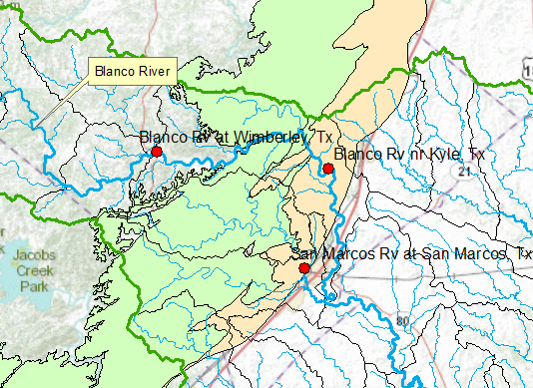
You can see that the gaging stations that you’ve put on the map lie at different, and very important locations with respect to the Edwards Aquifer. The Blanco River flows over the outcrop area of the Edwards Aquifer between the gaging stations at Wimberley and Kyle. The San Marcos River at San Marcos records from a very large artesian spring that arises from the downdip area of the Edwards Aquifer. Later on in the class, we’ll use a new USGS tool called NWIS Snapshot, to download flow data from the USGS and study the properties of the water at these locations. http://txpub.usgs.gov/snapshot/
Resave your Ex2Basin.mxd file.
To be turned in: A map showing the Edwards aquifer and the San Marcos basin
Summary of Items to be Turned in:
- A screen capture of the San Marcos basin with its HUC-10 and HUC-12 watersheds and subwatersheds.
- What is the average available water storage (cm) in the San Marcos basin? If the area of the basin is 3520 square kilometers, what volume of water (km³) could potentially be stored in the top 1m of soil in the San Marcos basin if the soil were fully saturated with water?
- How many HUC12 subwatersheds are there in the San Marcos Basin? What is their average area in km²? What is the total area of HUC12 subwatersheds in this basin in km²? What is the ratio of the length of the streamlines to the area of the HUC12 subwatersheds (called the drainage density) in km⁻¹?
- A map (a screen capture is ok) of the San Marcos Basin and streams. Add labels to show the San Marcos River, the Blanco River and Plum Creek.
- A map showing the labeled streams and streamgages for the San Marcos Basin
- A map showing the Edwards aquifer and the San Marcos basin

