Homework 1 Solution
GIS in Water Resources
Fall 2012
Prepared by Gonzalo E. Espinoza
- Map Projection Parameters
- What earth datum is used in this coordinate system?

North American 1983

- What map projection is used in this coordinate system?

Lambert Conformal Conic

- Sketch on the map the standard parallels, the central meridian and the latitude of origin of this projection.

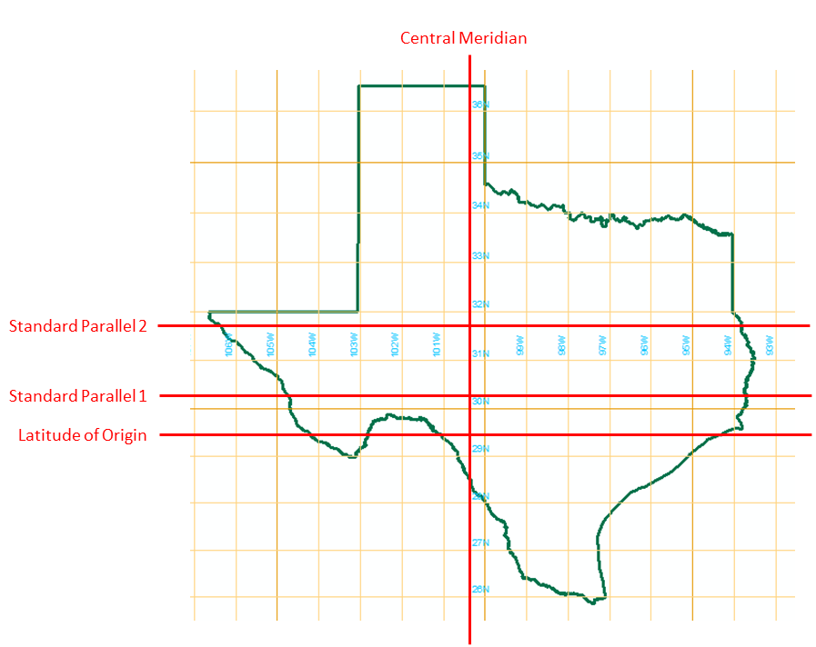
- For this projection, what are the coordinates of the origin (φo, λo) (in units of degrees minutes and seconds) and the corresponding (Xo, Yo) (in units of feet?

$$\left(ϕ_{0},λ_{0}\right)=\left(29°40'0"N;100°20'0"W\right)$$
$\left(x_{0},y_{0}\right)=\left(2,296,583.33;9,842,500.00\right)ft$

- Locations on the Earth

Austin $ϕ=30°17'10"N=30+17/60+10/3600=30.2861°$
$λ=97°{44}^{'}22"W=97+44/60+22/3600=-97.7394°$
$Lat,Long=\left(30.2861°,-97.7394°\right)$

Logan $ϕ=41°44'54"N=41+44/60+54/3600=41.7483°$
$λ=111°{48}^{'}30"W=111+48/60+30/3600=-111.8083°$
$Lat,Long=\left(41.7483°,-111.8083°\right)$

Lincoln $ϕ=40°49'09"N=40+49/60+9/3600=40.8192°$
$λ=96°{41}^{'}55"W=96+41/60+55/3600=-96.6986°$
$Lat,Long=\left(40.8492°,-96.6986°\right)$

Distances on the Earth

- Logan to Austin

Logan $ϕ_{A}=41.7483°\left(π/{180°}\right)=0.728646$
$λ_{A}=-111.8083°\left(π/{180°}\right)=-1.951424$

Austin $ϕ_{B}=30.2861°\left(π/{180°}\right)=0.528592$
$λ_{B}=-97.7394°\left(π/{180°}\right)=-1.705875$

$$R=6.371km$$
$$Dist=R\cos^{-1}\left[\sin{ϕ_{A}}\sin{ϕ_{B}}+\cos{ϕ_{A}}\cos{ϕ_{B}}\cos\left(λ_{A}-λ_{B}\right)\right]$$
$$Dist=1,791km$$

- Austin to Lincoln

Austin $ϕ_{B}=30.2861°\left(π/{180°}\right)=0.528592$
$λ_{B}=-97.7394°\left(π/{180°}\right)=-1.705875$

Lincoln $ϕ_{B}=40.8192°\left(π/{180°}\right)=0.712429$
$λ_{B}=-96.6986°\left(π/{180°}\right)=-1.687709$

$$R=6.371km$$
$$Dist=R\cos^{-1}\left[\sin{ϕ_{A}}\sin{ϕ_{B}}+\cos{ϕ_{A}}\cos{ϕ_{B}}\cos\left(λ_{A}-λ_{B}\right)\right]$$
$$Dist=1,175km$$

- Lincoln to Logan

Lincoln $ϕ_{B}=40.8192°\left(π/{180°}\right)=0.712429$
$λ_{B}=-96.6986°\left(π/{180°}\right)=-1.687709$

Logan $ϕ_{A}=41.7483°\left(π/{180°}\right)=0.728646$
$λ_{A}=-111.8083°\left(π/{180°}\right)=-1.951424$

$$R=6,371.0km$$
$$Dist=R\cos^{-1}\left[\sin{ϕ_{A}}\sin{ϕ_{B}}+\cos{ϕ_{A}}\cos{ϕ_{B}}\cos\left(λ_{A}-λ_{B}\right)\right]$$
$$Dist=1,265km$$

Slopes

- Logan to Austin

$$S=\frac{4,789-693}{1,791}\left(\frac{0.3048}{1,000}\right)=0.0007$$
The water would flow from Logan to Austin

- Austin to Lincoln
$$S=\frac{693-1,174}{1,175}\left(\frac{0.3048}{1,000}\right)=0.0001$$
The water would flow from Lincoln to Austin

- Lincoln to Logan

$$S=\frac{1,174-4,789}{1,265}\left(\frac{0.3048}{1,000}\right)=0.0009$$
The water would flow from Logan to Lincoln

- Web Mercator Coordinates

$$LatDD,LongDD=29.9942,-98.0886$$

The relationships between the Geographic Coordinates and the Web Mercator Coordinates are the following:

$$WebMercatorX=Semimajor Axis×LongDD$$
$$WebMercatorX=6,378,137m\left(-98.0886\right)\left(π/{180}\right)$$
$$WebMercatorX=-10,919,173m≈-10,919,174m$$

$$WebMercatorY=Semiminor Axis×LongDD$$
$$WebMercatorY=6,356,752.31m\left(29.9942\right)\left(π/{180}\right)$$
$WebMercatorY=3,327,744m≠3,502,800m$

The pair of coordinates in the X direction (Longitude) follows a simple relationship. In contrast, the pair of coordinates in the Y direction does not follow the simple relationship: $Wm=R_{e}×Angle$. This means that for the projection, the X direction is conserved and the error is carried by the Y direction (with a correction). This is because the Mercator is a cylindrical map projection and in the cylinder is oriented from South to North.
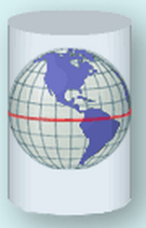

- Sizes of DEM cells

$$R_{e}=6,371.0km$$
$$∆λ=∆ϕ=1/8°=\left(0.125°\right)\left(π/{180°}\right)=2.1817×{10}^{-3}$$

- Austin

$$ϕ=30.2861°=0.528592$$

$$\overline{AB}=R_{e}∆λ\cos{ϕ}$$
$$\overline{AB}=\left(6,371.0km\right)\left(2.1817×{10}^{-3}\right)\cos\left(0.528592\right)$$
$$\overline{AB}=12.00km$$

$$\overline{AC}=R_{e}∆ϕ$$
$$\overline{AC}=\left(6,371.0km\right)\left(2.1817×{10}^{-3}\right)$$
$$\overline{AC}=13.90km$$

$$\overline{ABCD}=12.00×13.90=166.8km^{2}$$

- Logan

$$ϕ=41.7483°=0.728646$$

$$\overline{AB}=R_{e}∆λ\cos{ϕ}$$
$$\overline{AB}=\left(6,371.0km\right)\left(2.1817×{10}^{-3}\right)\cos\left(0.728646\right)$$
$$\overline{AB}=10.37km$$

$$\overline{AC}=R_{e}∆ϕ$$
$$\overline{AC}=\left(6,371.0km\right)\left(2.1817×{10}^{-3}\right)$$
$$\overline{AC}=13.90km$$

$$\overline{ABCD}=10.37×13.90=144.1km^{2}$$

- Lincoln

$$ϕ=40.8192°=0.712429$$

$$\overline{AB}=R_{e}∆λ\cos{ϕ}$$
$$\overline{AB}=\left(6,371.0km\right)\left(2.1817×{10}^{-3}\right)\cos\left(0.728646\right)$$
$$\overline{AB}=10.52km$$

$$\overline{AC}=R_{e}∆ϕ$$
$$\overline{AC}=\left(6,371.0km\right)\left(2.1817×{10}^{-3}\right)$$
$$\overline{AC}=13.90km$$

$$\overline{ABCD}=10.52×13.90=146.2km^{2}$$

