Pierre Gueudet

Term Project Fall 2003

Flood in Brownsville

Define the best place to build a house

Presentation of my results

Problem : Let’s take an example of a man who is moving into Brownsville (South Texas) and who wants to find a house as close as possible to a river because he loves fishing. He has the choice between four different places more or less close to a river. The problem is that this river is subjected to flood very frequently: the closer from the river he is, the highest the probability to be flooded is but the cheapest the house is. He is wondering what is the best choice to make given the fact that he plans to live there during 50 years. He wants me to help him…

Data: The data I have are:

- The yearly peak flow over 50 years for the river of interest at the downstream cross-section (from 1932 to 1982). I consider that the peak flow are statistically independent.
- A model that compute the map of the flood. To run a simulation (time consuming) the input are: the flow at the cross section downstream, the height at this cross-section corresponding to the flow and the Manning coefficient for the river. I consider that there is no uncertainty for the Manning coefficient in order to simplify the problem.
- A relationship between the height of the water and the flow at the downstream cross section.
- Four places available to build the house.

I - Design of the 100-year flood

First I would like to design the 100-year flood to have an idea of the possible extend of the flood. To obtain this result I have used a Type I approximation and a Monte Carlo simulation.

- Based on the available record, the yearly peak flow, X is modeled as a normal variate: X=N(470 cfs,209.4 cfs). The peak flow in 100 years, Yn, will tend toward a Type I distribution with the following parameters:

Un= 957.15
α_{n}= 0.0127
Therefore, the mean of the flow over 100 years is given by:
E(Yn)= 1002.50 cfs

- I have also used a Monte Carlo simulation to define the mean of the flow of the 100-year flood. To have a 95% confidence bounds in the estimated mean and 1% error we need to make 7625 simulations. The result is:

E(Yn)= 1016.26 cfs which is close from the asymptotic result.

With the information from the Monte Carlo simulation I have designed the 100-year flood.
Q(100 year flood)= 1016.26 cfs
H(100 year flood)=25.73 feet (obtained from the relationship H=f(Q))
We can notice that there is one house which is not in the flood plain.

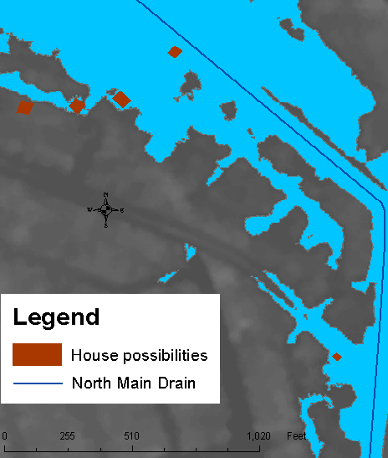

100-Year Flood

II - Estimation of the probability P(Yn>Q) over 50 years

To decide where to build the house we need to know the probability that the house is flooded over 50 years.
To do this I have used the Type I approximation:
P(Yn>q)=1-EXP(-EXP(-α_{n} *(q-Un)))

For example, the house A is flooded if a certain height h of water at the cross-section near the house is reached. With the model, I can define the value of Q required at the downstream cross-section. And with the above equation I can have the probability that this happens.

To draw the following map, I have computed the probability:
P(Yn>q)=1-EXP(-EXP(-α_{n} *(q-Un)))
for several value of q at the downstream cross-section. And for each q I have a delineated the flood plain.

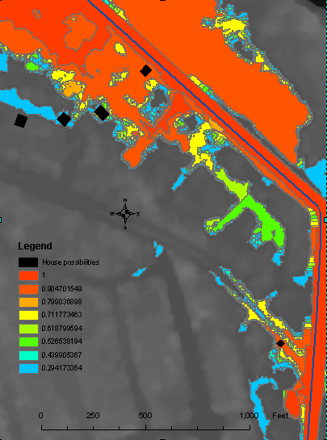
House A

House B

House C
House D
Map of the probabilities of the floods

- For house A:
P(House A flooded)= 0.9
Qdownstream=870 cfs
Distance to the river=63.74 feet

- For house B:
P(House A flooded)= 0.618
Qdownstream=960 cfs
Distance to the river=356.06 feet

- For house C:
P(House A flooded)= 0.29
Qdownstream=1040 cfs
Distance to the river=496 feet

- For house D:
P(House A flooded)= 0
This house is not in the flood plain.
Distance to the river=643.7 feet

III – Decision Tree

We can now make a decision with the information we have. Let’s make a decision tree:

probability | price house | Flood damage | Expected cost
0.9 | 700 | 320 | 988
0.1 | 700 | 0
0.618 | 850 | 320 | 1047.76
0.382 | 850 | 0
0.3 | 900 | 320 | 996
0.7 | 900 | 0
0 | 1000 | 320 | 1000
1 | 1000 | 0

House A Flooded
Not Flooded
House B Flooded
Not Flooded
House C Flooded
Not Flooded
House D Flooded
Not Flooded

If we only use the expected price to make our decision, we should choose to build the house at the location C. By doing that we don’t take into account the fact that the owner wants to leave near the water.
To describe this we can use a risk affinitive utility function.
I used the quadratic function with alpha=-0.3
And x=(cost-998)/(59.76)
Here are the results:

probability | price house | Flood damage | Expected cost | x | Utility | alpha
0.9 | 700 | 320 | 988 | 1 | 1.3225 | -0.3
0.1 | 700 | 0
0.618 | 850 | 320 | 1047.76 | 0 | 0
0.382 | 850 | 0
0.3 | 900 | 320 | 996 | 0.866131 | 1.125457
0.7 | 900 | 0
0 | 1000 | 320 | 1000 | 0.799197 | 1.029255
1 | 1000 | 0

In that case that owner should choose the place A to build his house.

Conclusion:

The answer to question asked in introduction is to build the house in place A. It is almost certain that the house will be flooded but the choice takes into account the willingness to be close to the river.

Annexe:

- Historic of the yearly peak flow:

Mean=470.01
Standard deviation=209.4

- Relation Q=f(h)
- Monte Carlo simulation

