Ryan Murdock
Kristina Schneider
CE 394K.2

BASINS

Basins stands for Better Assessment Science Integrating Point and Nonpoint Sources and was developed to aid in the determination of TMDLS (Total Maximum Daily Loads). The program is design to investigate water quality conditions in waterbodies and in itself is not a model. Basin provides an interface that allows the user to interact with point and nonpoint source pollution models in GIS based environment. The program ArcView is utilized to upload GIS data from the BASINS database, which is provided by EPA’s Office of Science and Technology. The three models available with BASINS 2.0 are Toxiroute, QUAL2E, and NPSM (HSPF). The database provides the data input for all the models, which include base cartographic data, environmental background data, environmental monitoring data, and point sources/loading data.

Stream Water Quality Models, one-dimensional steady state models.

Toxiroute uses dilution and first order decay algorithms to calculate final and average concentrations of common pollutants in receiving waters. Toxiroute does not consider nutrient or chemical reactions or transformations. The main user input is the pollutant half-life. Toxiroute is designed for large-scale analysis. The program can simulate pollutant daughter products. Toxiroute will not be included in BASINS 3.0.

QUAL2E simulates fate and transport of nutrients, BOD, DO, temperature, algae, conservative & nonconservative substances using complex algorithms under a given flow condition. The model is based on the advection-dispersion mass transport equation. It provides a more detailed picture of the kinetic processes in the stream than Toxiroute. QUAL2E requires over 100 inputs to describe a system but the BASINS database prescribes these values or allows for their estimation.

Nonpoint Source Water Quality Model, one-dimensional unsteady state model.

NPSM (HSPF) simulates nonpoint source runoff and pollution loadings for a watershed. In addition if performs water quality and flow routing in river reaches. Landscape data such as watershed boundaries and land use distribution are used to prepare input data. NPSM is a Windows-based interface with HSPF (EPA s Hydrologic Simulation Program-FORTRAN).

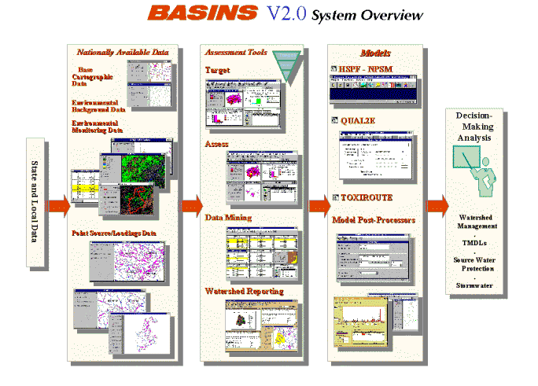

Website: www.epa.gov/OST/BASINS

