SWAT: Soil and Water Assessment Tool
http://www.brc.tamus.edu/swat/

- Predict the impact of land management practices on water, sediment, and agricultural yields in large complex watersheds with varying soils, land use and management conditions over long periods of time
- Requires specific information about weather, soil properties, topography, vegetation, and land management practices in watershed. SWAT models water movement, sediment movement, crop growth, and nutrient cycling with this information. Therefore, watersheds with no monitoring data can be modeled, and the effect of changes in input data can be quantified
- Water balance is the driving force, separated into two components

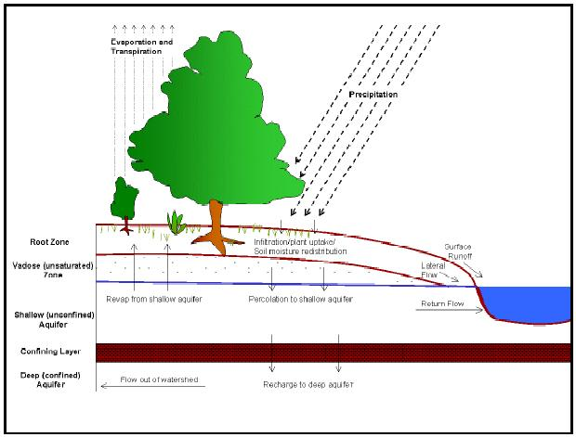 | 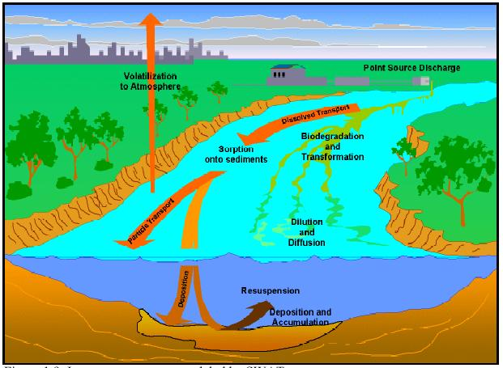
Land Phase of the Hydrologic Cycle  - Controls the amount of water, sediment, nutrient and pesticide loading to the main channel  - Use water balance equation:  SW_{t} = SW + Σ(R_{day}-Q_{i}-E_{a}-P_{i}-QR_{i})  SW, soil water content  t, time  R_{day}, amount of precipitation  Q_{i}, amount of surface runoff  E_{a}, amount of evapotranspiration  P_{i}, amount of percolation  QR_{i}, amount of return flow | Routing Phase of the Hydrologic Cycle  - The movement of water, sediments, etc. through the channel network of the watershed to the outlet  - Keeps track of mass flow in the channel  - Models the transformation of chemicals in the stream and streambed  - Inputs for Routing in the Main Channel or Reach: Flood Routing, Sediment Routing, Nutrient Routing, Channel Pesticide Routing  - Inputs for Routing in the Reservoir: Reservoir Outflow, Sediment Routing, Reservoir Nutrients, Reservoir Pesticides

Inputs for the Land Phase of the Hydrologic Cycle
- Climate: Daily Precipitation, Max/Min Air Temperature, Solar Radiation, Wind Speed and Relative Humidity (from observed data or generated using “Weather Generator”), Snow, Soil Temperature
- Hydrology: Canopy Storage, Infiltration, Redistribution, Evapotranspiration, Lateral Subsurface Flow, Surface Runoff, Ponds, Tributary Channels, Return Flow
- Land Cover/Plant Growth: Potential Growth, Potential and Actual Transpiration, Nutrient Uptake, Growth Constraints
- Erosion
- Nutrients: Nitrogen, Phosphorus
- Pesticides
- Management: Rotations, Water Use

Sources for Input
- SWAT Databases: Land Cover/Plant Growth, Tillage, Pesticide Use, Fertilizer Use, Urban (Input parameters used to simulate pollution runoff over impermeable areas), Soils, Weather Generator
- Other Sources
  - USGS: gage stations – streamflow data, DEMs – elevation and slope characteristics, LULC – land use/land cover
  - STATSGO: soil data
  - NRCS Soils-5 database: soils data
  - National Weather Service: daily precipitation, maximum/minimum air temperature
  - BASINS database

User Interfaces
- SWAT UTIL (Universal Text Integration Language) – DOS based interface
- Windows Interface – not available for SWAT 2000 (end of 2001)
- ArcView GIS interface – available January 2001

Other Programs that Accompany SWAT
- SWAT 99.2 Checker Program: checks inputs and warns user of values out of range or missing. SWAT/ArcView has checker built in.
- PHU (Potential Heat Unit) Program: estimates the number of heat units required to bring a plant to maturity. Used to simulate plant growth.
- Baseflow Filter Program: estimates baseflow and groundwater recharge from streamflow records using the methodology outlined by J.G. Arnold and P.M. Allen. Other baseflow filters not provided by SWAT are available and can be used instead.

Models Developed from SWAT
- SWIM (Soil and Water Integrated Model): developed by Potsdam Institute for Climate Impact Research.
- ESWAT (Extended SWAT): developed in Belgium. Allows detailed modeling of water quantity and quality processes in river basins.

Education
Three day workshops available. Tutorial datasets coming soon online.

