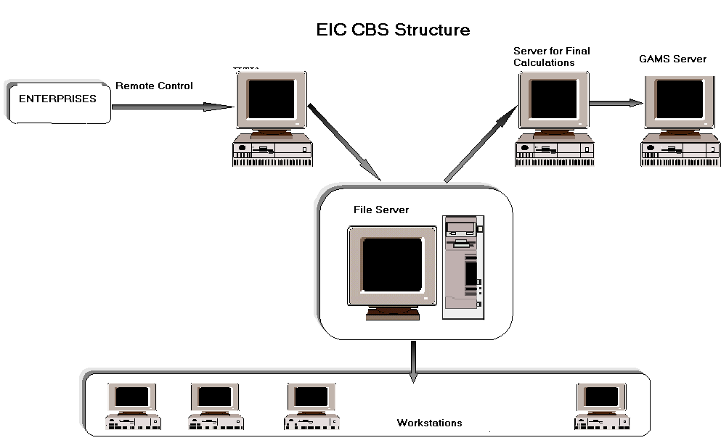
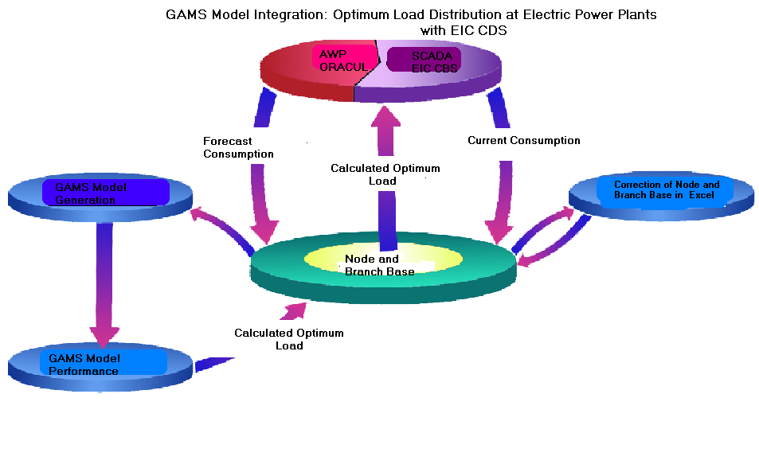
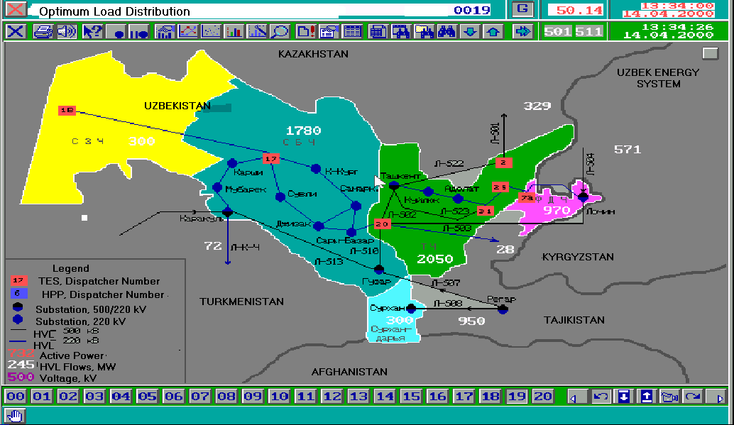
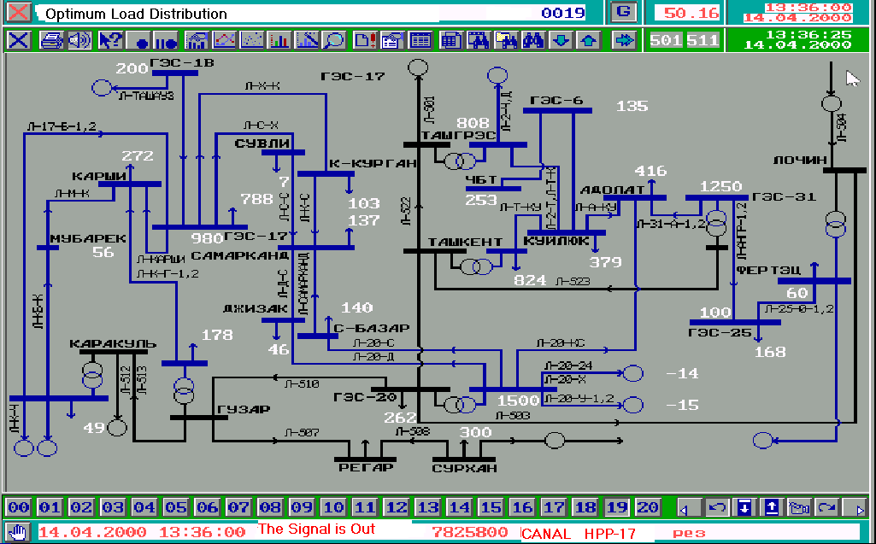
N027
N038
N010
G010
N047
N049
N028
N046
N045
N011
N026
N030
N025
N029
N012
N037
N040
N050
N006
N001
N051
G006
G056
N013
N014
N041
G041
N042
G042
N004
N043
N054
N002
N015
N016
N007
U007
G007
N003
G054
N053
N055
N005
G005
K8
N008
G008
N023
N009
N022
N048
СЗЧС

СУРХ. ЧС
ТЧC

СБЧС

ФЧС

G055
G001
G027

